**Uninformed Search**

Problem Solving as Search

• Search is needed to solve many real-world problem

8-puzzle problem Planning Go

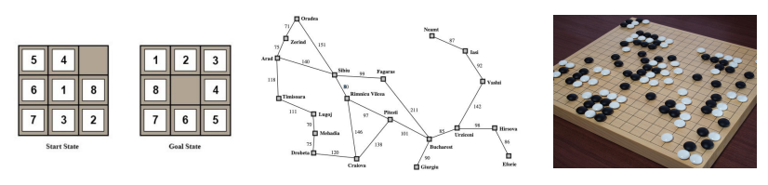

• Search is a central topic in AI

— Automated reasoning

— More recently: Given that almost all AI formalisms (planning, learning, etc.) are **NP-complete** or worse, some form of search is generally unavoidable (no “smarter” algorithm available).

Define a Search Problem

• A **search problem** consists of:

• **State space**: 

• A **successor function**: (action + cost)

• A **start state** and a **goal test**:

• A **path** is any sequence of states connected by a sequence of actions.

• **Path cost** – function that assigns a cost to a path; relevant if more than one path leads to the goal, and we want the shortest path.

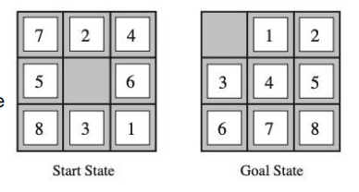• A **solution** is a sequence of actions (a plan) which transforms the **start state** to a **goal state**.

Example: The 8-Puzzle

• **State space**: • The location of each tile

• **Initial state**: • Any state can be the inital state

• **Goal test**: • Whether the state matches the goal state

• **Successor function**: • The movement of the blank space (Left, Right, Up or Down)

• **Path cost**: • Each step costs

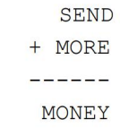Example: Cryptarithmetic

• Find **substitution of digits** **for letters** such that the resulting sum is arithmetically correct.

• Each letter must stand for a different digit.

• **State space**: an 8-tuple indicating a (partial) assignment of digits to letters.

• **Goal test**: all letters have been assigned digits and sum is correct

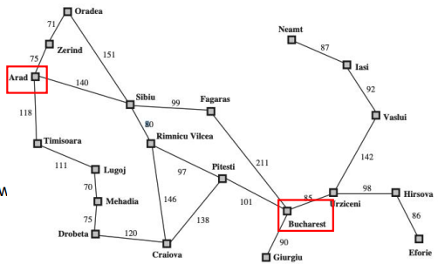• **Successo**r function: represents the act of assigning digits to letters

• **Path cost**: all solutions are equally valid; step cost = 0

Example: Traveling in Romania

**• State space**: • Cities

• **Initial state**: • Arad

• **Goal test**: • Is state == Bucharest

• **Successor function**: • Roads: go to adjacent cities with cost = distance

• **Path cost**: • The cost of a path

Solving a Search Problem: State Space Search

• **Input:** • Initial state • Goal test • Successor function • Path cost function

• **Output:** path from initial state to goal. Solution quality is measured by the path cost function

• Expanding: apply each legal action to the current state

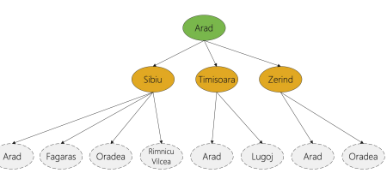• The leaf nodes available for expansion is called the frontier

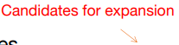Search procedure defines a search **tree**

**root node** — initial state

**Children of a node** — successor states

**Leaves of tree (frontier)** — states not yet expanded

**Search strategy** — algorithm for deciding which leaf node to expand next

Node Data Structure

• Node data structure is used to **keep track of** the search

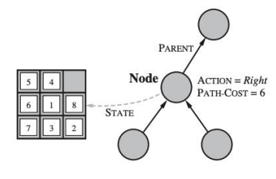• Nodes vs. States

• A node is a **bookkeeping data structure** used to represent the search tree

• A state corresponds to a **configuration** of the world

Evaluating a Search Strategy

• Completeness: is the strategy guaranteed to find a solution when there is one?

• Time complexity: how long does it take to find a solution?

• Space complexity: how much memory does it need?

• Optimality: does the strategy find the highest-quality solution when there are several different solutions?

Generic Tree-Search Algorithm

Add **initial state** to the **frontier**

Loop

**node** = remove-frontier( ) -- and save in order to return as part of path to **goal**

if goal-test(**node**) = true return path to goal

S = successors(**node**)

Add **S** to **frontier**

until **frontie**r is empty

return **failure**

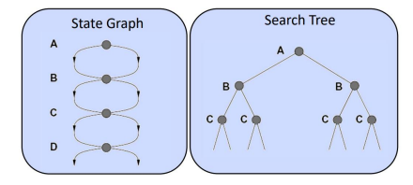Tree Search vs. Graph Search

• **Tree search** allows a state to be expanded more than once

• Failure to detect repeated states can cause more work

• Advantage: memory-efficient

Graph Search

•Idea: never expand a state twice

• How to implement:

• Tree search + set of expanded states (“closed set”)

• Expand the search tree node-by-node, but…

• Before expanding a node, check to make sure its state has never been expanded before

• If not new, skip it, if new add to closed set

Uninformed Search: BFS

• Use the **first-in, first out or FIFO** queue to store the frontier

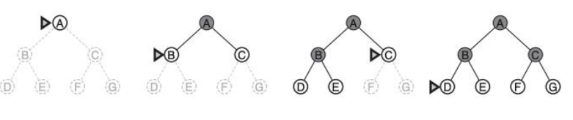• Consider paths of length 1, then of length 2, then of length 3, then of length 4, .

Time and Memory Requirements for BFS

• Let **b = branching factor** -> maximum number of successors of any node

• **d = solution depth** -> the shallowest goal node

• Then the maximum number of nodes generated is: b + b2+ ... + bd = O(bd)

• For graph search, O(bd-1) in the closed set and O(bd) in the frontier

• **branching factor = 10** • 1 million nodes / second • each node requires 1000 bytes of storage

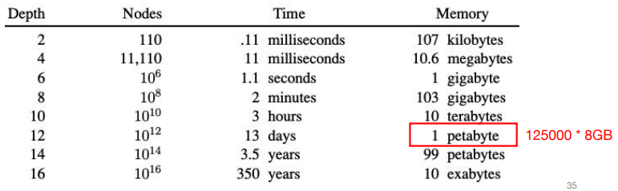

Uniform-Cost Search

• **Use BFS**, but always expand **the lowest-cost node** on the frontier as measured by path cost g(n)

• **g(Successor(n)) > g(n)** is a **necessary condition** for completeness and a **sufficient condition** for optimality

Uninformed search: DFS

• Use the last-in, first out or LIFO queue to store the frontier

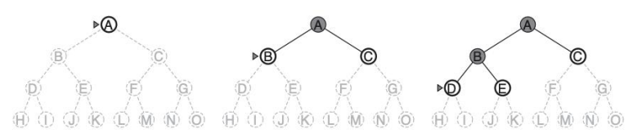

Time and Memory Requirements for DFS

• Let **b = branching factor** -> maximum number of successors of any node

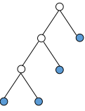• **m = maximum depth of any node**

• Time: for tree search, then the maximum number of nodes generated is: **O(bm)**

• Space: for tree search, only need to store **O(bm)** nodes

• at depth l < d we have b-1 nodes

• at depth d we have b nodes

• total = (m-1)*(b-1) + b = O(bm)

DFS vs. BFS

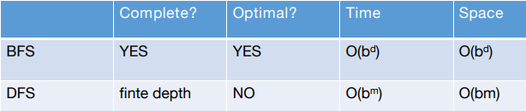

**d**: depth of the shallowest solution **m**: maximum depth

• Takeaways:

• If the solution is not far from the root: BFS might be faster

• If the search tree is very deep: DFS may never find solution

• If the search tree is wide: BFS might take too much memory

• If d is known: DFS is preferred

• If optimal solution is needed: BFS is preferred

Iterative Deepening [Korf 1985]

• Problem of DFS: cannot avoid infinite loops

• Idea: Use an artificial depth cutoff, **c**. If search to depth **c** succeeds, we are done. if not, increase **c** by 1 and start over. Each iteration searches using DFS. Combine the benefit of the DFS and BFS

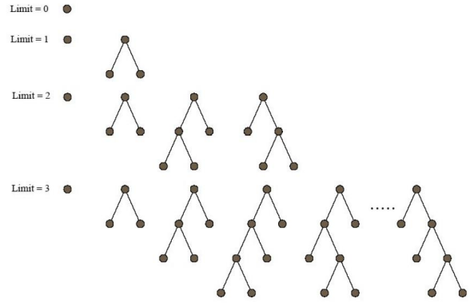

Iterative Deepening

• Space requirements: same as DFS.

• Time requirements: would seem very expensive! But not much different from single BFS or DFS to depth d

• Reason: **Almost all work is in the final couple of layers**. E.g., binary tree: 1/2 of the nodes are in the bottom layer. With b = 10, 9/10th of the nodes in the final layer!

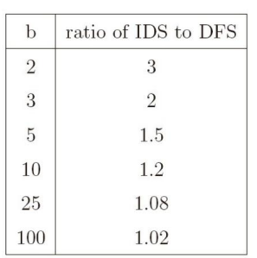• So, repeated runs are on much smaller trees (i.e., expoentially smaller)

Examples: b = 10, d = 5, the number of nodes generated in a BFS:

b + b2 + ... + bd = 10 + 100 + 1,000 + 10,000 + 100,000 = 111,110

For **IDS**: (d)b + (d-1)b2 + ... + (1)bd = 50 + 400 + 3,000 + 20,000 + 100,000 = 123,450

Cost of repeating the work at shallow depths is not prohibitive

Cost of Iterative Deepening

• Space: O(bd) as in DFS, time: O(bd)

• Asymptotic ratio of the number of nodes generated by BFS and IDS: • (b+1)/(b-1)

Bidirectional Search

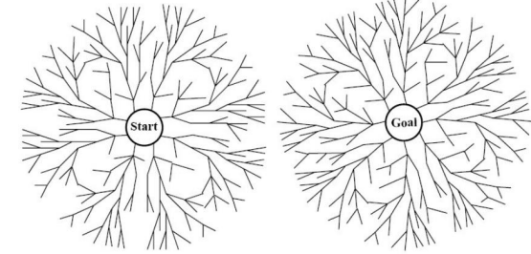

• When is bidirectional search applicable?

• Generate predecessors is easy • Goal state is clearly specified. (“no queen attacks another queen”)

• **Search forward from the start** state and **backward from the goal** state simultaneously and **stop when the two searches meet the middle**.

• If **branching factor = b** from both directions, and solution exists at **depth d**,

then need only O(2bd/2) = O(bd/2) steps.

• Example: b = 10, d = 6 then BFS needs 1,111,110 nodes and bidirectional search needs only 2,220.

Limitations

• What are the problems of all the methods? **Slow**!

• The search is blind in the sense that the information of the goal state is not used

• Informed search: • with the guidance of the goal state.

**Informed Search**

Define a Search Problem

• A **search problem** consists of:

• **State space**: 

• A **successor function**: (action + cost)

• A **start state** and a **goal test**:

**b: branching factor** **d: depth of the shallowest solution** **m: maximum depth**

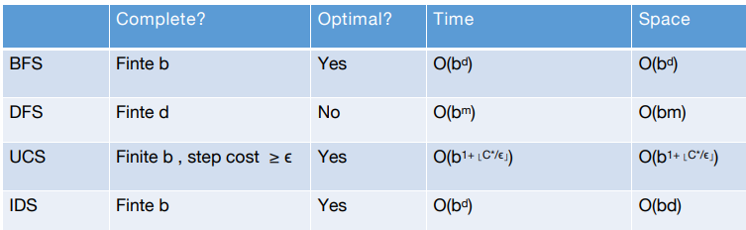

Informed Methods: Heuristic Search

• Informed methods use problem-specific knowledge

**• The location of the goal**

• Humans rely on informed search!

• We want to have some **estimate** of the distance from **the states** **in the frontier** to **the goal state**.

• Why estimate? Because the states we can reach are based on the actions we can take.

• We use an **evaluation** function f(n) as our **estimate**

• Best-first search:

**• Nodes are selected for expansion** based on the evaluation function, f(n).

• Expand the node with the **lowest** evaluation

• The evaluation function can be complex: f(n) = f1 (n) + f2 (n) + …

Greedy Best-First Search

•One natural component of f(n):

• Heuristic function:

• h(n) = **estimated cost** of the **cheapest** path from the state at **node n** to a **goal state**

Heuristic search is an attempt to search the most promising paths first.

• Greedy Best-First Search

• Expands the node that is “closest” to the goal as measured by h(n)

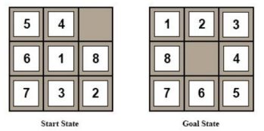• A common case:

• Best-first takes you straight to the (wrong) goal

• Worst-case: like a badly guided DFS.

Example: 8-puzzle problem

• Design of heuristic function is important

• One possible heuristic function: • The number of tiles misplaced

Example: Find a Path from Arad to Bucharest

• One possible heuristic function:

• the straight-line distance to Bucharest

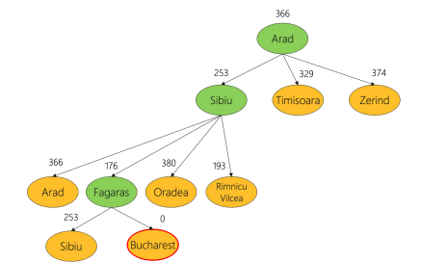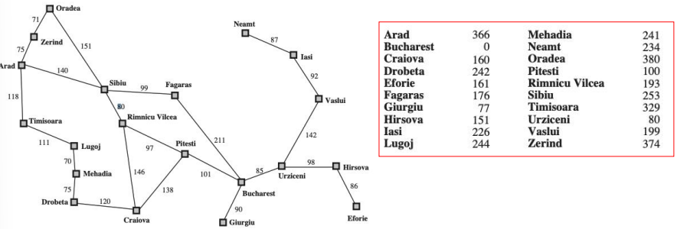

Example: Find a Path from Arad to Bucharest

• One possible heuristic function: • the **straight-line distance** to Bucharest

• Expand the node **seems “closest”**.

Greedy Best-First Search Can be Suboptimal

• From Arad to Sibiu to Fagaras -- but to Rimnicu would have been better

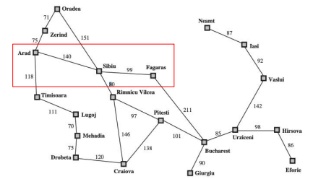

• What is missing? • **The cost of getting from the start node (Arad) to intermediate nodes**.

Greedy Best-First Search is Incomplete

• Start state: Iasi • Goal state: Fagaras

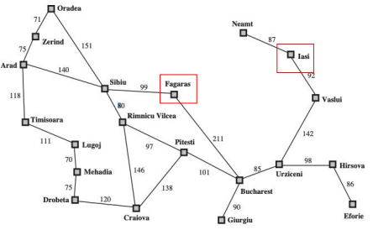

A* Search

• Proposed in 1968 by Peter Hart, Nils Nilsson and Bertram Raphael

• Most widely known form of Best-First Search.

• Combining **Uniform-Cost Search** **and Greedy Best-First Search** .

• f(n) = g(n) + h(n)

• g(n): the path cost from the start node to node n

• h(n): the estimated cost of the cheapest path from node n to the goal node

• When h(n) satisfies certain properties, A* is both complete and optimal!

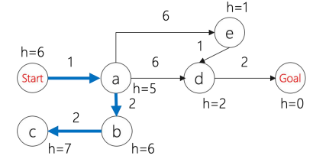

• **Uniform-cost** orders by path cost g(n)

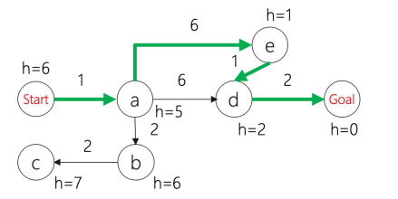

• **Greedy best first search** orders by estimated goal proximity h(n).

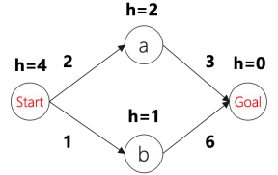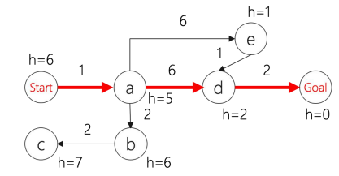

• **A* search combines** g(n) and h(n)

When to terminate in A* Search

• Similar to Uniform Cost Search, the goal test is applied to a node when it is selected for **expansion**,

• The path cost to the goal state may get **update**.

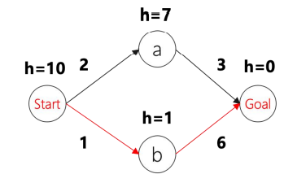Is A* Search Optimal?

• What went wrong?

• Actual goal cost < estimated goal cost

• Solution?

Need Some Conditions

• To guarantee that A* finds an **optimal solution**, we need that h(n) **never overestimates** the cost of reaching the goal

• Called an **admissible** (có thể chấp nhận được) heuristic

• Transfer to f, i.e., f also doesn't **overestimate**.

Formal Definition of Admissibility

• Let h*(n) be **the actual cost** to reach a goal from n.

•A heuristic function h is **optimistic** or **admissible** if 0 ≤ h(n) ≤ ℎ*(n) all nodes n.

•If h is **admissible**, then the A* algorithm will never return a sub-optimal goal node

Example: Admissible Heuristic

• Path finding: • the **straight-line distance** to Bucharest

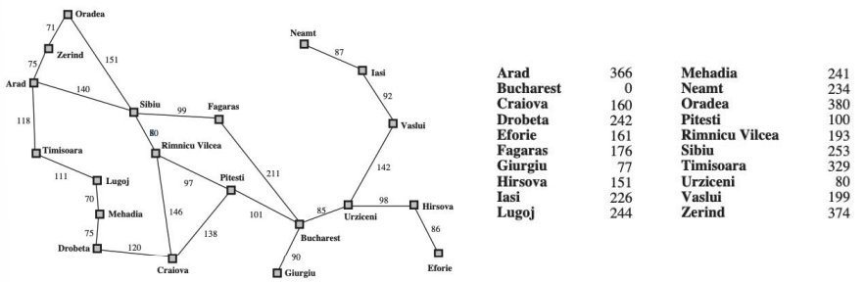

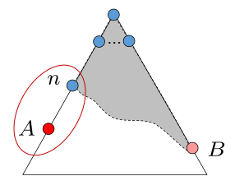Optimality of A* Tree Search Assume:

• A is an **optimal** goal node

• B is a **sub-optimal** goal node

• h is **admissible**

Claim: A will be expanded before B. 1. **f(n) is less or equal to f(A)**

Let h*(n) be the cheapest cost of getting to A from n

• h is admissible -> h(n) ≤ h*(n)

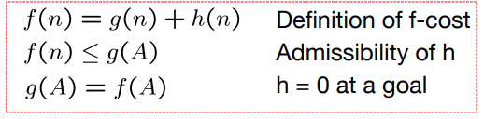• h*(n) = g(A) - g(n) -> h(n) ≤ g(A) - g(n) • -> f(n) ≤ f(A)

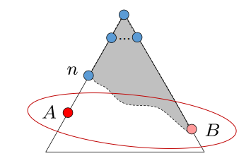Proof:

• Imagine B is on the frontier

• Some ancestor n of A is on the frontier, too (maybe A!)

• Claim: n will be expanded before B

1. f(n) is less or equal to f(A)

2. f(A) is less than f(B)

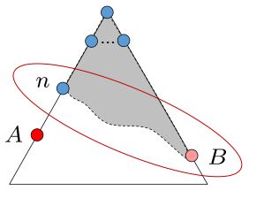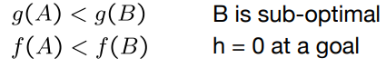

3. n expands before B

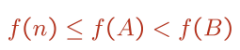

• **All ancestors of A expand before B --> A expands before B**

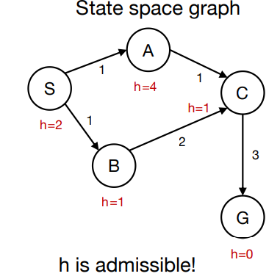A* Graph Search Gone Wrong

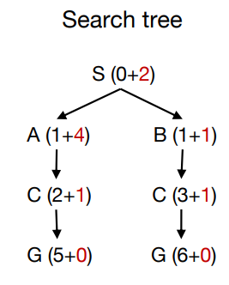

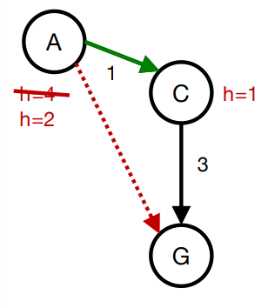Consistency (Tính nhất quán) of Heuristic

• Main idea: estimated heuristic costs ≤ actual costs

• Admissibility: heuristic cost ≤ actual cost to goal **h(A) ≤ actual cost from A to G**

• **Consistency**: heuristic “arc” cost ≤ actual cost for each arc **h(A) – h(C) ≤ cost(A to C)**

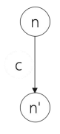Consequence of Consistency

• The f value along a path **never decreases**

f(n') = g(n') + h(n')

= g(n) + c + h(n')

≥ g(n) + h(n) consistency

= f(n)

• When A* **selects a node for expansion**, the **optimal path** to that node has been found.

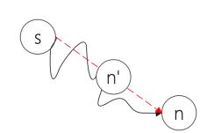• Proof:

• Assume g(n) > g*(n)

• Let n’ be the shallowest node in frontier on optimal path from s to n

• g(n') = g*(n') and f(n') = g*(n') + h(n')

• We have f(n') ≤ g*(n') + c(n' , n) + h(n) **consistency**

• f(n') ≤ g*(n) + h(n)

• f(n') < f(n) **contradiction**.

Optimality of A* Graph Search

• Consider what A* does with **a consistent heuristic**:

• Fact 1: A* expands nodes in nondecreasing total f value

• Fact 2: For every state s, nodes that reach s optimally are expanded before nodes that reach s suboptimal

• Result: **A* graph search is optimal**.

Summary

• Tree search:

• A* is optimal if heuristic is **admissible**

• UCS is a special case (h = 0)

• Graph search:

• A* optimal if heuristic is consistent

• UCS optimal (h = 0 is consistent)

• **Consistency implies admissibility**

• In general, most natural admissible heuristics tend to be consistent.

Intuition(trực giác) A*

• Let f* be the cost of optimal solution path.

• We have

• A* expands all nodes with f(n) < f*

• A* may then expand some nodes right on “goal contour” , with f(n) = f* before selecting a goal node.

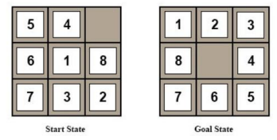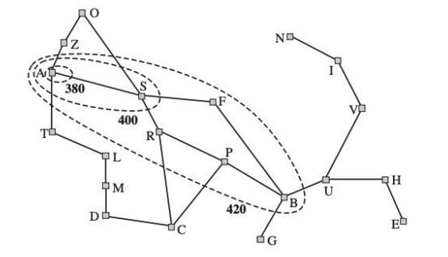

• A* Gradually adds "**f-contours**" of nodes

• Contour i has all nodes with f=fi, where fi < f i+1 .

Design of Heuristics

1. h1 = number of misplaced tiles

2. h2= Manhattan distance

• the sum of the distances of the tiles from their goal positions

Which one should we use? h1 ≤ h2 ≤h*

Importance of h(n) hc ≤ hm ≤ h*

• **Prefer** hm

• **Note:** Expand all nodes with f(n) = g(n) + h(n) < f*?

• **Every node with h(n) < f* - g(n) will be expanded**

• • Since h1 ≤ h2 , every node expanded with h2 will be expanded by h1 .

• Aside. How would we get an hopt?

Comparison of Search Costs on 8-Puzzle

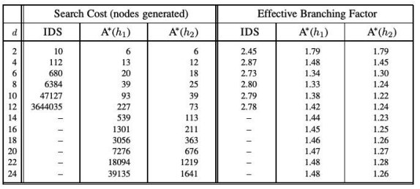

• Effective branch factor b*: characterize the quality of a heuristic N + 1 = 1 + b* +(b*)2 +….+(b*)d .

Where Does the Heuristics

• Most of the work in solving hard search problems optimally is in coming up with admissible heuristics

• Admissible heuristics: h(n) ≤ℎ*(n)

• But if ℎ*(n) is unknown, how can we verify the condition?

• Often, admissible heuristics are solutions to **relaxed problems**, where new actions are available -> **fewer constraints**

• The cost of an optimal solution to a relaxed problem is an admissible heuristic for the original

• The models obtained by such constraint-deletion processes are called **relaxed models**

Example: 8 Queen

• Description of actions: A tile can move from square A to square B if A is adjacent to B and B is blank

(a) A tile can move from square A to square B if A is adjacent to B.

(b) A tile can move from square A to square B if B is blank

(c) A tile can move from square A to square B

Example: Traveling Salesman Problem

• Find the shortest route that visits each city exactly once and returns to the origin city

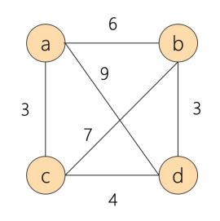

• Find an estimate for the cheapest path that starts at a city X, ends at city Y, and go through each unvisited city.

Example: Traveling Salesman Problem

• Find an estimate for the cheapest path that starts at a city X, ends at city Y, and go through each unvisited city.

• Three conditions for the path:

• Being a graph • Being connected • Being degree 2.

• Find an estimate for the cheapest path that starts at a city X, ends at city Y, and go through each unvisited city.

• Three conditions for the path:

• Being a graph -> Optimal Assignment Problem

• Being degree 2

• Find an estimate for the cheapest path that starts at a city X, ends at city Y, and go through each unvisited city.

• Three conditions for the path: • Being a graph • Being connected -> Minimum Spanning Tree Problem

Consistency

• Heuristics come from **relaxed problems** are guaranteed to be **consistent**.

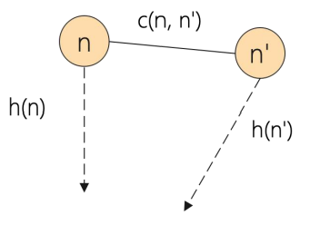

• h(n) and h(n') stand for the minimum cost of finding solution for some relaxed problem. We have

h(n) ≤ **c'(n, n')** + h(n') relaxed cost -> h(n) ≤ c(n, n') + h(n)

What if We Have Multiple Heuristics

• Suppose we have heuristics h1 (n), h2 (n), h3 (n)

• Every node with h(n) < f* - g(n) will be expanded

• The final heuristic h(n) = max(h1 (n), h2 (n), h3 (n)).

A* Applications

• Video games • Pathing / routing problems • Resource planning problems • Robot motion planning • Language analysis • Machine translation • Speech recognition.

A*: Summary

**Optimal**: Yes A* is optimally efficient: given the information in h, no other optimal search method can expand fewer nodes

**Complete:** Unless there are infinitely many nodes with f(n) < f*. Asussme locally finite: (1) finite branching, (2) every operator costs at least ε >0

**Complexity (time and space**): still exponential because of breadth-first nature. Unless |h(n) - h*| <= O(log(h*(n)), with h true cost of getting to goal, the time complexity is polynomial.

Link: [https://vi.wikipedia.org/wiki/Gi%E1%BA%A3i_thu%E1%BA%ADt_t%C3%ACm_ki%E1%BA%BFm_A*](https://vi.wikipedia.org/wiki/Gi%E1%BA%A3i_thu%E1%BA%ADt_t%C3%ACm_ki%E1%BA%BFm_A*)

. <https://vi.wikipedia.org/wiki/Heuristic#:~:text=Heuristic%20(%2Fhj%CA%8A%C9%99%CB%88r%C9%AA,%C4%91%E1%BA%A3m%20b%E1%BA%A3o%20l%C3%A0%20t%E1%BB%91i%20%C6%B0u>.

.

<https://en.wikipedia.org/wiki/Consistent_heuristic#:~:text=In%20the%20study%20of%20path,cost%20of%20reaching%20that%20neighbour>.

**Local Search**

Search Algorithms

•BFS, DFS, UCS, A* etc

• Explore the state-space **systematically** to the goal state

• Need to reconstruct the **path**.

Local Search Methods

• The search spaces for some real-world problems is **enormously big**

• How many combinations can 500 processes be assigned to 100 computers? 100500 states

• There are 3361 states in Go board

• A completely different kind of method is called for: • Local Search Methods

Local Search Methods

• Applicable when we're interested in the Goal State -- **not in how to get there**

• E.g. N-Queens, Course Scheduling Problem or Job-shop Scheduling

• Basic idea:

- use a single current state

- don't save paths followed

- generally move only to sucessors/neighbors of that state

- find the best state according to an objective function or cost function

Local Search Methods

• Advantages:

• Use very little memory

• Can be applied to problems with a large number of states

• Can be applied to problems with changing state spaces

• Disadvantages:

• Cannot recover the path

• The solution may not be optimal

State-Space Landscape

• Local Search Methods rely on an objective function or a cost function to compute the state-space landscape

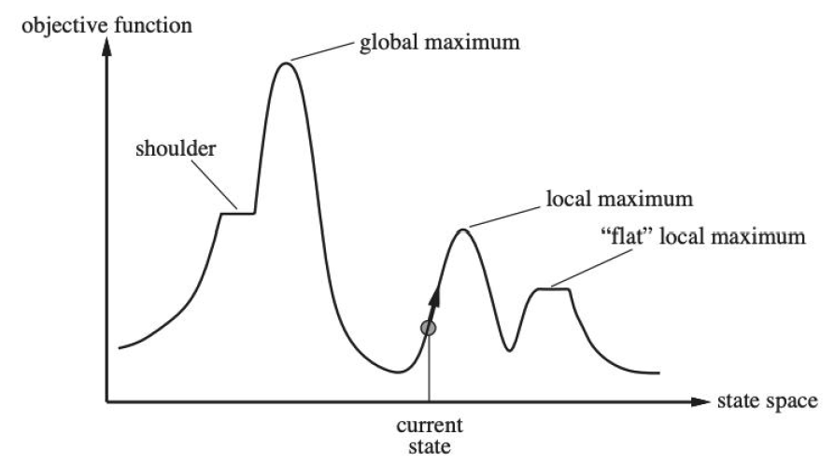

• Local search algorithms explore this landscape

Hill Climbing Search

• Move in the direction of increasing value

• Terminate when it reaches a “peak” where no neighbor has a higher value.

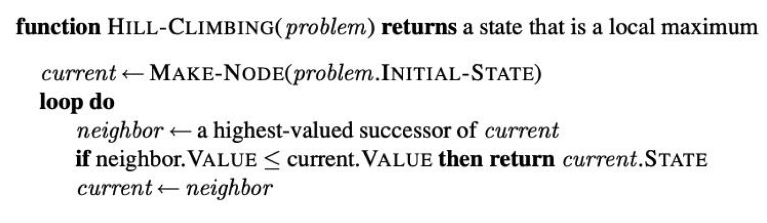

• Only need to record the state and the value of the objective function or cost function

• **Similar to greedy algorithm**, **only check the value of the immediate neighbors**

• Rely on **complete-state formulation** instead of incremental formulation

Complete-State Formulation vs. Incremental Formulation

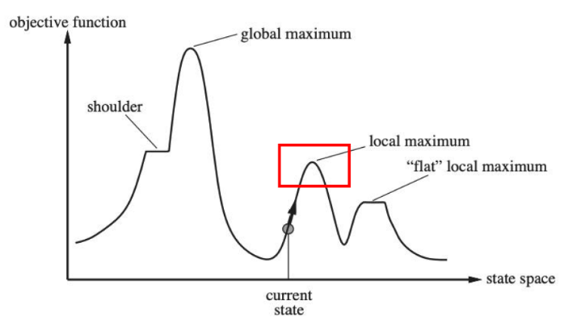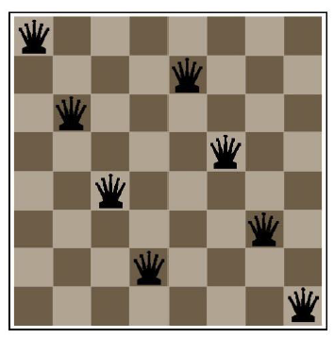

• Complete-State Formulation

• **All queens are in the board**. Move any queen in the same column

• **Why used in local search**? -> Divide object function

• Incremental Formulation

• Add each queen to the board one by one (used in many search algorithms we covered before)

Hill Climbing Search Can Get Stuck

• Local maxima

• A peak that is higher than all its neighbors but lower than the global maximum.

• Ridges: • A sequence of local maxima

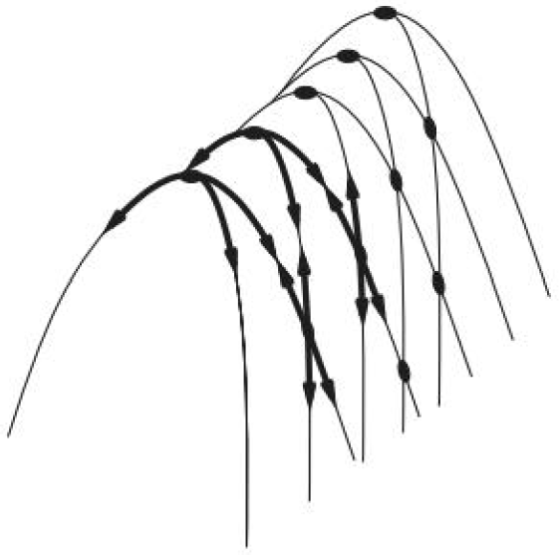

• Plateaux or shoudlers • The objective function is constant

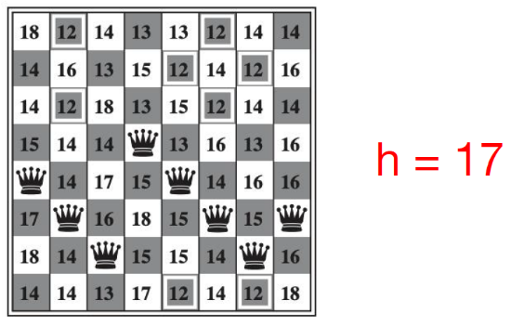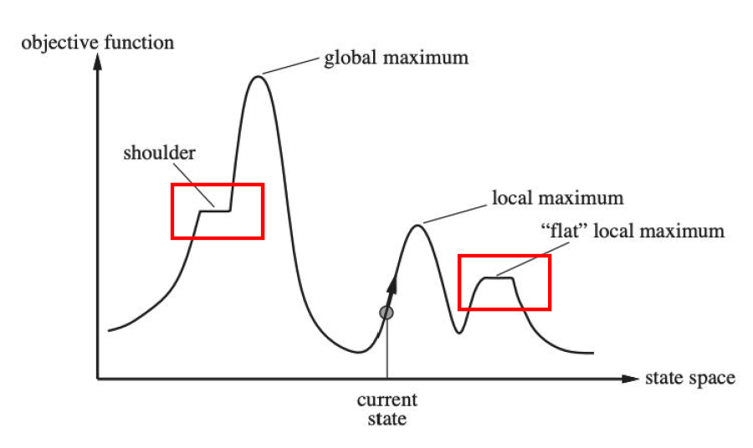

Example: 8-queen problem

• Put n queens on an n × n board with no two queens on the same row, column, or diagonal

• What is the **state-space** of this problem?

• How is this problem different from the 8-puzzle problem?

Example: 8-queen problem

• Heuristic cost function: the number of pairs of queens that are attacking each other, either directly or indirectly

• Each time we can move the queen to another square in the same column

Example: 8-queen problem

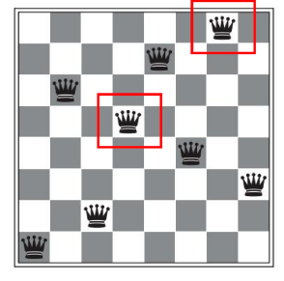• Heuristic cost function: the number of pairs of queens that are attacking each other, either directly or indirectly

• Local minimum with h =1

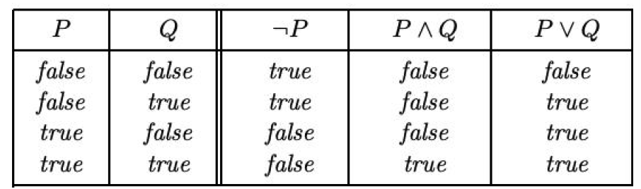Example: Satisfiability

• Propositional logic:

• Literals (**True or False**) A, B, C, ...

• Logical connectives: 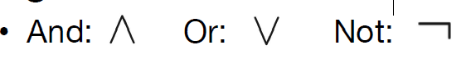

• Clause: a disjunction of literals 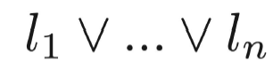

• Conjunctive normal form: 

Example: Satisfiability

• A wide variety of key CS problems can be translated into a propositional logical formalization

e.g., 

• Solved by finding a truth assignment to the propositional variables (A,B,C,…) that makes it true, i.e., a model.

• If a formula has a model, we say that it is “satisfiable”

Example: Satisfiability Testing

• Best-known method: Davis-Putnam Procedure (1960)

- Backtrack search (DFS) through the space of truth assignments

• Assigning values to variables one by one and simplifying at each step

• Cannot be satisfied 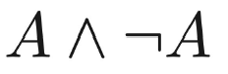

Example: Satisfiability Testing

Best-known method**: Davis-Putnam Procedure** (1960): <https://www.youtube.com/watch?v=ENHKXZg-a4c>

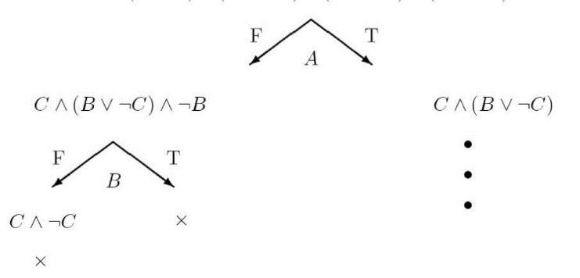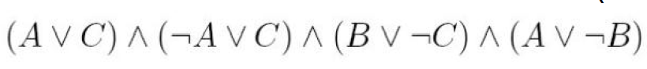

• To date, Davis-Putnam Procedure is still the fastest sound

and complete method.

• However, there are classes of formulas where the procedure

scales badly.

• Consider an incomplete local search procedure

Greedy Local Search -- GSAT

• Begin with a random truth assignment (assume CNF).

• Flip the value assignment to the variable that **yields the greatest number of satisfied clauses**. (Note: Flip even if there is no improvement.)

• Repeat until a model is found, or have performed a specified maximum number of flips.

• If a model is still not found, repeat the entire process, starting from a different initial random assignment.

• Input: a conjunctive normal form α, MAX-FLIPS, MAX-TRIES

• Output: a satisfying truth assignment if found

• For i = 1 to MAX-TRIES:

T := **a randomly generated truth assignment**

For j = 1 to MAX-FLIPS:

If T satisfies α, then return T

p := **a propositional variable such that a change of its truth leads to the largest number of satisfied clauses**

T := **T with the truth value of p reversed**

return “no satisfying assignment found”

Greedy Local Search -- GSAT

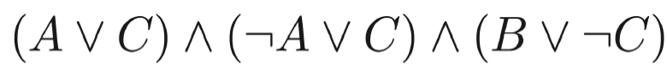

• A: False B: False C: True

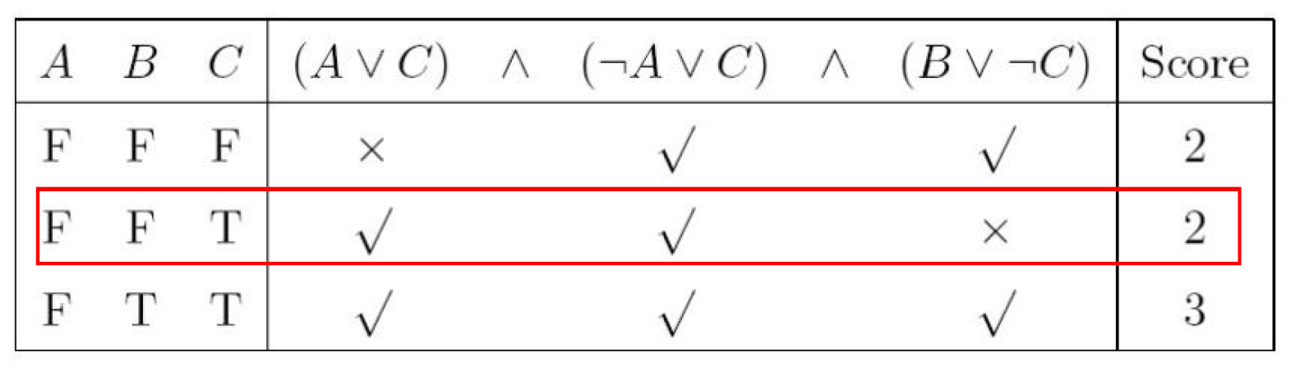

How well does it work?

• First intuition: It wil get stuck in local minima, with a few unsatisfied clauses.

• Note we are not interested in almost satisfying assignments

• E.g., a plan with one “magic” step is useless.

• Contrast with optimization problems.

• GSAT is not complete.

• **Surprise:** It often finds global minimum!

• i.e., finds satisfying assignments

• Generate a large number of random formulas

• Different number of propositional variables

• Different number of clauses

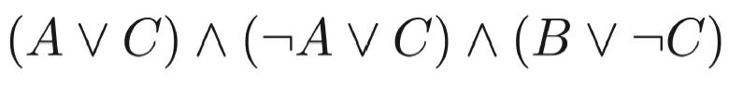

• Run GSAT and Davis-Putnam Procedure on the generated formulas and measure the time to find the right assignment.

Greedy Local Search – GSAT

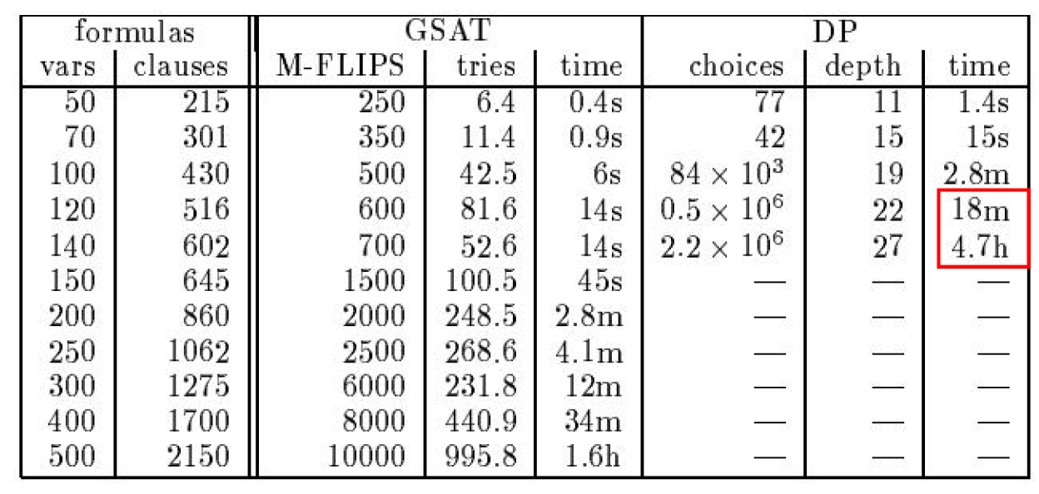

Limitations of GSAT



• Can be satisfied only when A is True

• But GSAT prefers a negative assignment

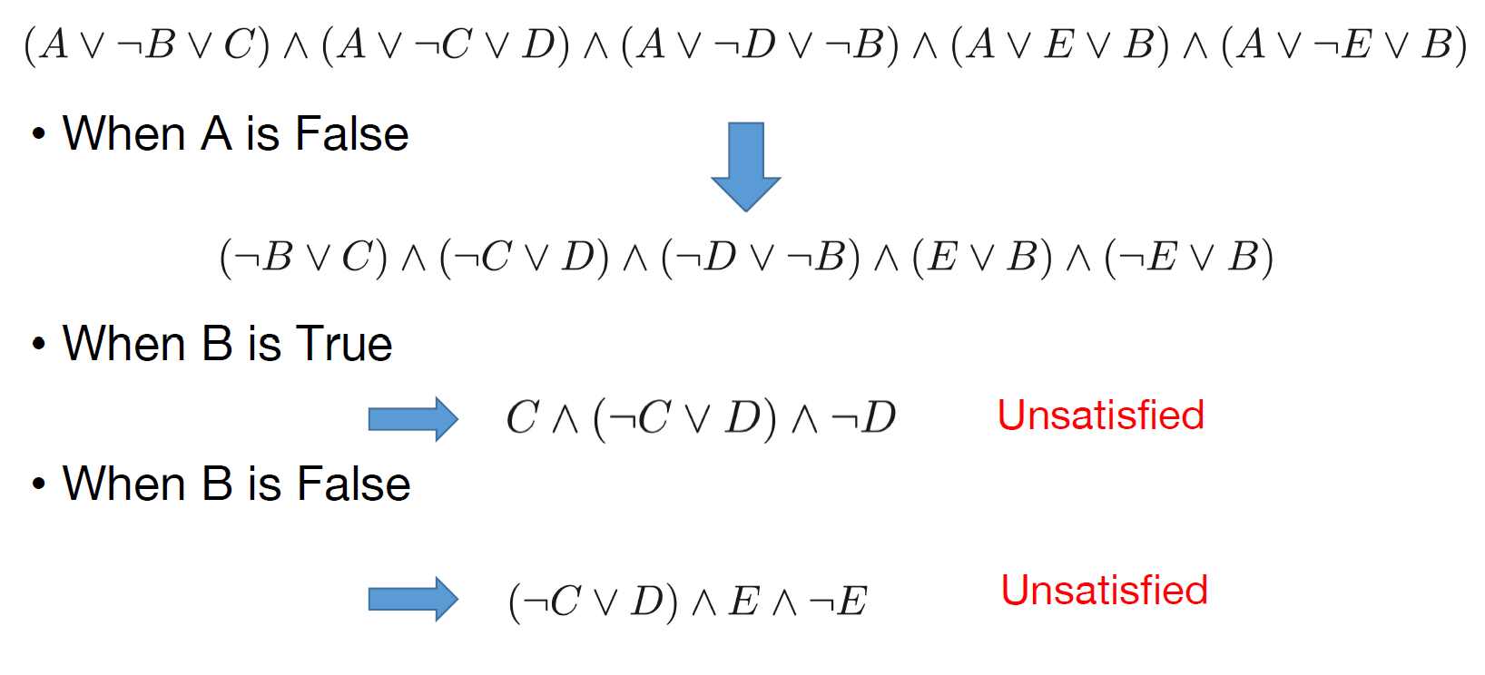

HCS:

<https://www.youtube.com/watch?v=oSdPmxRCWws>

<https://www.youtube.com/watch?v=rTcRLIxCxVs>

Best-known method**: Davis-Putnam Procedure** (1960): <https://www.youtube.com/watch?v=ENHKXZg-a4c>

GSAT: <https://www.youtube.com/watch?v=SAXGKCnOuP8>

**Local Search**

Improvements to Basic Local Search

• Issue: How to move more quickly to successively higher plateaus and avoid getting “ stuck” / local minima

• Idea: Introduce uphill moves (“ noises”) to escape from long plateaus (or true local minima).

• Strategies: • Simulated Annealing • Random-restart hill-climbing • Tabu search • Local beam search • Genetic Algorithms.

Variation on Hill-Climbing

• Random restarts: simply restart at a new random state after a pre-defined number of local steps

• Tabu: prevent returning quickly to the same state. • Implementation: Keep fixed length queue (“tabu list”): add most recent step to queue; drop “oldest” step. Never make step that’s currently on the tabu list

• **Uphill moves are acceptable** if no downhill moves are available.

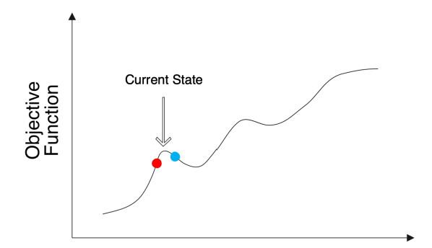Simulated Annealing

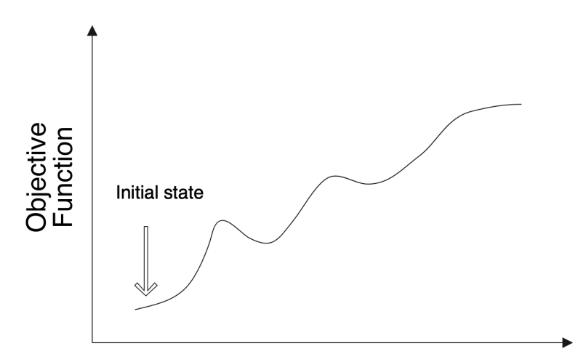

• Idea: • Use conventional hill-climbing techniques, but occasionally take a step in a direction **other than that in which the rate of change is maximal**.

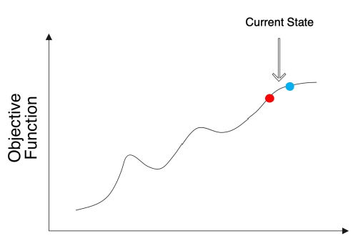

As time passes, • The size of any down-hill step taken is **decreased**.

• The probability that a down-hill step is taken is gradually reduced

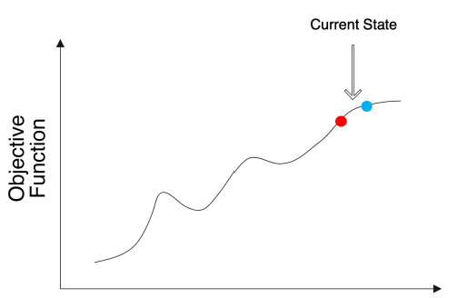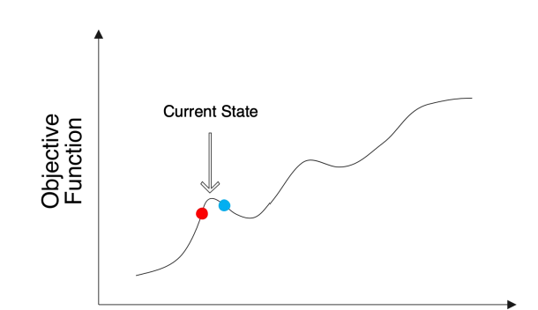

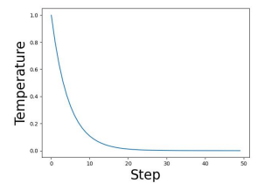Simulated Annealing

• Intuition:

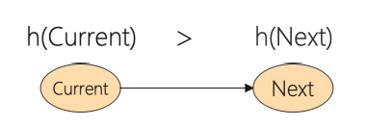

• The probability of move to a bad state should decrease exponentially with the “badness” h(Next) - h(Current)

• The probability decreases as the “temperature” T goes down

• How to schedule the “temperature”? • Initially with a high temperature and gradually decays

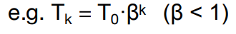

SA Algorithm

• Current, Next: nodes/states

• T: “temperature” controlling probability of downward steps

• Schedule: mapping from time to “temperature”

• H: heuristic evaluation function.

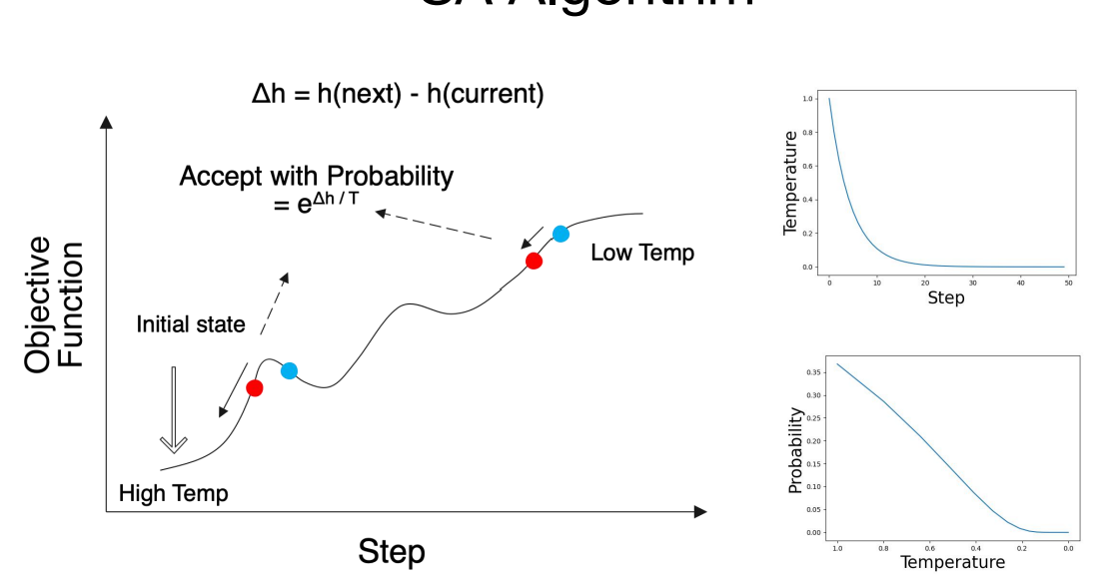

current ← initial state

for t ← 1 to inf do

T ← schedule[t]

if T = 0 then return current

next ← randomly selected successor of current

Δh ← h(next) - h(current)

if Δh > 0 then current ←next uphill

else current ← next only with probability eΔh/T downhill.

SA Algorithm: Convergence

• If the schedule lowers T slowly enough, SA will find a global minimum with probability approaching 1

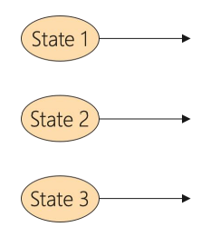• In practice, reaching the global minimum could take a large number of iterations.

Local Beam Search

• Instead of maintaining one current state, local beam search **keep track of k states**

• **All of the successors** of the k states are generated

• Local beam search selects the **best k states** from all the successors and repeat until the goal state is found.

• Useful information is passed among the parallel search threads

• Disadvantage: • All k states can become stuck in a small region of the state space

Example: Satisfiability

• A wide variety of key CS problems can be translated into propositional logical formalization

e.g., 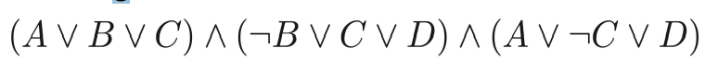

• Solved by finding a truth assignment to the propositional variables (A,B,C,…) that make it true, i.e., a model.

• If a formula has a model, we say that it is “satisfiable”

Random Walk SAT

Random walk SAT algorithm: 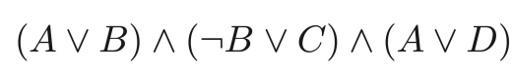

I Pick random truth assignment.

II Repeat until all clauses satisfied:

Flip variable from any unsatisfied clause.

Solve 2-SAT (2 variables per clause) in O(n2) flips

Does not work at all for hard k-SAT (k >= 3)

Walk SAT: Mixing Random Walk w/ Greedy Search(Selman et al. 1996)

• With probability p, walk, i.e., pick a variable in some unsatisfied clause and flip it;

• With probability (1-p) make a **greedy** flip, i.e., one that makes greatest decrease in number of unsatisfied clauses.

• Cannot detect **un-satisfiability**.

Experimental Results: Hard Random 3CNF

• Noise: different from Walk SAT, the selected randomly flipped variable is not restricted to be in an unsatisfied clause

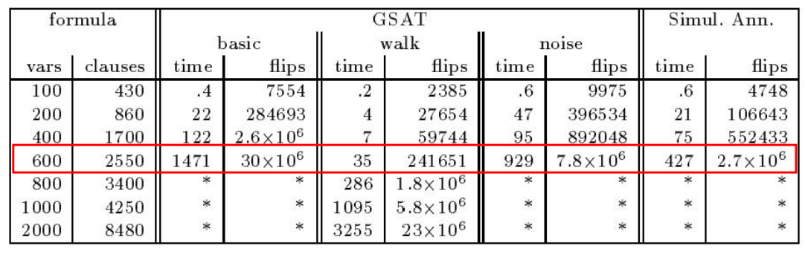

• Complete methods, such as DP, up to 400 variables

• **Walk SAT** better than **Simulated Annealing** better than **Basic GSAT** better than **Backtracking (Davis-Putnam)**.

Local Search in continuous Spaces

• Originated in the 17th century, after the development of calculus by Newton and Leibniz.

Min f(x1, x2,x3,…). 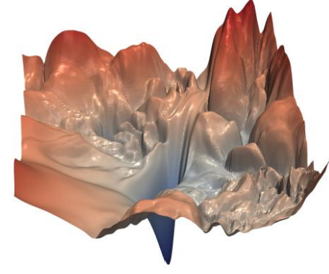

• Example: • Place a storage center (x, y) that are close to n cities(ai ,bi).

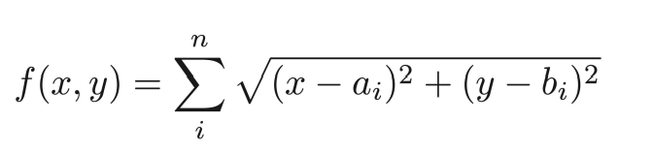

Gradient Descent

• Similar to hill-climbing search but the states are continuous

• Basic idea:

• Use the gradient of the cost function for updating the unknowns. 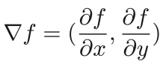

• The gradient gives the direction for decreasing the objective function.

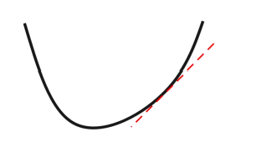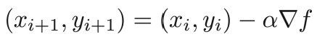

• For small enough α, we have

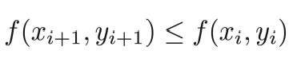

**Local Search**

Genetic Algorithms

• Approach mimics evolution

• Usually presented using a rich (and different) vocabulary:

- fitness, populations, individuals, genes, crossover, mutations, etc.

• Still, can be viewed quite directly in terms of standard local search.

Features of Evolution

• High degree of parallelism

• New individuals (“ next state / neighboring states”):derived from “ parents” (“ crossover operation”)genetic mutation

• Selection of next generation based on survival of the fittest.

General Idea of Genetic Search

• Maintain a population of individuals (states/ strings/candidate solutions)

• Similar to local beam search

• Each individual is evaluated using a fitness function ,i.e., an evaluation function. The fitness scores force individuals to compete for the privilege of survival and reproduction.

• Similar to hill climbing

• Generate a sequence of generations:

• From the current generation, select pairs of individuals(based on fitness) to generate new individuals, using crossover

• Introduce some noise through random mutations

• Hope that average and maximum fitness(i.e., value to be optimized) increases over time

Genetic Algorithms as Search

• Genetic algorithms are **local heuristic search algorithms**.

• Especially good for problems that have large and poorly understood search spaces

• Genetic algorithms use a **randomized parallel beam search** to explore the state space

• You must be able to define **a good fitness function**, and of course, **a good state representation**.

Binary String Representation

• Individuals are usually represented as **a string over a finite alphabet**, usually bit strings.

• Individuals represented can be **arbitrarily complex**.

• E.g. each component of the state description is allocated a specific portion of the string, which encodes the values that are acceptable.

• Bit string representation allows **crossover** operation to change multiple values in the state description. **Crossover** and **mutation** can also produce previously unseen values.

8-queens State Representation

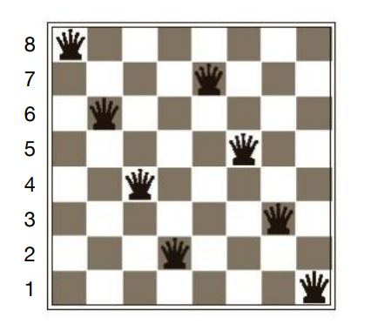

• Option 1: 86427531 • Option 2: 111 101 011 001 110 100 010 000

GA: High-level Algorithm

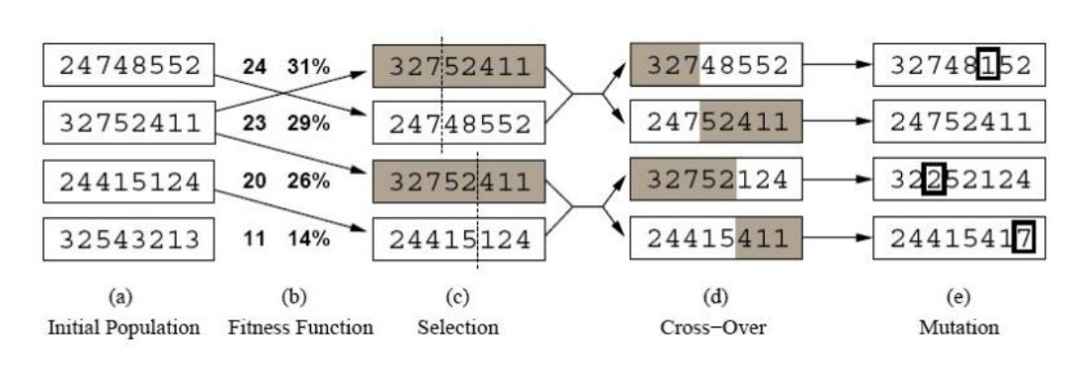

Selecting the Most Fit Individuals

• Individuals are chosen probabilistically for survival and **crossover** based on fitness proportionate selection:

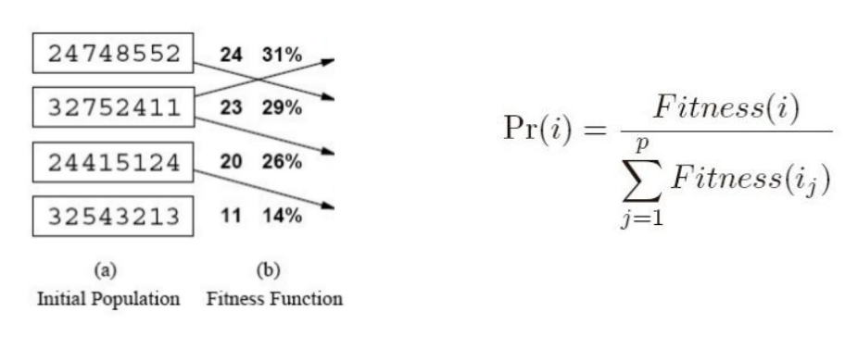

Other Selection Methods

• Tournament Selection:

• Two individuals selected at random. **With probability** p ,the more fit of the two is selected. **With probability**(1−p), the less fit is selected.

• Rank Selection:

• The individuals **are sorted by fitness** and the probability of selecting an individual is proportional to its rank in the list.

Crossover Operators

•Single-point crossover:

Parent A: 1 0 0 1 0 1 1 1 01

Parent B: 0 1 0 1 1 1 0 1 10

Crossover Operators

•Single-point crossover:

Parent A: 1 0 0 1 0 1 1 1 01

Parent B: 0 1 0 1 1 1 0 1 10

Child AB: 1 0 0 1 0 1 0 1 10

Child BA: 0 1 0 1 1 1 1 1 01

Crossover Operators

• Two-point crossover:

Parent A: 1 0 0 1 0 1 1 1 01

Parent B: 0 1 0 1 1 1 0 1 10

Crossover Operators

• Two-point crossover:

Parent A: 1 0 0 1 0 1 1 1 01

Parent B: 0 1 0 1 1 1 0 1 10

Child AB: 1 0 0 1 1 1 0 1 01

Child BA: 0 1 0 1 0 1 1 1 10

Crossover Operators

• Uniform crossover:

Parent A: 1 0 0 1 0 1 1 1 01

Parent B: 0 1 0 1 1 1 0 1 10

Child AB: 1 1 0 1 1 1 1 1 01

Child BA: 0 0 0 1 0 1 0 1 10

Mutation

• Mutation: randomly flip one bit

Individual A: 1 0 0 **1** 0 1 1 101

Individual A': 1 1 0 **0** 0 1 1 101

Mutation

• The mutation operator introduces random variations, allowing solutions to jump to different parts of the search space.• What happens if the mutation rate is too low?

• What happens if the mutation rate is too high?

• A common strategy is to use a high mutation rate when search begins

• But to decrease the mutation rate as the search progresses.

GA: High-level Algorithm

GA(Fitness, Fitness theshold, p, r, m)

P ← randomly generate p individuals

For each i in P, compute Fitness(i)

While [ max Fitness(i) < Fitness theshold]

1. Probabilistically select (1 − r)p members of P to add to Ps

2. Probabilistically choose r · p / 2 pairs of individuals from P. Foreach pair <i1,i2> apply **crossover** and add the offspring to Ps

3. **Mutate** m · p random members of Ps

4. P ← PS 5. For each i in P, compute Fitness(i) Return the individual in P with the highest fitness.

Example

• Maximize the function f(x) = x3 , where x ∈[0, 15]

Step 1: Choose an encoding 0 15

↓ ↓

0000 1111

Step 2: Randomly choose an initial population 4, 7, 9, 12

Step 3: Select parents

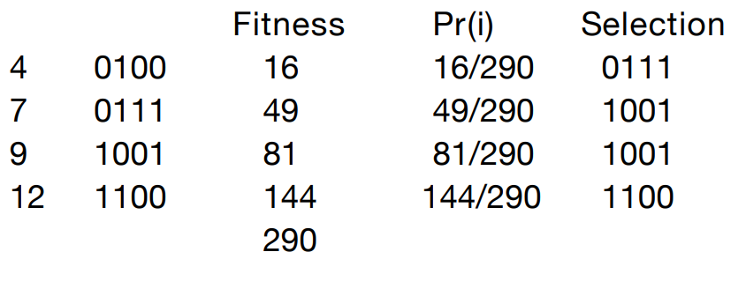

Step 4: Crossover and Mutation

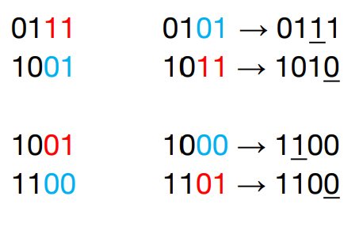

Step 5: Evaluate the offspring

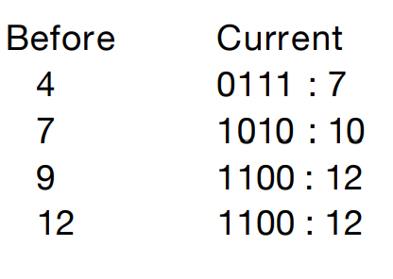

How Does Genetic Algorithm Work?

• Based on the idea of schema

• For example, 246***** is a schema for 8-queenproblem

• 11** is a schema for the optimization problem

• Each schema can be thought as a **building block** of the final solution

• If the average fitness of the instances of a schema is **above the mean**, then the number of instances of the schema within the population will **grow over time**.

Limitations of GA

•It is expensive to evaluate the fitness function

• The stopping criterion is not clear

• Can get stuck in local minimum

Genetic Programming

• In Genetic Programming**, programs** are evolved instead of **bit strings**.

• We want to find the program that completes the task we have.

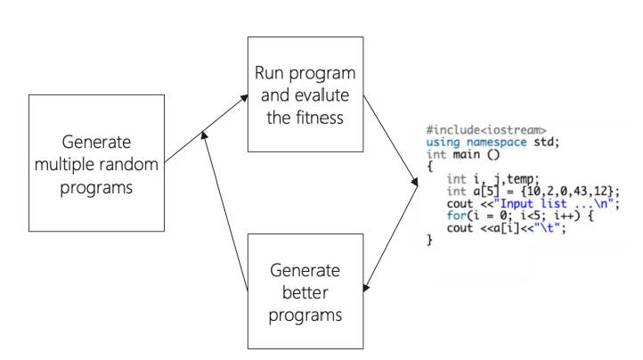

Genetic Programming

• In Genetic Programming, programs are evolve dinstead of bitstrings.

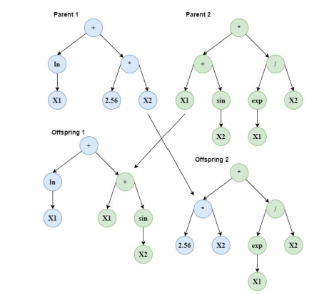

Remarks on GA’s

• In practice, several 100 to 1000’s of strings. Value of **crossove**r difficult to determine (so far).

• Crowding can occur when an individual that is much more fit than others reproduces like crazy, which **reduces diversity** in the population.

• In general, GA’s are highly sensitive to the representation

**Constraint Satisfaction Problem**

Standard Search Problem

* **Standard Search Problems**:
  + State is a “black box”: **arbitrary** data structure
  + Goal test can be **any** function over states
  + Successor function can also be **anything**

Constraint Satisfaction Problems (CSP)

* Constraint satisfaction problems (CSPs):
  + A special subset of search problems
  + State is defined by variable Xi with values from a domain D (sometimes D depends on i)
  + Goal test is a set of constraints specifying allowable combinations

of values for subsets of variables

* Why CSPs?
  + Allows useful general-purpose algorithms with more power than standard search algorithms

Example: Map-Coloring Problem

* 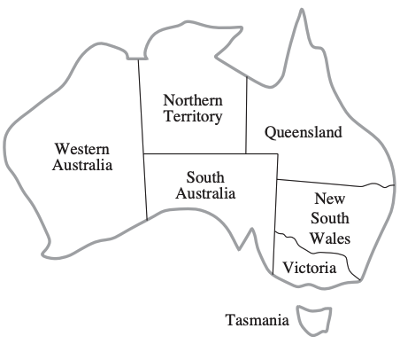Color each region either red, green or blue in such a way that no neighboring regions have the same color
  + **Variables**: different regions
  + **Domains**: colors

Constraint Satisfaction Problems (CSP)

* A **powerful** representation for (discrete) search problems.
* A Constraint Satisfication Problem (CSP) is defined by:
  + **X** is a set of n variables X1, X2, ...., Xn, each defined by a finite domain D1, D2, ..., Dn of possble values
  + **C** is a set of constraints C1, C2, ..., Cm. Each Ci involves some subset of the variables; specifices the allowable combinations of values for that subset.

A **solution** is an assigment of values to the variables that **satisfies all constraints.**

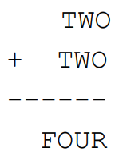Cryptarithmetic as a CSP

* **Variables**:

F O U R T W C1 C2 C3

* **Domains**:

{0, 1, 2, 3, 4, 5, 6, 7, 8, 9}

* **Constraints**:

O + O = R + 10 * C1

C1 + W + W = U + 10 * C2

C2 + T + T = O + 10 * C3

C3 = F

**alldiff**(F, O, U, R, T, W)

Cryptarithmetic Constraint Graph

* 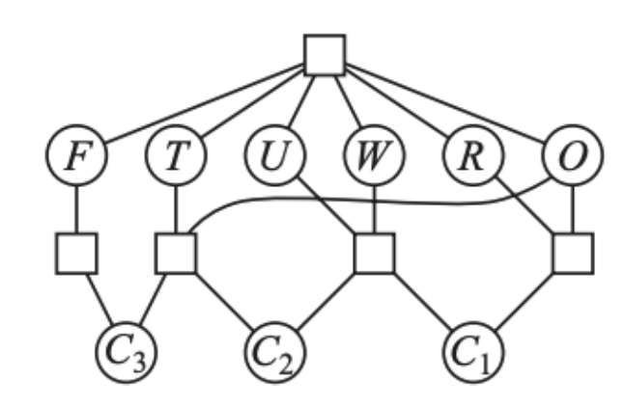Variables: F O U R T W C1 C2 C3
* Domains:

{0, 1, 2, 3, 4, 5, 6, 7, 8, 9}

* Constraints:

O + O = R + 10 * C1

C1 + W + W = U + 10 * C2

C2 + T + T = O + 10 * C3

C3 = F

**alldiff**(F, O, U, R, T, W)

Map-Coloring Problem

* **Variables:** WA, NT, Q, NSW, V, SA, T
* **Domains**: {red, green, blue}
* **Constraints**:

Adjacent regions must have **diffe-**

**rent** colors

Implicit: WA NT

Explicit: (WA, NT) {(red, green), {red, blue}, ...}

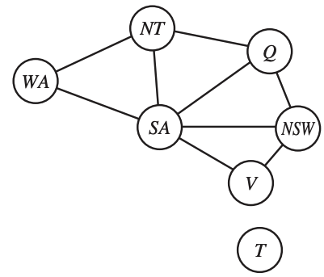Constraint Graph

* **Variables**:

WA, NT, Q, NSW, V, SA, T

* **Domains**:

{red, green, blue}

* **Constraints**:

Adjacent regions must have **diffe-**

**rent** colors

Implicit: WA NT

Explicit: (WA, NT) {(red, green), {red, blue}, ...}

Map-Coloring Problem

* **Variable**s:

WA, NT, Q, NSW, V, SA, T

* **Domains**:

{red, green, blue}

* **Constraints**:

Adjacent regions must have **diffe-**

**rent** colors

Implicit: WA NT

Explicit: (WA, NT) {(red, green), {red, blue}, ...}

Varieties of CSPs

* **Discrete variables**
  + **Finite domains:** each variable can be only assigned to **finite** number of values.
  + 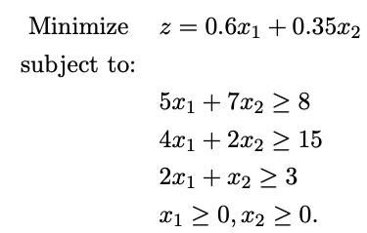**Infinite domains:** each variable can be assigned to infinite number of values, e.g., set of integers
* **Continuous variables**
  + Linear programming

Varieties of Constraints

* **Unary constraints** involve a single variable (equivalent to reducing domains), e.g.:
  + SA ≠ Green
* **Binary constraints** involve pairs of variables, e.g.:
  + SA ≠ WA
* **Higher-order constraints** involve 3 or more variables
* **Preferences** (soft constraints):
  + E.g., red is better than green

Real-World CSPs

* **Assignment problems**
  + e.g., who teaches what class
* **Timetabling problems**
  + e.g., which class is offered when and where?
* **Transportation scheduling**
* **Factory scheduling**

Constraint Satisfaction Problems (CSP)

* For a given CSP the problem is one of the following:
  + Find **all** solutions
  + Find **one** solution
  + The **optimal** solution given an objective function
  + Determine if a solution **exists**

How to View a CSP as a Search Problem?

* **Initial State** -- state in which all the variables are **unassigned**.
* **Successor function** -- assign a value to a variable from a set of possible values.
* **Goal test** -- check if all the variables are assigned and all the constraints are satsified. We call the assignment is complete.
* **Path cost** -- assumes constant cost for each step

Backtracking Search

* Depth-first search for CPSs with single-variable assigments is called backtracking search

- Backtracks when a variable has no legal values left to assign

**Backtracking search** is the basic uninformed algorithm for CSPs.

The Backtracking Search Algorithm

**Backtrack**(assignment, csp):

**If** assignment is complete **then return** assignment

var ← select one unassigned variable

**for** each value **in** the domain of var **do**

**if** value is consistent with assignment **then**

add {var = value} to assignment

result ← **Backtrack**(assignment, csp)

**if** result ≠ failure **then**

**return** result

remove {var = value} from assignment

**return** failure

Backtracking Example



The Backtracking Search Algorithm

**Backtrack**(assignment, csp):

**If** assignment is complete **then return** assignment

var ← select one unassigned variable ← which one to select?

**for** each value in the domain of var **do** ← which one to use?

**if** value is consistent with assignment **then**

add {var = value} to assignment ← detect failure early

result ← **Backtrack**(assignment, csp)

**if** result ≠ failure **then**

**return** result

remove {var = value} from assignment

**return** failure

Improving Backtracking Efficiency

General-purpose methods can give huge gains in speed:

1. Which variable should be assigned next?

* + Choose the **most constrained variable**, and break ties by choosing the **most constraining variable**

2. In what order should its values be tried?

* + Choose the **least constraining value**

3. Can we detect inevitable failure early?

* + Forward checking, constraint propagation

Improving Backtracking Efficiency

1. Which variable should be assigned next?

* + Choose the **most constrained variable**, and break ties by choosing the **most constraining variable**

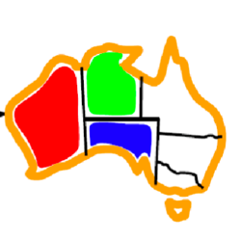Variable Selection Heuristic 1: Most Constrained Variable

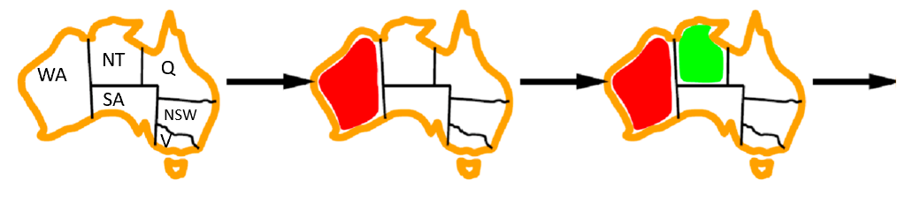

**Most constrained variable**:

Choose the variable with the fewest legal values a.k.a**. mininum remaining values (MRV)** heuristic

* Why min rather than max?
* “Fail-fast” ordering
* 1000× faster or more

Variable Selection Heuristic 2: Most Constraining Variable

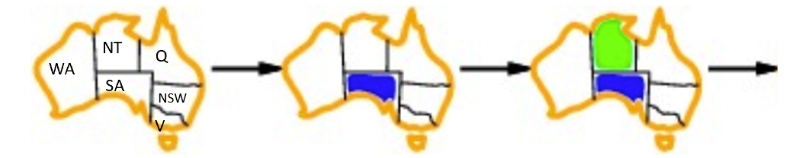

* Tie-breaker among most constrained variables

**Most constraining variable**:

* choose the variable with the most constraints on remaining variables

Improving Backtracking Efficiency

2. In what order should its values be tried?

Choose the **least constraining value**

Value Select Heuristic: Least Constraining Value

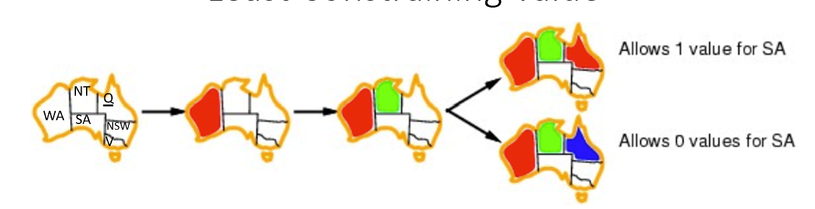

* Given a variable, choose the **least constraining value**:

the one that rules out the fewest values in the remaining variables

* Why least rather than most?

Variable and Value Ordering Heuristics

* The heuristics should be applied whenever a **variable/value** needs be chosen during the search process
* They should **not** be applied once and for all at the beginning of the search process

Improving Backtracking Efficiency

3. Can we detect inevitable failure early?

* + Forward checking, constraint propagation

Consistency-Enforcing Procedure 1: Forward Checking

* Idea:

Keep track of **remaining legal values** for **unsigned variables**

Terminate search when any variable has no legal values.

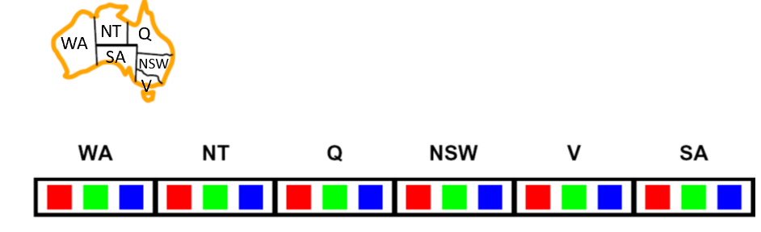

Consistency-Enforcing Procedure 2: Constraint Propagation

* Forward checking propagates information from **assigned** to **unassigned** variables, but doesn't provide early detection for all failures:

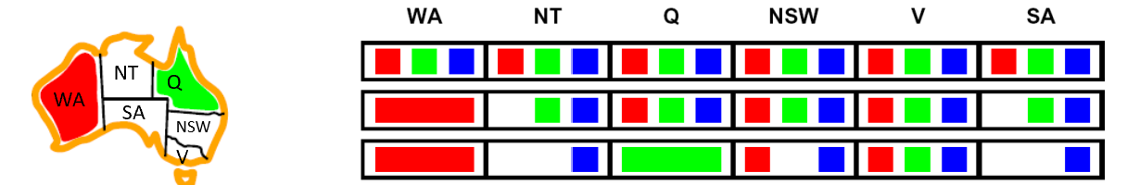

* NT and SA cannot both be blue!
* ***Constraint propagation***repeatedly enforces constrains locally*.*

Consistency-Enforcing Procedure 2: Constraint Propagation

* Using the constraints to reduce the number of legal values for a variable
* **Constraint propagation** may be intertwined with search, or it may be done as a preprocessing step, before search starts
* Sometimes this preprocessing can solve the whole problem, so no search is required at all!
* **Local consistency**

Arc Consistency

* An arc X → Y **is consistent**iff for *every* x in the tail there is *some* y in the head which could be assigned **without violating a constraint**

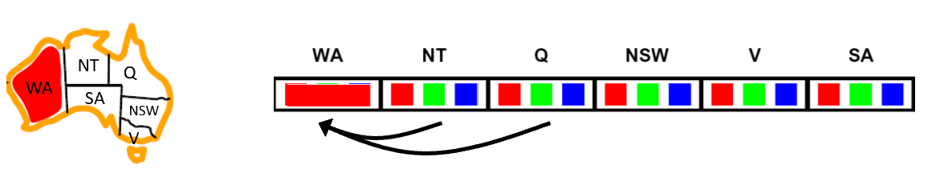

* **Forward checking**: Enforcing consistency of arcs pointing to each new assignment

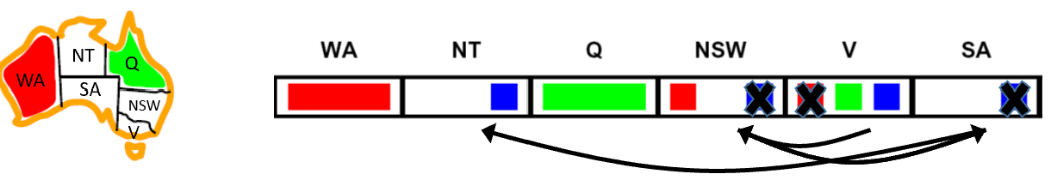

. Arc consistency detects failure earlier than forward checking

. Can be run as a **preprocessor** or after each assignment

Arc Consistency

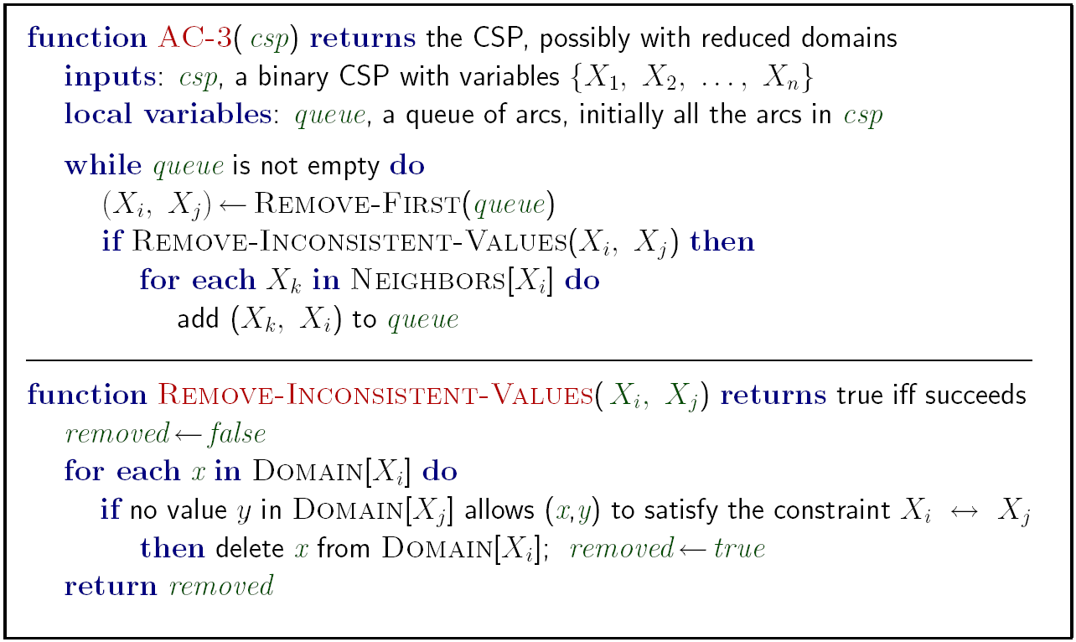

Runtime: O(n2d3) n: # of variables d: domain size

Limitations of Arc Consistency

* After enforcing arc consistency:
  + Can have **one** solution left
  + Can have **multiple** solutions left
  + Can have **no** solutions left (and not know it)

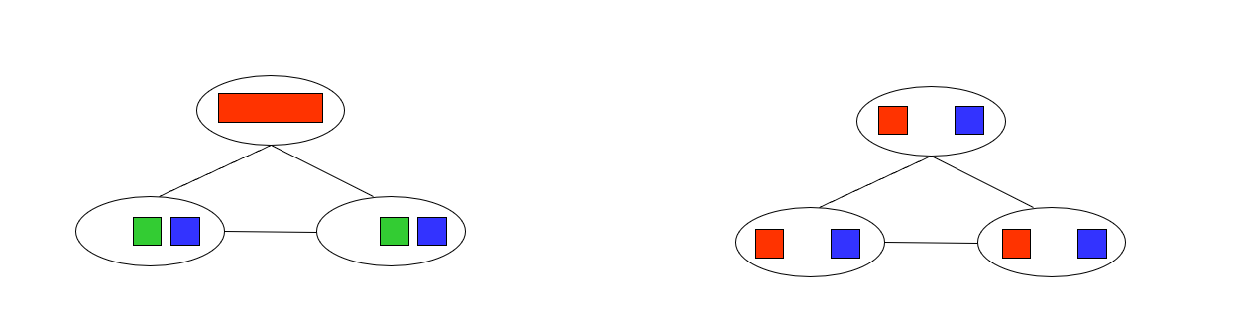

K-Consistency

* 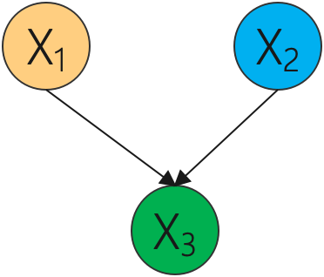Increasing **degrees** of consistency
  + **1-Consistency** (Node Consistency): Each single node’s domain has a value which meets that node’s **unary constraints**
  + **2-Consistency** (Arc Consistency): For each pair of nodes, any consistent assignment to one can be extended to the other
  + **K-Consistency**: For each k nodes, any consistent assignment to k-1 can be extended to the kth node.

Consistency-Enforcing Procedures

* **Forward checking**
* **Constraint propagation**
* **Variable/value ordering heuristics**
* They can used in combination to improve search process.

General Purpose CSP Algorithm

1. If all values have been successfully assigned then stop, else go on to 2.
2. Apply the **consistency enforcing procedure** (e.g. **forward checking** if feeling computationally mean, or **constraint propagation** if extravagant.)
3. If a deadend is detected then backtrack (e.g., DFS-type backtrack.). Else go on to step 4.
4. Select the next variable to be assigned (using your **variable ordering heuristic**)
5. Select a promising value (using your **value ordering heuristic**)
6. Create a new search state. Cache the info you need for backtracking. And go back to 1.

Local Search for CSPs

* **Hill-climbing, simulated annealing** typically work with “complete” states, i.e., all variables assigned
* To apply to CSPs:

allow states with unsatisfied constraints operators **reassign** variable values

* **Variable selection**: randomly select any conflicted variable
* **Value selection** by **min-conflicts** heuristic:

Choose value that violates the fewest constraints

i.e., hill-climb with h(n) = total number of violated constraints

Example: 4-Queens

* **States**: 4 queens in 4 columns (256 states)
* **Actions**: move queen in column
* **Goal test**: no attacks
* **Evaluation**: h(n) = number of attacks

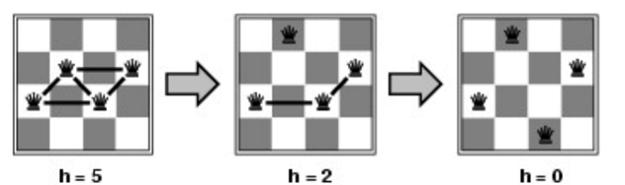

* Give random initial state, can solve n-queens in almost constant time for arbitrary n with high probability (e.g., n = 10,000,000)

**Constraint Satisfaction Problem**

Standard Search Problem

• Standard Search Problems:

• State is a “black box ” : arbitrary data structure

• Goal test can be any function over states

• Successor function can also be anything

Constraint satisfaction Problems(CSP)

• **Constraint satisfaction problems (CSPs**):

• A **special subset** of search problems

• **State** is defined by variable Xi with values from a domain D(sometimes D depends on i)

• Goal test is **a set of constraints** specifying allowable combinations of values for subsets of variables

• **Why CSPs?**

• Allows useful **general-purpose algorithms** with more power than standard search algorithms

Example: Map-Coloring Problem

• Color each region either red, green or blue in such away that no neighboring regions have the same color

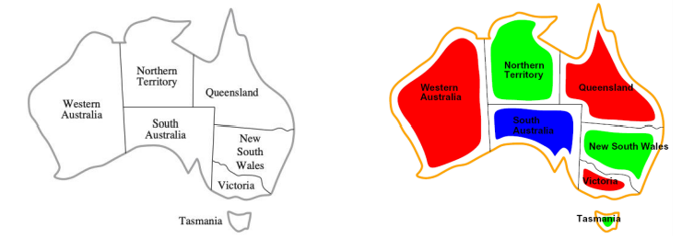

• Variables: different regions

• Domains: colors

Constraint satisfaction Problems(CSP)

• A powerful representation for (discrete) search problems.

• A **Constraint Satisfaction Problem (CSP)** is defined by:

• **X** is a set of n variables X1 , X2 , ...., Xn , each defined by afinitedomainD1 , D2 , ..., Dn of possible values

• **C** is a set of constraints C1 , C2 , ..., Cm. Each Ci involves some subset of the variables; specifies the allowable combinations of values for that subset.

A **solution** is an assignment of values to the variables that satisfies all constraints.

Cyptarithmetic as a CSP

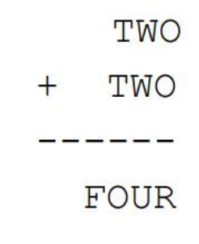• Variables: F O U R T W C1 C2 C3

• Domains: {0, 1, 2, 3, 4, 5, 6, 7, 8, 9}

• Constraints:

O + O = R + 10 * C1

C1 + W + W = U + 10 * C2

C2 + T + T = O + 10 * C3

C3 = F alldiff(F, O, U, R, T, W)

Cyptarithmetic Constraint Graph

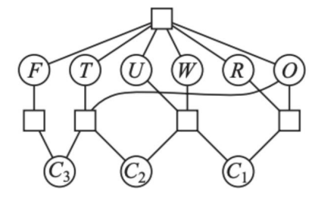• Variables: F O U R T W C1 C2 C3

• Domains: {0, 1, 2, 3, 4, 5, 6, 7, 8, 9}

• Constraints: O + O = R + 10 * C1

C1 + W + W = U + 10 * C2

C2 + T + T = O + 10 * C3

C3 = F alldiff(F, O, U, R, T, W)

Map-Coloring Problem

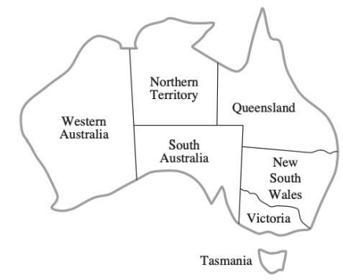• **Variables:** WA, NT, Q, NSW, V, SA, T

• Domains: {red, green, blue}

• Constraints:

Adjacent regions must have different colors

Implicit: WA ≠ NT

Explicit: (WA, NT) ∈ {(red, green), {red, blue}, ...}

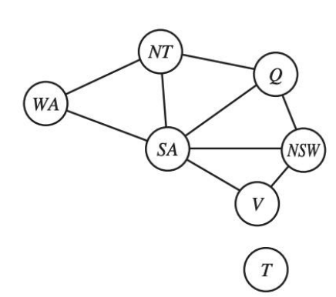Constraint Graph

• Variables: WA, NT, Q, NSW, V, SA, T

• Domains: {red, green, blue}

• Constraints:

Adjacent regions must have different colors

Implicit: WA ≠ NT

Explicit: (WA, NT) ∈ {(red, green), {red, blue}, ...}

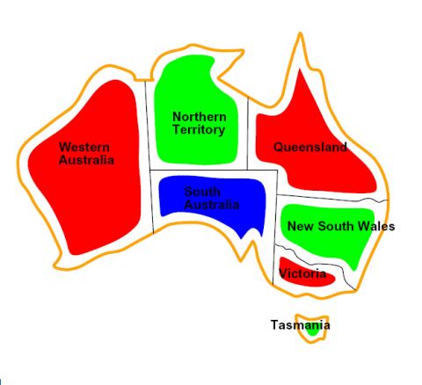Map-Coloring Problem

• Variables: WA, NT, Q, NSW, V, SA, T

• Domains: {red, green, blue}

• Constraints:

Adjacent regions must have different colors

Implicit: WA ≠ NT

Explicit: (WA, NT) ∈ {(red, green), {red, blue}, ...}

Varieties of CSPs

• Discrete variables

• Finite domains: each variable can be only assigned to finite number of values.

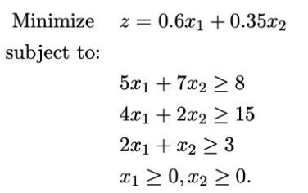• Infinite domains: each variable can be assigned to infinite number of values, e.g., set of integers

• Continuous variables • Linear programming

Varieties of Constraints

• Unary constraints involve a single variable (equivalent to reducing domains), e.g.:

• SA ≠ Green

• Binary constraints involve pairs of variables, e.g.: • SA ≠ WA

• Higher-order constraints involve 3 or more variables

• Preferences (soft constraints): • E.g., red is better than green

Real-World CSPs

• Assignment problems • e.g., who teaches what class

• Timetabling problems • e.g., which class is offered when and where?

• Transportation scheduling • Factory scheduling

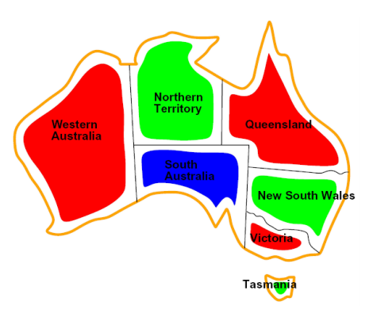Constraint Satisfaction Problems(CSP)

• For a given CSP the problem is one of the following:

• Find all solutions

• Find one solution

• The optimal solution given an objective function

• Determine if a solution exists

How to View a CSP as a Search Problem?

• Initial State -- state in which all the variables are unassigned.

• Successor function -- assign a value to a variable from a set of possible values.

• Goal test -- check if all the variables are assigned and all the constraints are satisfied. We call the assignment is complete.

• Path cost -- assumes constant cost for each step.

Back tracking Search

• Depth-first search for CPSs with single-variable assignments is called backtracking search

- Backtracks when a variable has no legal values left to assign

Backtracking search is the basic uninformed algorithm for CSPs.

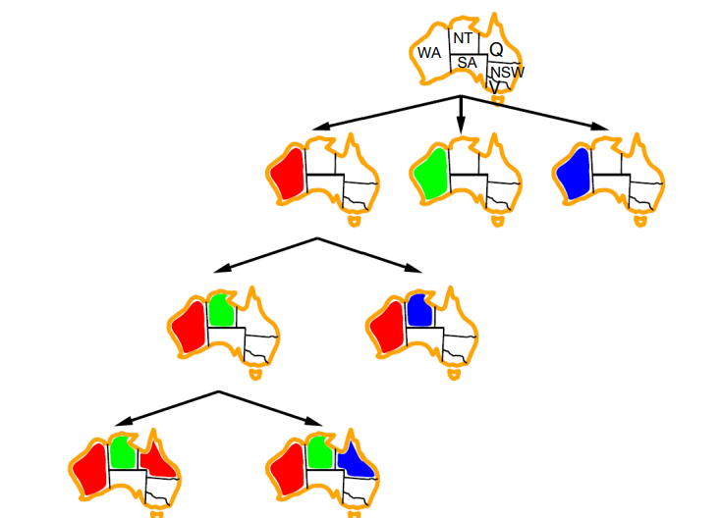The Backtracking Search Algorithm

Backtrack(assignment, csp):

If assignment is complete then return assignment

var ← select one unassigned variable

for each value in the domain of var do

if value is consistent with assignment then

add {var = value} to assignment

result ← Backtrack(assignment, csp)

if result ≠ failure then

return result

remove {var = value} from assignment

return failure

The Backtracking Search Algorithm

Backtrack(assignment, csp):

If assignment is complete then return assignment

var ← select one unassigned variable ← which one to select?

for each value in the domain of var do ← which one to use?

if value is consistent with assignment then

add {var = value} to assignment ←detect failure early

result ← Backtrack(assignment, csp)

if result ≠ failure then

return result

remove {var = value} from assignment

return failure

Improving Backtracking Efficiency

General-purpose methods can give huge gains in speed:

1. **Which variable should be assigned next**? • Choose the most constrained variable, and break ties by choosing the most constraining variable

2. **In what order should its values be tried**? • Choose the least constraining value

3. **Can we detect inevitable failure early**? • Forward checking, constraint propagation

Improving Backtracking Efficiency

General-purpose methods can give huge gains in speed:

1. Which variable should be assigned next?

* + Choose the **most constrained variable**, and break ties by choosing the **most constraining variable**

2. In what order should its values be tried?

* + Choose the **least constraining value**

3. Can we detect inevitable failure early?

* + Forward checking, constraint propagation

Improving Backtracking Efficiency

1. Which variable should be assigned next?

* + Choose the **most constrained variable**, and break ties by choosing the **most constraining variable**

Variable Selection Heuristic 1: Most Constrained Variable



**Most constrained variable**:

Choose the variable with the fewest legal values a.k.a**. mininum remaining values (MRV)** heuristic

* Why min rather than max?
* “Fail-fast” ordering
* 1000× faster or more

Variable Selection Heuristic 2: Most Constraining Variable



* Tie-breaker among most constrained variables

**Most constraining variable**:

* choose the variable with the most constraints on remaining variables

Improving Backtracking Efficiency

2. In what order should its values be tried?

Choose the **least constraining value**

Value Select Heuristic: Least Constraining Value



* Given a variable, choose the **least constraining value**:

the one that rules out the fewest values in the remaining variables

* Why least rather than most?

Variable and Value Ordering Heuristics

* The heuristics should be applied whenever a **variable/value** needs be chosen during the search process
* They should **not** be applied once and for all at the beginning of the search process

Improving Backtracking Efficiency

3. Can we detect inevitable failure early?

* + Forward checking, constraint propagation

Consistency-Enforcing Procedure 1: Forward Checking

* Idea:

Keep track of **remaining legal values** for **unsigned variables**

Terminate search when any variable has no legal values.



Consistency-Enforcing Procedure 2: Constraint Propagation

* Forward checking propagates information from **assigned** to **unassigned** variables, but doesn't provide early detection for all failures:



* NT and SA cannot both be blue!
* ***Constraint propagation***repeatedly enforces constrains locally*.*

Consistency-Enforcing Procedure 2: Constraint Propagation

* Using the constraints to reduce the number of legal values for a variable
* **Constraint propagation** may be intertwined with search, or it may be done as a preprocessing step, before search starts
* Sometimes this preprocessing can solve the whole problem, so no search is required at all!
* **Local consistency**

Arc Consistency

* An arc X → Y **is consistent**iff for *every* x in the tail there is *some* y in the head which could be assigned **without violating a constraint**



* **Forward checking**: Enforcing consistency of arcs pointing to each new assignment



. Arc consistency detects failure earlier than forward checking

. Can be run as a **preprocessor** or after each assignment

Arc Consistency



Runtime: O(n2d3) n: # of variables d: domain size

Limitations of Arc Consistency

* After enforcing arc consistency:
  + Can have **one** solution left
  + Can have **multiple** solutions left
  + Can have **no** solutions left (and not know it)



K-Consistency

* Increasing **degrees** of consistency
  + **1-Consistency** (Node Consistency): Each single node’s domain has a value which meets that node’s **unary constraints**
  + **2-Consistency** (Arc Consistency): For each pair of nodes, any consistent assignment to one can be extended to the other
  + **K-Consistency**: For each k nodes, any consistent assignment to k-1 can be extended to the kth node.

Consistency-Enforcing Procedures

* **Forward checking**
* **Constraint propagation**
* **Variable/value ordering heuristics**
* They can used in combination to improve search process.

General Purpose CSP Algorithm

1. If all values have been successfully assigned then stop, else go on to 2.
2. Apply the **consistency enforcing procedure** (e.g. **forward checking** if feeling computationally mean, or **constraint propagation** if extravagant.)
3. If a deadend is detected then backtrack (e.g., DFS-type backtrack.). Else go on to step 4.
4. Select the next variable to be assigned (using your **variable ordering heuristic**)
5. Select a promising value (using your **value ordering heuristic**)
6. Create a new search state. Cache the info you need for backtracking. And go back to 1.

Local Search for CSPs

* **Hill-climbing, simulated annealing** typically work with “complete” states, i.e., all variables assigned
* To apply to CSPs:

allow states with unsatisfied constraints operators **reassign** variable values

* **Variable selection**: randomly select any conflicted variable
* **Value selection** by **min-conflicts** heuristic:

Choose value that violates the fewest constraints

i.e., hill-climb with h(n) = total number of violated constraints

Example: 4-Queens

* **States**: 4 queens in 4 columns (256 states)
* **Actions**: move queen in column
* **Goal test**: no attacks
* **Evaluation**: h(n) = number of attacks



* Give random initial state, can solve n-queens in almost constant time for arbitrary n with high probability (e.g., n = 10,000,000)
* _________________

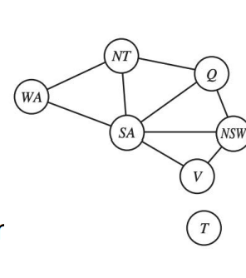Problem Encoding

• How can the problem structure help to find a solution quickly?

• Decomposition of the original problem:

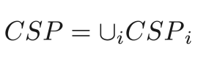

• Solutions can be combined to solve the original problem:

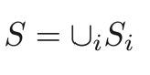

Problem Encoding

• Extreme case**: independent** subproblems • Example: Tasmania and mainland do not interact

• **Independent subproblems** are identifiable as connected components of constraint graph

• Suppose a graph of n variables can be broken into subproblems of only c variables:

• Worst-case solution cost is O((n/c)(dc)), linear in n

• E.g., n = 80, d = 2, c =20

• 280 = 4 billion years at 10 million nodes/sec

• (4)(220) = 0.4 seconds at 10 million nodes/sec

Tree-Structured CSPs

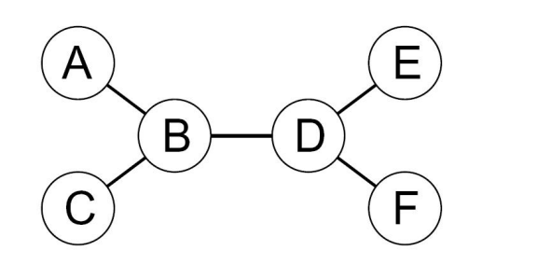

• Theorem: if the constraint graph has no loops, the CSP can be solved in O(nd‑) time

• Compare to general CSPs, where worst-case time is O(dn)

Tree-Structured CSPs

• Algorithm for tree-structured CSPs:

• Order: Choose a root variable, order variables so that parents precede children

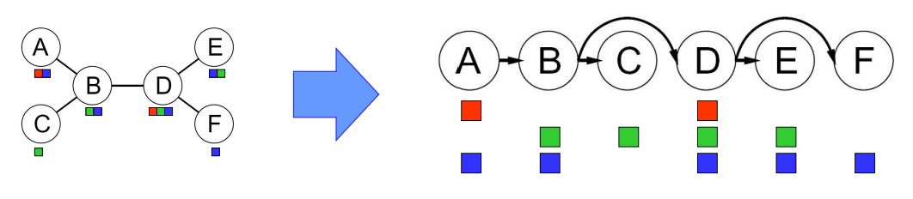

• Remove backward: For i = n : 2, apply Remove Inconsistent(Parent(Xi),Xi)

• Assign forward: For i = 1 : n, assign Xi consistently with Parent(Xi)

General CSPs

• Removing nodes: • cut set conditioning: remaining variables form a tree

• Collapsing nodes • Tree decomposition: construct a set of connected subproblems.

Nearly Tree-Structured CSPs

• Conditioning: instantiate a variable, prune its neighbors' domains

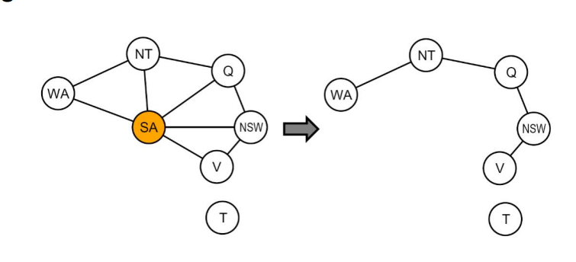

• Cutset conditioning:

• instantiate (in all ways) a set of variables S such that the remaining constraint graph is a tree

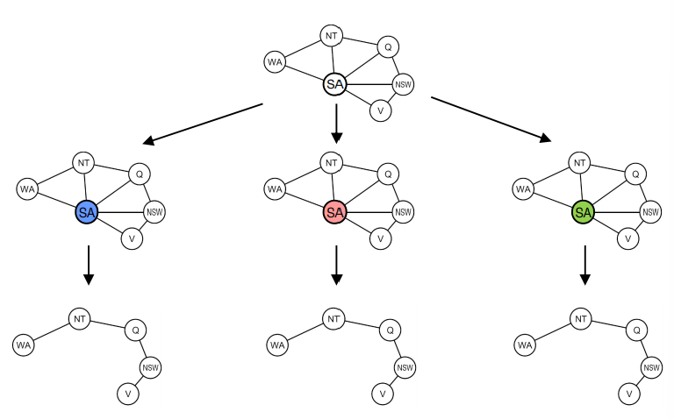• Solve the remaining constraint graph and return it with the assignment of S.

• If the cutset has size c, then the run time is O(dc ·(n-c)d2)

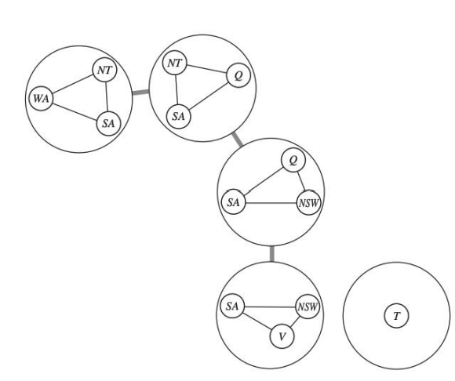Tree Decompositon

• Every variable must appear in **at least one subproblem**

• If two variables are connected by a constraint in the original problem, they must appear together (along with the constraint) in at least one of the subproblems.

• If a variable occurs in two subproblems in the tree, it must appear in every subproblem on the path that connects the two

Tree Width

• The subproblem should be as small as possible..

• Tree width w of a tree decomposition is the size of **largest** sub-problem minus 1

• Tree width of a graph is minimal tree width over all possible tree decompositions (hard to find)

Tree Decompositon

• Solve for all solutions of each subproblem.

• Use tree-structured algorithm, treating the subproblem solutions as variables for those subproblems.

**• O(ndw+1)** where w is the tree width of the graph.

Application: Satisfiability

• 3SAT:

• find assignments s.t. (p1∨p3 ∨p4) ∧(¬p1∨p2∨¬p3)∧ … is satisfied

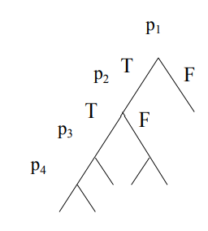• DFS, GSAT, random walk SAT,…

Davis-Putnam-Logemann-Loveland(DPLL) tree search algorithm

(p1∨p3 ∨ p4) ∧ (¬p1∨p2 ∨¬p3) ∧…

• Backtrack when some clause becomes empty

• **Unit propagation** (for variable & value ordering):

• if some clause only has one literal left, assign that variable the value that satisfies the clause (never need to check the other branch).

Variants of CSPs

• Dynamic CSPs: • The constraints are evolved. • Can be considered as a sequence of static CSPs.

• Flexible CSPs: • Not all constraints need to be satisfied.

• Distributed CSPs: • The variables are distributed among multiple agents.

Summary

• CSPs are a special kind of problem:

• **states** defined by values of a fixed set of variables

• **goal** test defined by constraints on variable values

• Backtracking = DFS with one variable assigned per node

• Variable ordering and value selection heuristics help significantly

• Forward checking prevents assignments that guarantee later failure

• Constraint propagation (e.g., arc consistency) does additional work to constrain values and detect inconsistencies

• Iterative min-conflicts is usually effective in practice

**Adversarial Search**

Game Playing An AI Favorite

• Structured task

• Not initially thought to require large amounts of knowledge

• Focus on games of perfect information



Game Playing: State-of-the-Art

• Checkers: 1950: First computer player. 1994: First computer champion: Chinook ended 40- year-reign of human champion Marion Tinsley using complete 8-piece endgame. 2007: Checkers solved!

• Chess: 1997: Deep Blue defeats human champion Gary Kasparov in a six-game match. Deep Blue examined 200M positions per second, used very sophisticated evaluation and undisclosed methods for extending some lines of search up to 40 ply.

• Go: In 2016, AlphaGo defeats the human champion

Types of Games

• Many different kinds of games! • Stochastic vs. Deterministic • One, two or more players

• Zero sum? • Perfect information?

• Want algorithms for calculating a strategy which recommends a move from each state.

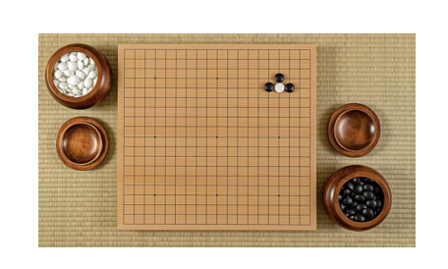Deterministic Games

• One possible formulation

• **States:** S (start at s0 )

• **Players**: P = {1...N} (usually take turns)

• **Actions**: A (may depend on player / state)

• **Transition Function**: S x A → S • Terminal Test: S → {True, False}

• **Terminal Utilities**: SxP → R

• Solution for a player is a **policy**: S →A

Zero-Sum Games

• Agents have **opposite** utilities (values on outcomes)

• Lets us think of a single value that one (**MAX**) maximizes and the other minimizes

• Adversarial, pure competition.

Games VS. Search Problems

• Unpredictable opponent

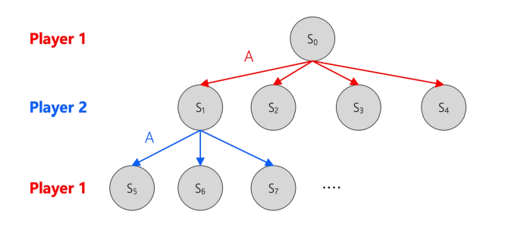• specifying a move for **every possible** opponent reply

• Time limits

• unlikely to find goal, must approximate

Game Playing as Search

• We can list all the possible **actions** and **states**

• In each step, play 1 searches for an **action** which leads to the maximum **utility.**

Search Tree for Tic-Tac-Toe

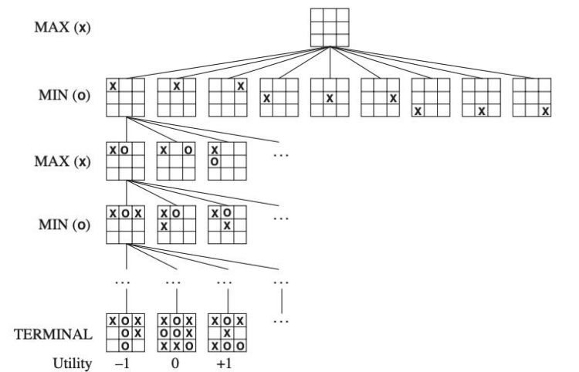

Tic-Tac-Toe

• High values are **good** for **MAX** and **bad** for **MIN**. It is MAX’s job to use the search tree and utility values to determine the best move.

• Root is initial position. Next level are all moves player 1(MAX) can make; tree is from Max’s viewpoint. Next level are all possible responses from player 2 (MIN).

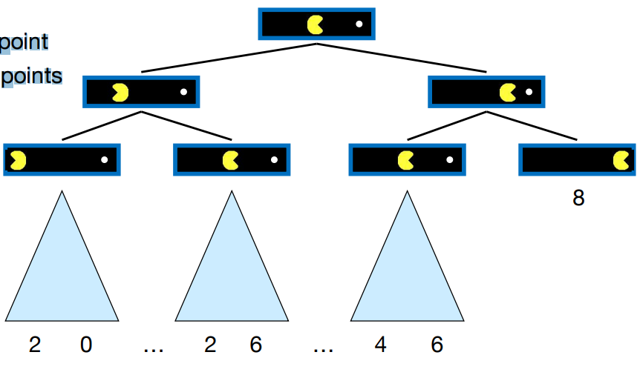• Max has to find a strategy that will lead to a winning terminal state **regardless of what Min** does. Strategy has to include the correct move for Max for each possible move by Min.

Pac-Man Trees

• Each step costs 1 point

• The dot worth 10 points

Value of a State

Value of a state: The best achievable outcome (utility) from that state

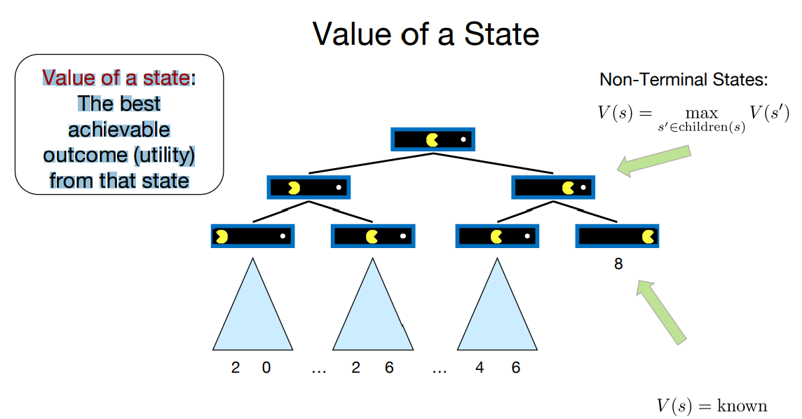

Adversarial Search Tree

Minimax Values

Minimax Search

**• Why do we take the min value every other level of the tree?**

• These nodes represent the opponent’s choice of move.

• The computer assumes that the human will choose that move that is of least value to the computer.

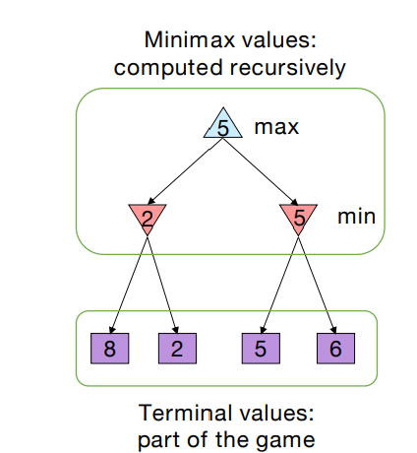Minimax Search

• **Deterministic, zero-sum games**:

• Tic-tac-toe, chess, checkers

• One player maximizes result

• The other minimizes result

• Compute each node’s **minimax value**:

• the best achievable utility against a rational (optimal) adversary

Simplified Minimax Algorithm

1. Expand the **entire tree** below the root

2. Evaluate the **terminal nodes** as wins for the minimizer or maximizer

3. Select an unlabeled node, n, all of whose children have been assigned values. If there is no such node, we’re done —return the value assigned to the root.

4. If n is a **minimizer** move, assign it a value that is **the minimum of** the **values of its children**. If n is a **maximizer** move, assign it a value that is the **maximum of the values of its children**. Return to Step 3.

**Another Example**

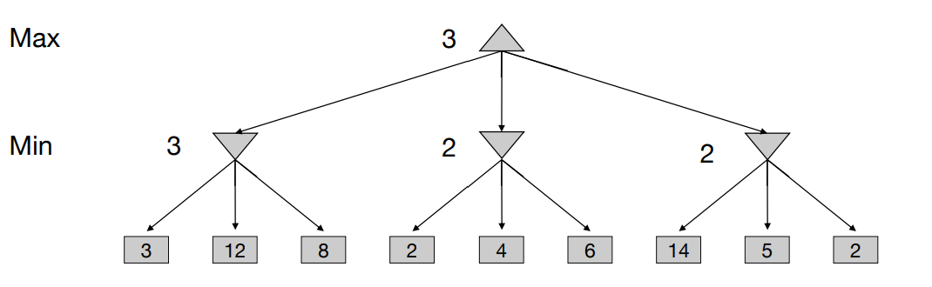

Summary

• In game tree search**, a move is a pair of actions**. One player’s action is a ply. 2-ply = one move.

• Called a minimax decision because it maximizes the utilityunder the assumption that the opponent will play perfectly to minimize it.

• **Time complexity**:

• O(bm) (m plies and b branching.) Impractical for e.g. chess(b≈ 30 to 40). 1000k for k moves.

• **Space complexity**: O(bm)

Size of Search Space

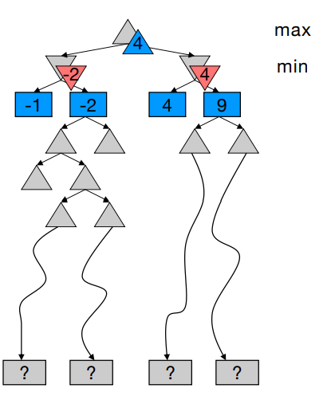• Chess:

• branching factor b ≈ 35

• game length m ≈ 100

• search space bm = 35100 ≈ 10154

• The Universe

• number of atoms ≈ 1078

• **Exact search is infeasible**.

The Need for Imperfect Decisions

• Problem:

• **Minimax** assumes the program has time to search to the terminal nodes.

• In realistic games, cannot search to leaves!

• Solution: Cut off search earlier and apply a heuristic evaluation function to the leaves

• Guarantee of optimal play is gone

Static Evaluation Functions

• **Minimax** depends on the translation of board quality into a single, summarizing number. Difficult. Expensive

• **Evaluation** functions score non-terminals in depth-limited search

• Do you control the center of the board?

• How well protected is your king?

• Add up values of pieces each player has (weighted by importance of piece).

• Mobility

• Strategies change as the game proceeds.

Design Issues for Heuristic Minimax Evaluation

Function: What features should we evaluate and how should we use them? An evaluation function should:

1. Match utility function on terminal states

2. Not take too long

3. Accurately reflect the chance of winning.

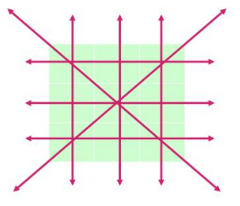Evaluation Functions for Tic-Tac-Toe

• Let p be a position in the game

• Define the utility function **f(p)** by

• count the number of lines where **X** can win

• subtract number of lines where **O** can win

• **f(p)** = the number of lines where X can win – the number of lines where O can win

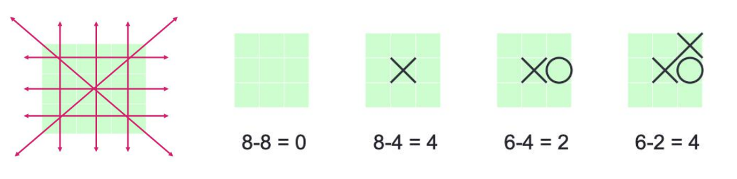

Linear Evaluation Functions

• Let **fi** be features and **wi** be weights

• Linear evaluation function: w1 f1 + w2 f2 + ... + wn fn This is what most game playing programs use

• For example: f = 6·material + 4·mobility + center control

• Steps in designing an evaluation function:

1. Pick informative features

2. Find the weights that make the program play well

• Deep Blue used ~6,000 different features!

Minimax Search

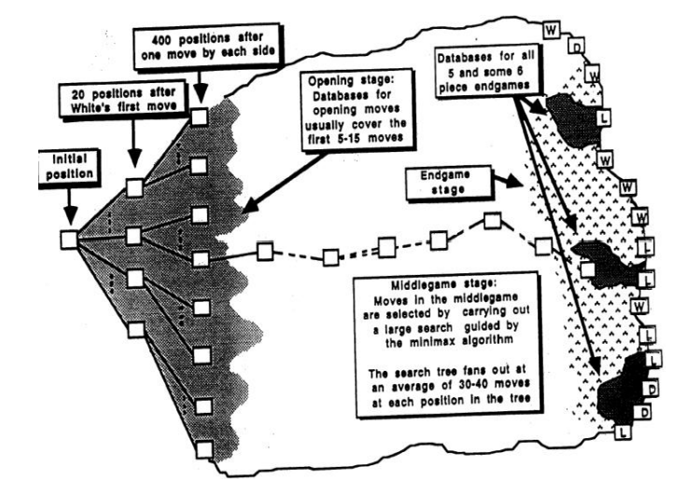

Design Issues for Heuristic Minimax

• Depth-limited search:

• search to a constant depth

•Problems:

• Some portions of the game tree may **be less stable** than the others

• Horizon effect.

**Unstable States**

• Unstable state: drastic change from one level to the next

• A chess evaluation function that counts material gains may evaluate a given state poorly even the play can capture a queen in the next move.

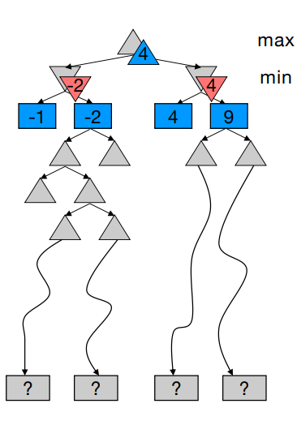• Are you about to lose an important piece?

• Evaluation functions can only be trusted when applied to **stable board states**

• One solution is to extend the normal search to look for stable states.

The Horizon Effect

• You may incorrectly estimate the value of a state by overlooking an event that is just **beyond the depth limit**

• Opponent moves, move is significant damage and cannot not be avoided

• Fixed-depth searches can be **mislead** by the fact that these damaging moves can be delayed

• The damage is beyond the search horizon and so is not seen

The Horizon Effect

• The **negative** horizon effects

• MAX may try to avoid a bad situation which is actually inevitable.

• For example, MAX tries to avoid losing the queen and appears to be able to do so using a lookahead tree of depth 6, but a little deeper it becomes obvious that the queen is going to be lost.

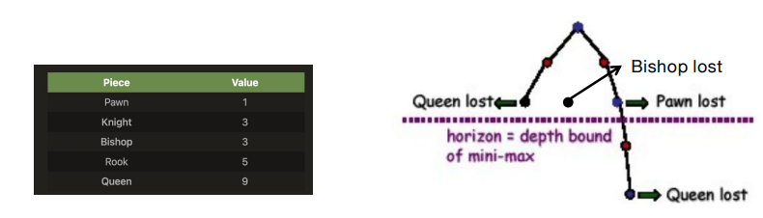

The Horizon Effect

The **positive** horizon effect:

.MAX may not realize that something good is going to be achievable.

. For example, MAX would like to take MIN's queen and that can happen

- but the restricted horizon prevents MAX from making the right choices to realize this possibility

α - β pruning

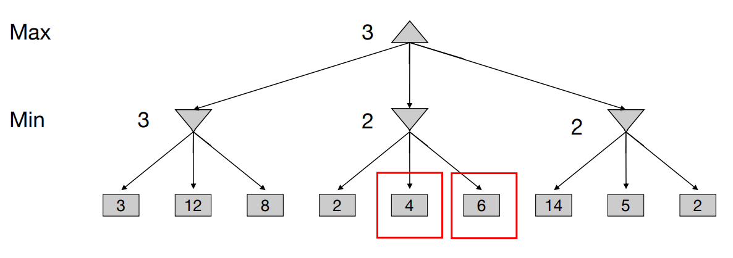

Improving Minimax -- α- βpruning

• The number of game states is exponential in the depth of the tree.

• It is possible to prune large parts of the tree from consideration.

• Intuition: prune away branches that cannot possibly in fluence the value of the state.

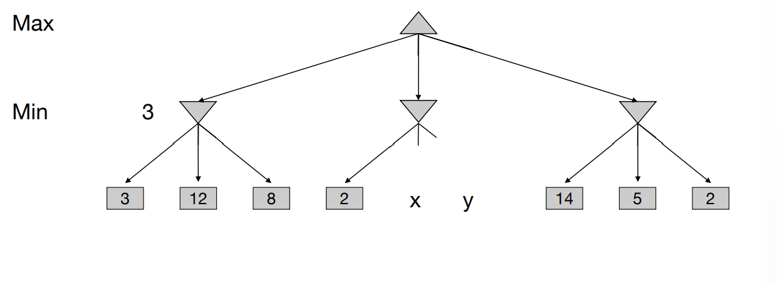

Algebraic Solution

• Minimax(root) = max(min(3, 12, 8), min(2, x, y), min(14, 5, 2))= max(3, min(2, x, y), 2) = max(3, z, 2) where z = min(2, x, y) <=2= 3

• The value of the root is **independent** of the values of x and y.

Another Example

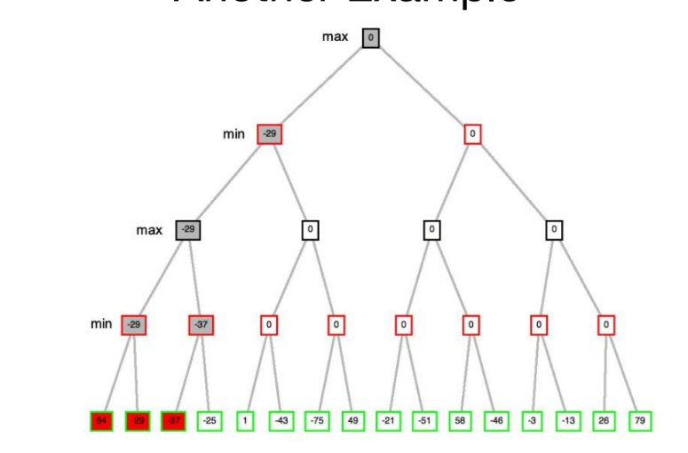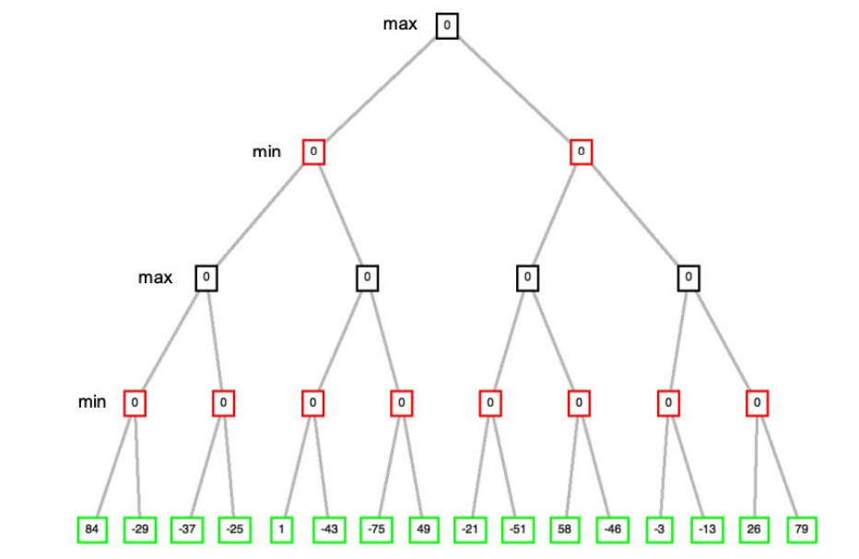

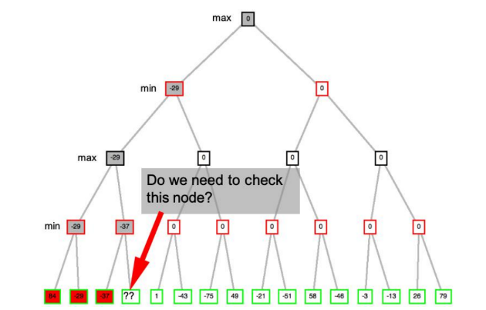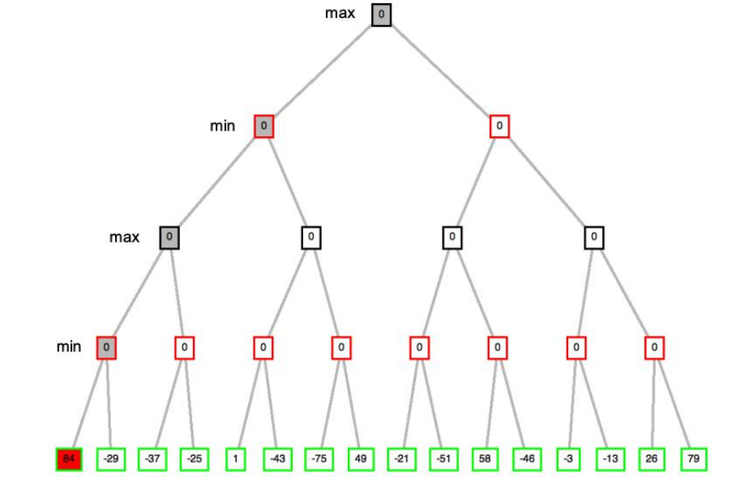

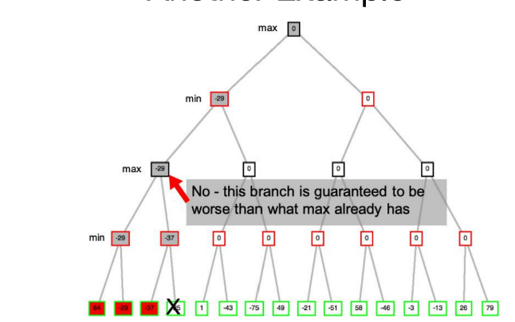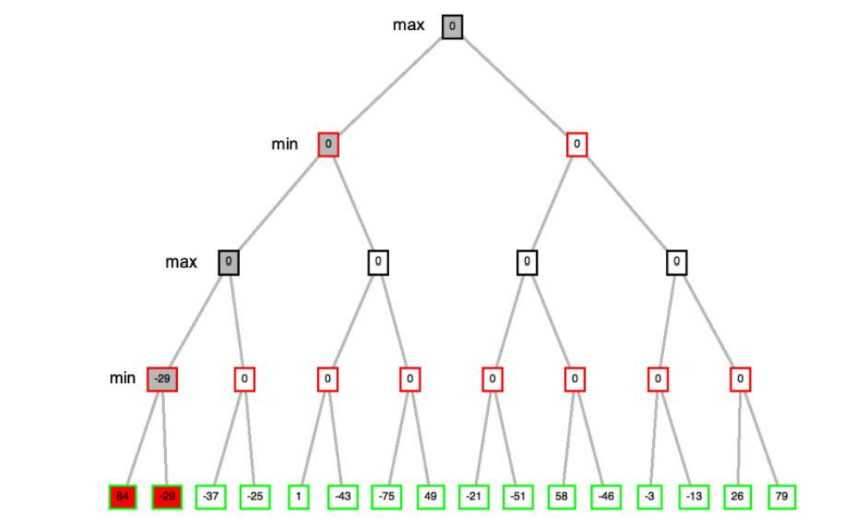

Improving Minimax -- α- β pruning

• The alpha-beta procedure can speed up a depth-first mini max search.

• Alpha: a lower bound on the value that a max node may ultimately be assigned at that level or above

v ≥ α

• Beta: an upper bound on the value that a min node may ultimately be assigned at that level or above

v ≤ β

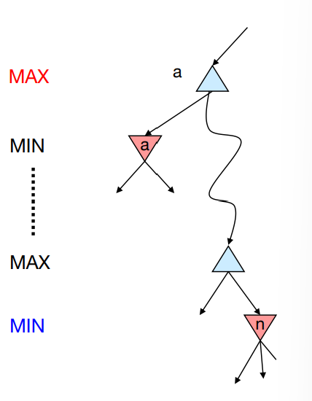α - β Pruning

**• General configuration (MIN version)**

• We’re computing the MIN-VALUE at some node n

• We’re looping over n’s children • n’s estimate of the childrens’ min is dropping

• Who cares about n’s value? MAX

• Let a be the best value that MAX can get at any choice point along the current path from the root

• If n becomes worse than a, MAX will avoid it, so we can stop considering n’s other children **(it’s already bad enough that it won’t be played**)

α - β Pruning

**Beta:** an **upper bound** on the value that a min node may ultimately be assigned at that level or above **Alpha**: a **lower bound** on the value that a max node may ultimately be assigned at that level or above.

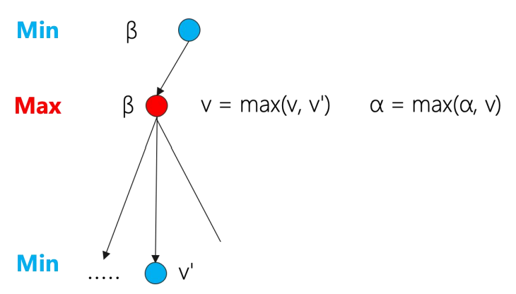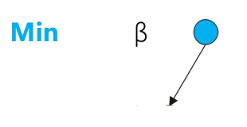

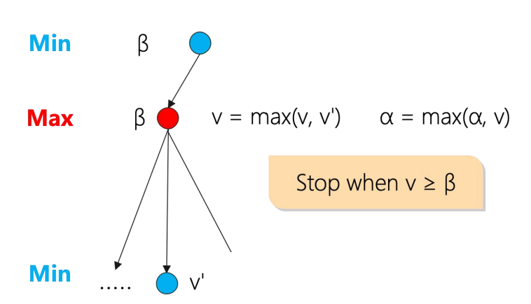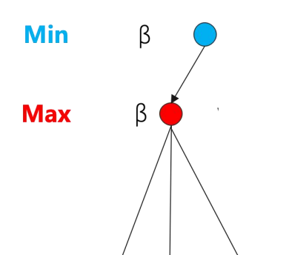

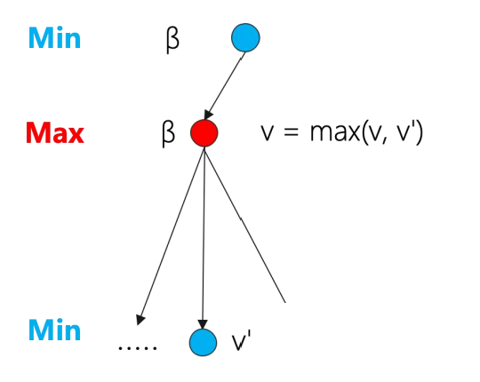

Another Example

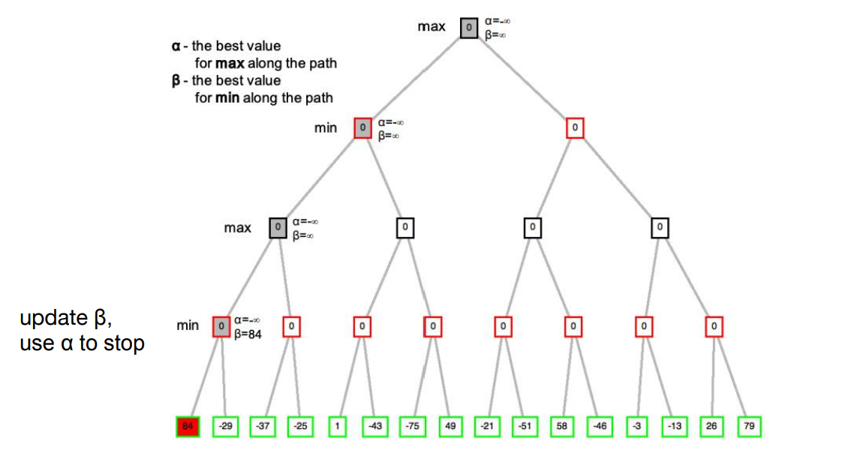

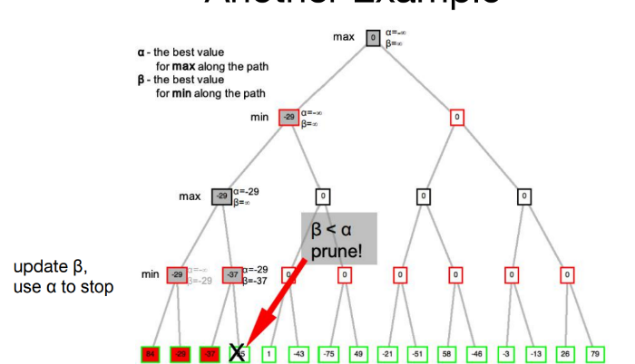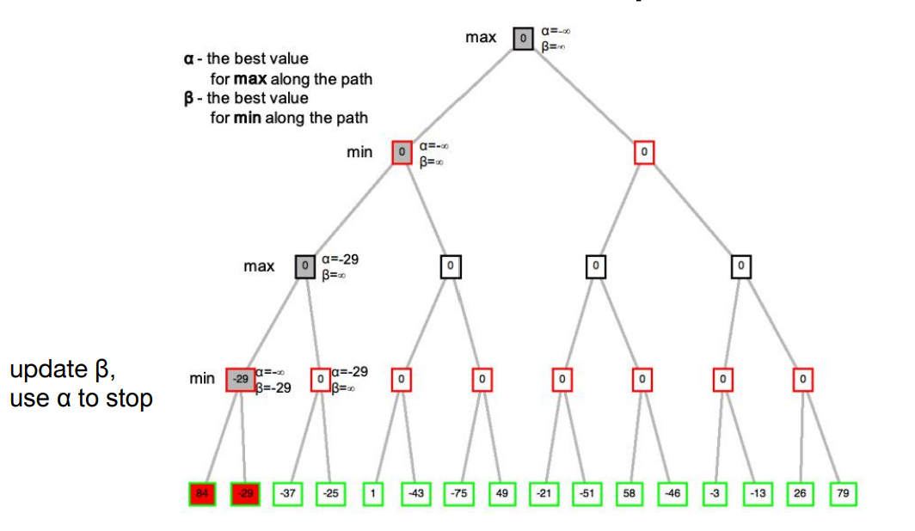

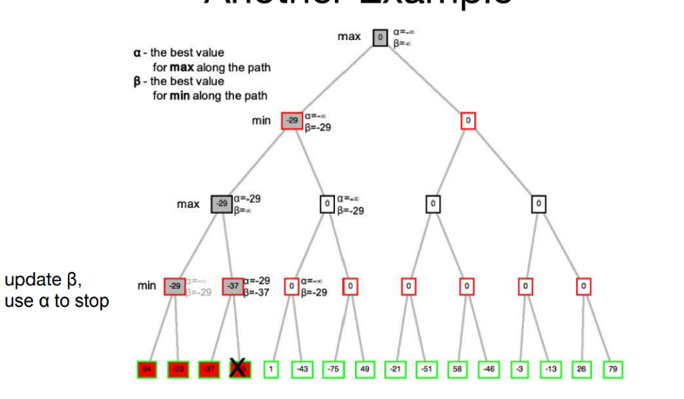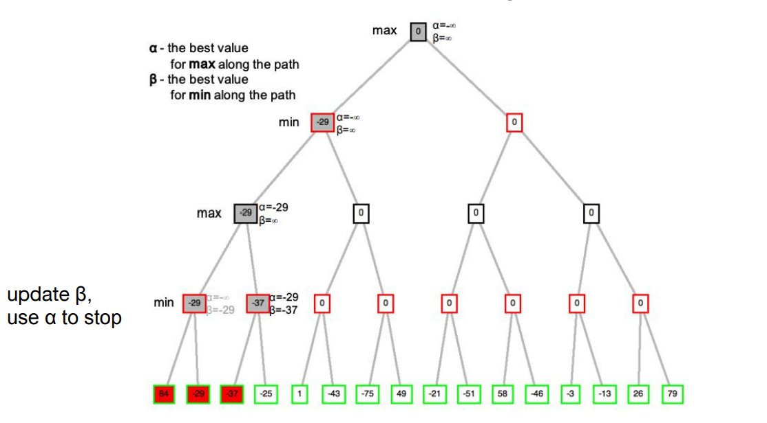

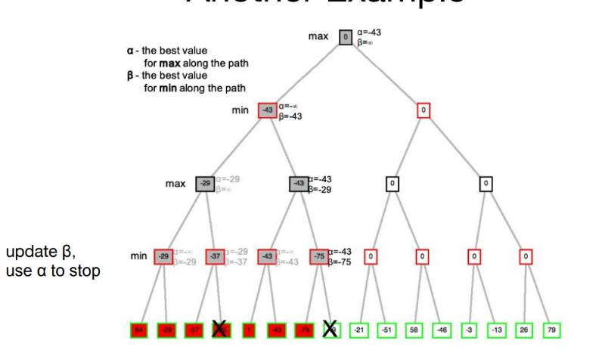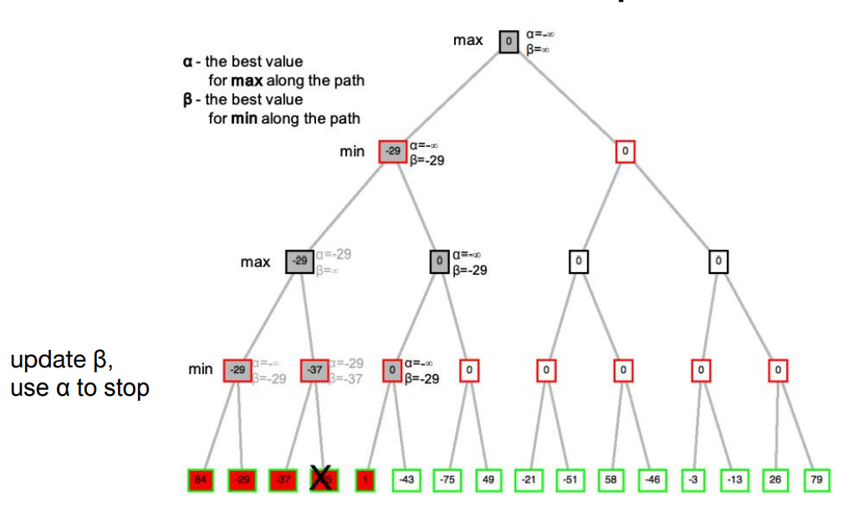

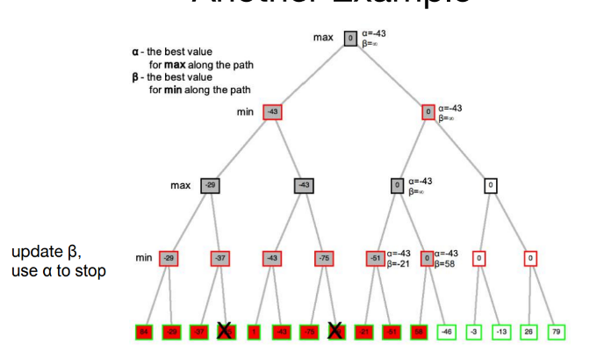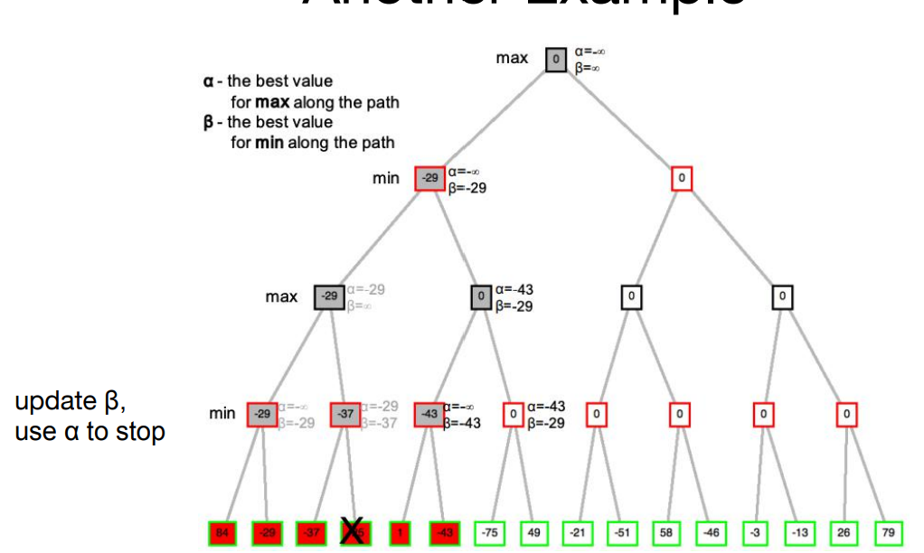

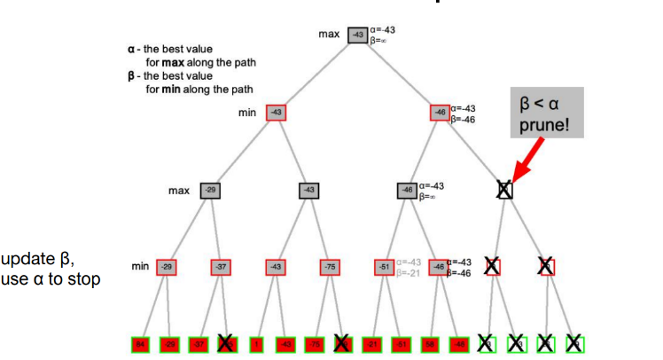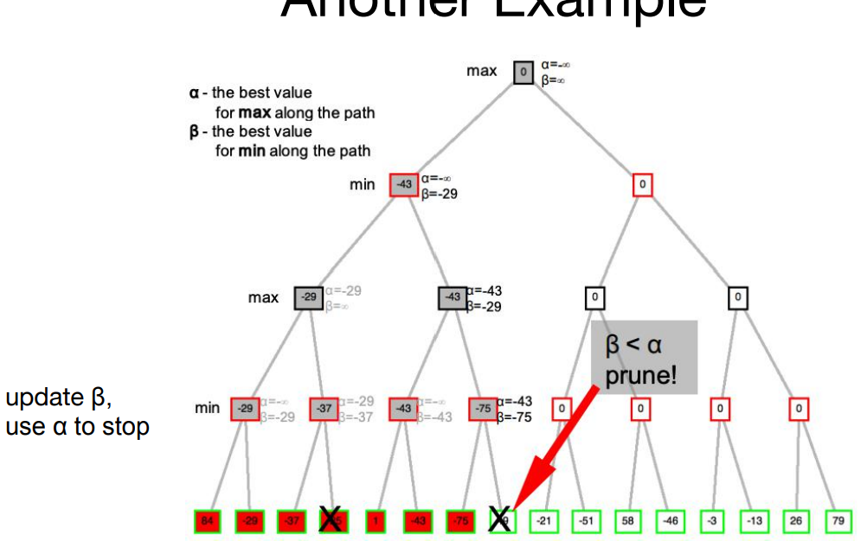

α - β Search

• c = search cutoff

• α = **lower bound** on Max's outcome; initially set to-∞

• β = **upper bound** on Min's outcome; initially set to+∞

• We'll call α - β procedure recursively with a **narrowing range** between α and β

• Maxmizing levels may reset α to a **higher** value;

• Minimizing levels may reset β to a **lower** value.

α - β Search Algorithm

α: MAX’s best option on path to root

β: MIN’s best option on path to root

**def max-value(state, α, β):**

initialize v = -∞

for each successor of state:

v = max(v, value(successor, α, β))

if v ≥ β return v α = max(α, v)

return v

**def min-value(state, α, β):**

initialize v = +∞for each successor of state:

v = min(v, value(successor,α,β))

if v ≤ α return v β = min(β, v)

return v

Alpha-Beta Pruning Properties

• This pruning has **no effect** on minimax value computed for the root!

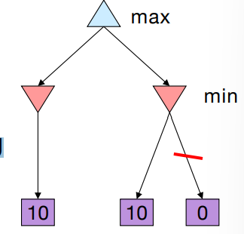• Values of **intermediate nodes** might be wrong

• Important: children of the root may have the wrong value

• So the most naïve version won’t let you do **action selection**

• Good child ordering improves **effectiveness** of pruning

• With “perfect ordering”:

• Time complexity drops to O(bm/2)

• Doubles solvable depth!

• Full search of, e.g. chess, is still hopeless

α - β Search Quiz

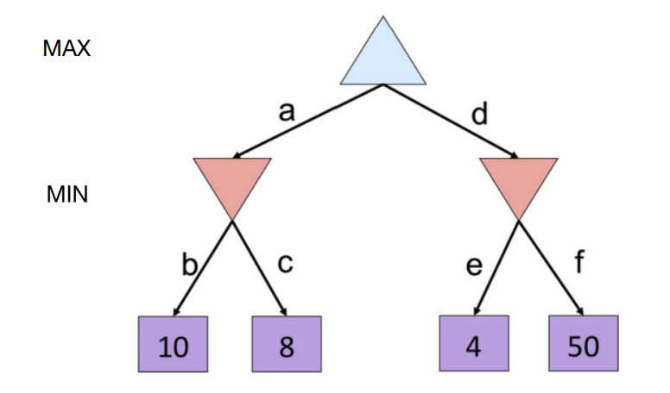

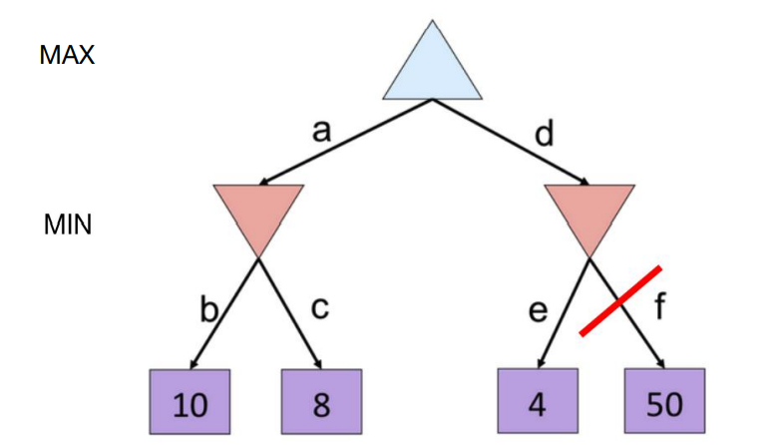

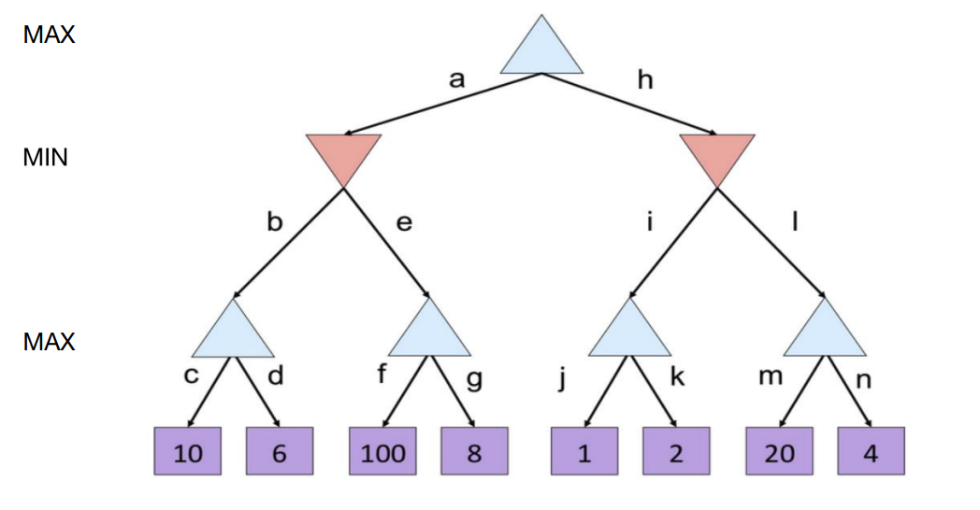

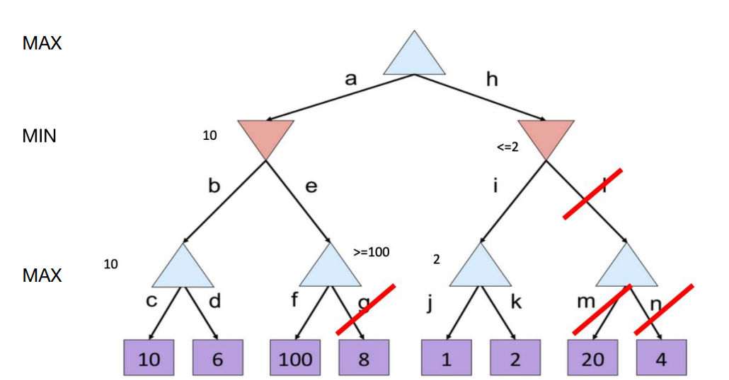

Knowledge Representation and Reasoning

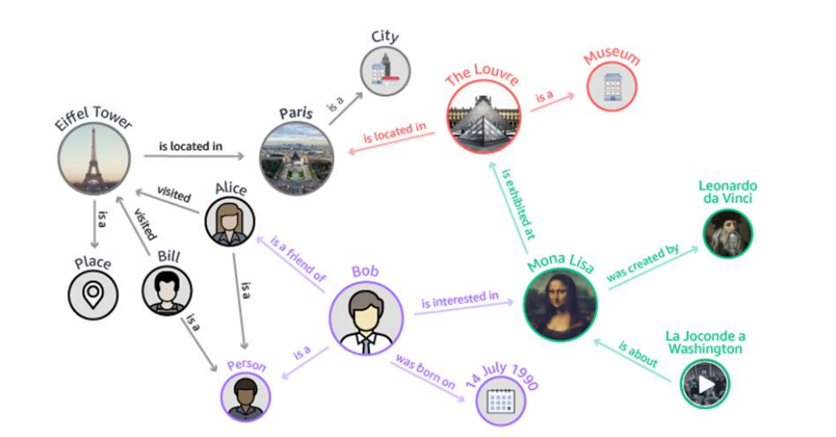

• **Knowledge**: • the fact or condition of knowing something with familiarity gained through experience or association

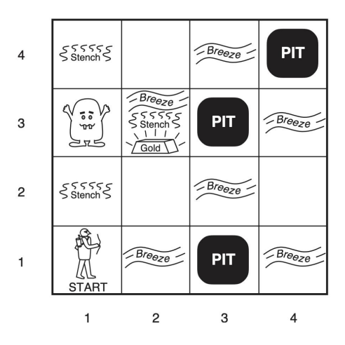• **Reasoning**: • the drawing of inferences or conclusions through the useof reason

Knowledge + Reasoning →New Knowledge

The Wumpus World

• A decision-maker needs to represent **knowledge** of the world **and reason** with it in order to safely explore this world.

E.g. In the squares directly adjacent to a pit, the agent will perceive a Breeze

→ There a pit in [2, 2] or [3, 1] or both

Knowledge Representation

• Human intelligence relies on a lot of back ground knowledge(the more you know, the easier many tasks become/ “knowledge is power”)

E.g. SEND + MORE = MONEY puzzle.

• Natural language understanding

• Time flies like an arrow.

• Fruit flies like bananas.

• The spirit is willing but the flesh is weak. (English)

• The vodka is good but the meat is rotten. (Russian)

• Or: Plan a trip to L.A.

Knowledge Representation

Q. How did we encode (domain) knowledge sofar?

For search problems?

Fine for limited amounts of knowledge / well-defined domains.

Otherwise: **knowledge-based systems approach**.

Knowledge-Based Systems/Agents

Key components

• knowledge base: a set of **sentences** expressed in some knowledge representation language

• Inference / reasoning mechanisms to query what is known and to derive new information or make decisions

Knowledge-Based Systems/Agents

• Natural candidate: **logical language** (propositional /first-order) combined with a logical inference mechanism

• How close to human thought?

• In any case, appears reasonable strategy for machines.

Logic

• Logic: • defines a formal language for logical reasoning

• It gives us a tool that helps us to understand how to construct a valid argument

• Logic defines: • the meaning of statements • the rules of logical inference

Logic as a Knowledge Representation

Three components:

• **syntax**: specifies which sentences can be constructed in a given formal logic

• E.g. x + y = 4

• **semantics:** specifies what a sentence means

• x + y = 4 is True if x = 2 and y = 2

• **proof theory**: a set of general purpose rules that allow efficient derivation of new information from the sentences in the knowledge base.

Logic as a Knowledge Representation

Model: a **truth assignment** to every propositional symbol

Logic entailment: A sentence follows logically from another sentence: 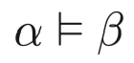

In **every** model in which α is true, β is also true.

Logic as a Knowledge Representation

• Logic inference:

• Given a knowledge base KB and a sentence α

• Does a KB semantically entail α? KB ⊨ α

One possible approach: Model Checking: enumerate all the possible models to check if α is true in all models in which KB is true.

Logic as a Knowledge Representation

Proof theory: Sound: An inference algorithm that derives only **entailed sentences**

Complete: an inference algorithm is complete if it can derive any sentence that is entailed

Connecting Sentences to the Real World

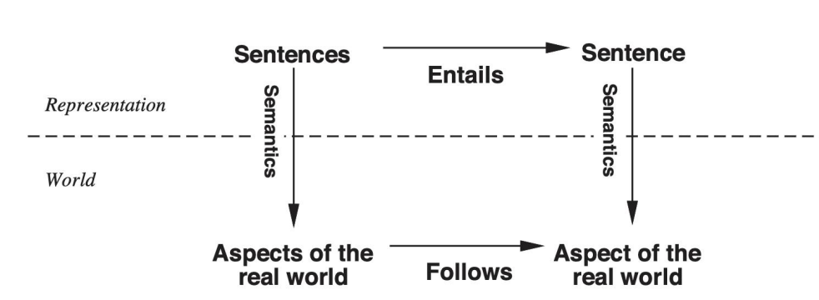

• Logical reasoning should ensure that the new configurations represent aspects of the world that actually follow from the aspects that the old configurations represent.

Tenuous Link to Real World

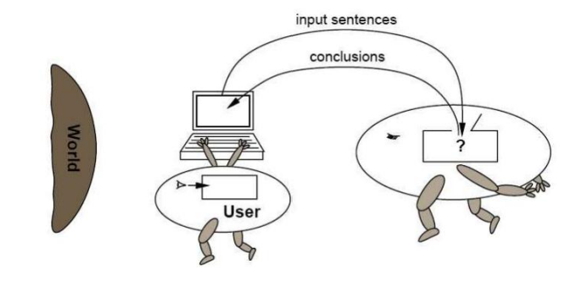

• All computer has are **sentences** (hopefully about the world).

KR Language: Propositional Logic

• Go back to 3rd century B.C. studied by Stoic school of philosophy

• Real development began in the mid-19th century and was initiated by the English mathematician G. Boole

• The classical propositional calculus was first formulated as a formal axiomatic system by the eminent German logician G.Frege in 1879.

KR Language: Propositional Logic

• The simplest logic

• Definition • A proposition is a statement that is either true or false.

• Example:

• 5 + 2 = 8 (F)

• It is raining today • (either T or F)

KR Language: Propositional Logic

• Literal: an atomic formula or its negation - Positive literal: P, Q - Negative literal: ¬P, ¬Q

• Syntax: build sentences from atomic propositions, using connectives:

• ∧: and • ∨: or • ¬ : not • ⇒ : implies • ⇔ : equivalence (biconditional)

KR Language: Propositional Logic

Syntax: build **sentences** from atomic propositions, using connectives

∧, ∨, ¬ , ⇒, ⇔ (and / or / not / implies / equivalence (biconditional))

E.g.: ¬P

Q ∧ R

( ¬P ∨ (Q ∧ R)) ⇒ S

KR Language: Propositional Logic

• Clause: a disjunction of literals E.g.: Q ∨ R

• Conjunctive normal form (CNF): a conjunction of clauses E.g.: (Q ∨ R) ∧(P ∨R)

• Every formula can be equivalently written as a formula in conjunctive normal form

(Q ∧ R) ∨ P → (Q ∨P)∧(R ∨P )

Semantics

Semantics specifies what something means.

In propositional logic, the semantics (i.e., meaning) of a sentence is the set of interpretations (i.e., **truth assignments**) in which the sentence evaluates to True.

Example:

The semantics of the sentence P∨Q ⇒ R is

• P is True, Q is True, R is True

• P is True , Q is False, R is True

• P is False , Q is True , R is True

• P is False , Q is False , R is True

• P is False , Q is False , R is False

Interpretations: The Key to Semantics

An interpretation is a logician’s word for “truth assignment”

• Given 3 propositional symbols P, Q, R, there are 8 interpretations.

• Given n propositional symbols P1 , P2 ,... Pn , there are 2n interpretations

In propositional logic:

• an interpretation is a mapping from propositional symbols to truth values.

• the meaning of a sentence is the set of interpretations in which the sentence evaluates to True

How to evaluate a sentence under a given interpretation?

Evaluating a sentence under interpretation I

We can evaluate a sentence using a truth table

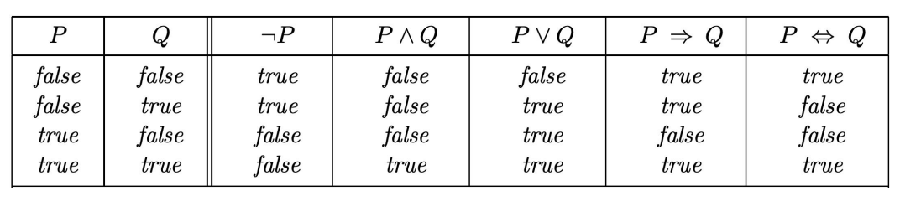

Note: is somewhat counterintuitive

What's the true value of “5 is even implies Sam is smart” If P is True, then I claim Q is True

Three Important Concepts

• Logic Equivalence • Validity • Satisfiability

Logic Equivalence

• Two sentences **are equivalent** if they are true in the same set of models.

• We write this as α ≡ β. α ≡ β if and only if α ⊨ βandβ⊨α

For example: I. If Lisa is in Denmark, then she is in Europe

II. If Lisa is not in Europe, then she is not in Denmark

Logic Equivalence

• (α∧β) ≡ (β∧α) commutativity of ∧

• (α∨β) ≡ (β∨α) commutativity of ∨

• ((α∧β) ∧γ) ≡ (α∧(β ∧γ)) associativity of ∧

• ((α∨β) ∨γ) ≡ (α∨(β ∨γ)) associativity of ∨

• ¬(¬ α) = α double-negation

• (α ⇒ β) ≡ (¬β ⇒ ¬α) contraposition

• (α ⇒ β) ≡ (¬α∨β) implication elimination

• (α ⇔ β) ≡ ((α ⇒ β) ∧(β ⇒ α)) biconditional elimination

• ¬(α∧β) ≡ (¬α∨¬β) De Morgan

• ¬(α∨β) ≡ (¬α∧¬β) De Morgan

• (α∧(β∨γ)) ≡ ((α∧β)∨(α∧γ)) distributivity of ∧ over ∨

• (α∨(β∧γ)) ≡ ((α∨β)∧(α∨γ)) distributivity of ∨ over ∧

These equivalences play much the same role in logic as arithmetic identities do in ordinary mathematics.

Validity

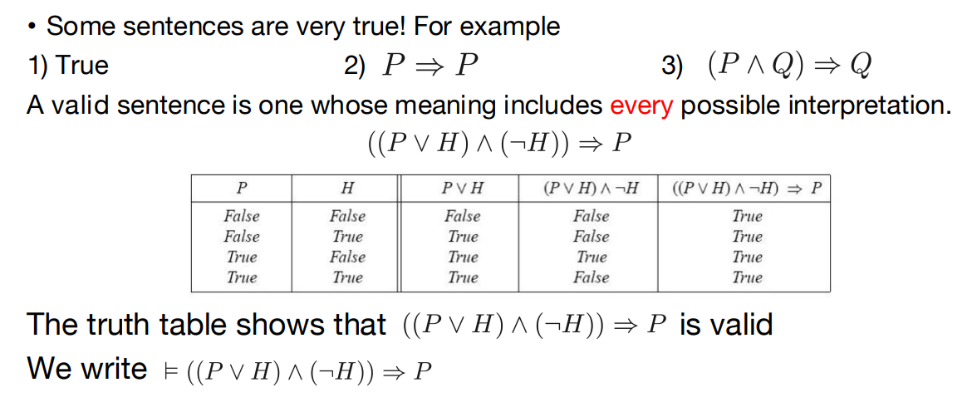

Satisfiability

• An unsatisfiable sentence is one whose meaning has **no interpretation**(e.g., P∧¬P )

• A satisfiable sentence is one whose meaning has **at least** one interpretation.

• A sentence must be either **satisfiable or unsatisfiable** but it can’t be both.

• If a sentence is valid then it’s satisfiable.

• If a sentence is satisfiable then it may or may not be valid.

• The SAT problem is to determine the satisfiability of sentences

• Connection to validity:

• α is valid iff ¬α is unsatisfiable

• α is satisfiable iff ¬α is not valid

• Proving by checking the unsatisfiability: α ⊨ β if and only if the sentence (α ∧¬β) is unsatisfiable

Knowledge Base and Models

• Knowledge base: a **set of sentences**. Each sentence represents some assertation about the world.

• A model of a set of sentences (KB) is a truth assignment in which each of the KB sentences evaluates to True.

• With more and more sentences, the models of KB start looking more and more like the “real-world”.

Models

If a sentence α holds (is True) in all models of a KB, we say that α is entailed by the KB.

α is of interest, because whenever KB is true in a worldαwill also be True.

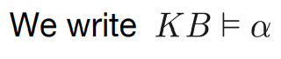

Entailment Examples

KB

R1: CS4365 Lectures ⇒ (TodayIs Tuesday ⋁ TodayIsThursday)

R2: ¬TodayIsThursday

R3: TodayIsSaturday ⇒ SleepLate

R4: Rainy ⇒ GrassIsWet

R5: CS4365Lectures ⋁ TodayIsSaturday

R6: ¬ SleepLate

Then which of these are correct entailments?

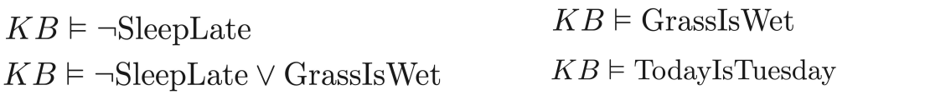

Entailment Examples

• KB

• Propositional symbols:

• CS4365Lectures, TodayIsTuesday, TodayIsThursday, TodayIsSaturday, SleepLate, Rainy, GrassIsWet

• Model checking:

• **Enumerate all the possible models** to check if α is true in all models is in all models in which KB is true

Entailment Examples

KB

R1: CS4365Lectures ⇒ (TodayIsThursday ⋁ TodayIsThusday)

R2: ¬TodayIsTuesday

R3: TodayIsSaturday ⇒ SleepLate

R4: Rainy ⇒ GrassIsWet

R5: CS4365Lectures ⋁ TodayIsSaturday

R6: ¬ SleepLate

CS4365Lectures: T TodayIsThursday: T TodayIsTuesday:F TodayIsSaturday: F SleepLate: Rainy:F GrassIsWet:T/F

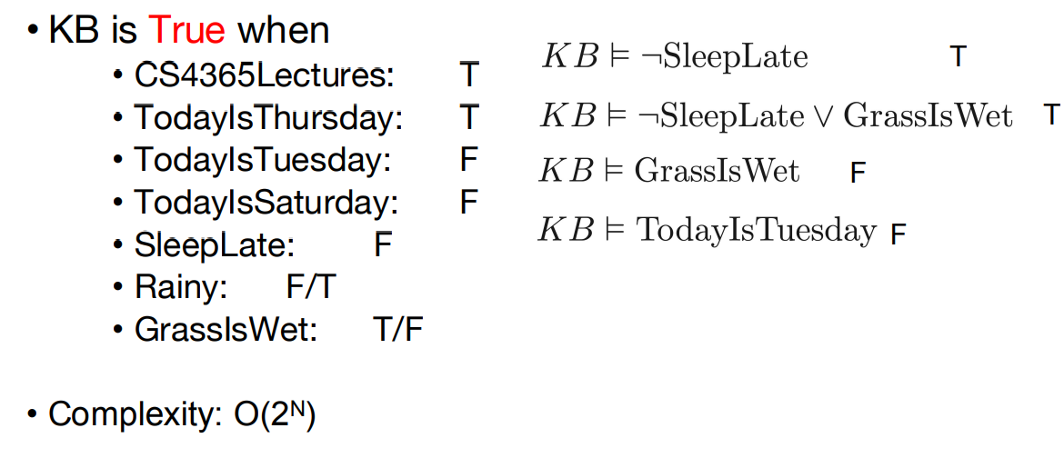

Logical Inference

• Problem definition:

• The computer has a **knowledge base KB**.

• The user inputs a **sentence**.

• The computer tells the user whether the sentence is entailed by the knowledge base.

Humans who are doing proofs almost never use this brute-force approach. Then how to do logical inference **efficiently**?

Proof Theory

• A set of purely **syntactic** rules for efficiently determining entailment

• We write: KB ⊢ α, i.e., α can be **deduced** from KB or α is **provable** from KB.

Key property:

Both in **propositional** and in **first-order logic** we have a proof theory (“calculus”) such that:

⊨ and ⊢ are equivalent

Proof Theory (cont.)

If KB ⊢ α implies KB ⊨ α, we say the proof theory is **sound**

If KB ⊨ α implies KB ⊢ α , we say the proof theory is **complete.**

Why so important?

Allow computer to ignore semantics and “just push symbols

Example Proof Theory

One rule of inference: Modus Ponens From α and α ⇒ β

it follows that β. Semantic soundness can easily be verified (using truth table).

Another rule of inference: **And-Elimination** From α∧β, it follows that α and β.

Example Proof Theory

Axiom schemas:

(Ax. I) α ⇒ (β ⇒ α)

(Ax. II) ((α ⇒ (β ⇒ γ)) ⇒ ((α ⇒ β) ⇒ ((α ⇒γ)))

(Ax. III) (¬α ⇒ β) ⇒ ((¬α ⇒ ¬β) ⇒ α)

Note: α, β, γ stand for arbitrary sentences. So, we have an infinite collection of axioms

Example Proof

• Now, α can be **deduced** from a set of sentences φ iff there exists a **sequence of applications** of modus ponens that leads from φ to α(possibly using axioms).

• One can prove that:

• Modus ponens with the above axioms will generate exactly all (and only those) statements logically entailed by φ

. So, we have a way of generating entailed statements in a purely syntactic manner! (Sequence is called a proof. Finding it can be hard …)

Example Proof Lemma.

1) For any α , we have 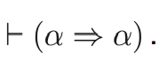

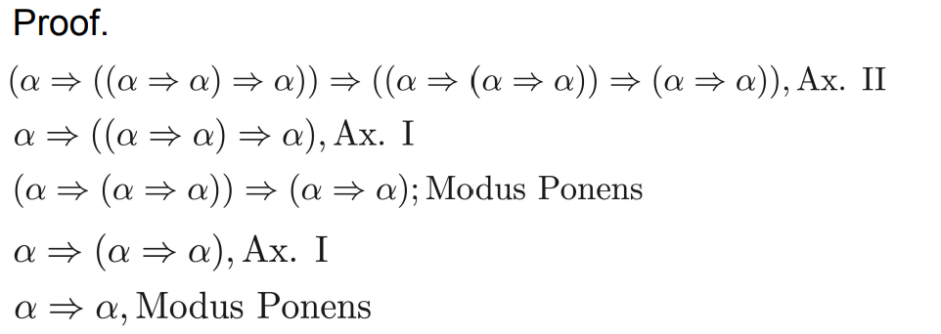

Another Example Proof

Lemma. 2) For any α and β, we have β, ¬β ⊢ α

Proof.

(¬α ⇒ β) ⇒ ((¬α ⇒ ¬β) ⇒ α), (Ax. III)

β, (hyp.)

β ⇒ (¬α ⇒ β), (Ax. I)

¬α ⇒ β, (Modus Ponens)

(¬α ⇒ ¬β) ⇒ α, (Modus Ponens)

¬β, (hyp.)

¬β ⇒ (¬α ⇒ ¬β), (Ax. I)

¬α ⇒ ¬β, (Modus Ponens)

α, (Modus Ponens)

Another Example Proof

Why are lemma 1 and lemma 2 true semantically? I.e., ⊨ α ⇒ α and β, ¬β ⊨ α

Note: **proofs** are purely **syntactic** --- machines does not need to know anything about the meaning of the sentences!

Whatever is **syntactically** derived will be **semantically** true, and we can derive everything syntactically that is semantically true.

**How hard is it to find proofs?**

Monotonicity

• The set of entailed sentences can only **increase** as information is added to the knowledge base.

• For any sentence α and β if KB ⊨ α then KB∧β ⊨ α

• Propositional logic is monotonic

Key Properties

We have the following properties (also for first-order logic):

For a sound and complete proof theory, the following three conditions are equivalent:

1. φ ⊨ α
2. (II) φ ⊢ α
3. (III) φ, ¬α is inconsistent (i.e., can be refuted)

(I) is semantic; (II) syntactic; (III) at high-level semantic but we have a nice syntactic automatic procedure: **resolution.**

What common proof technique does III represent?

Resolution

First need **canonical** form: CNF

Conjunction of disjunctions / CNF (conjunctive normal form)

Example:

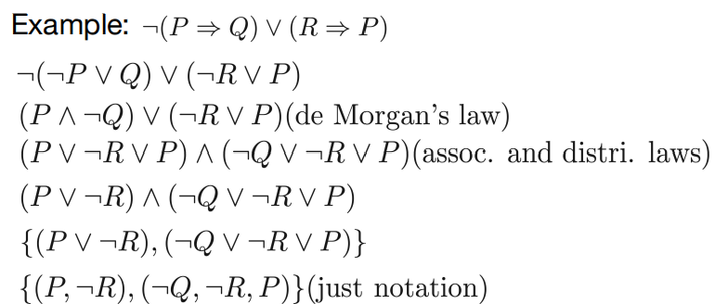

Resolution

Given a CNF, a single inference rule (and no axioms) will allow us to determine **inconsistency**.

So, using property III (above) and **resolution**, we have a **sound** and **complete** proof procedure for propositional logic (which can be extended to first-order logic).

The Resolution Rule (clausal form)

From α ∨ p and ¬p ∨ β , we can derive:

α ∨ β (α and β are **disjunctions of literals**, where a literal is a propositional variable or its negation).

• Reason:

• If p is true, β must be true • If p is false, α must be true • So β or α holds

The Resolution Rule(clausal form)

From α ∨ p and ¬p ∨ β , we can derive:

α ∨ β (**resolvent**)

(α and β are **disjunctions of literals**, where a literal is a propositional variable or its negation).

Note: ¬α ⇒ p and p ⇒ β gives ¬α ⇒ β It is a “ chaining rule”.

General Resolution Rule

If 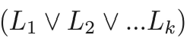 is True,

And 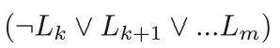 True,

then we can conclude that 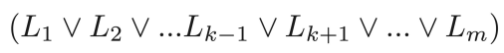 is True.

A **resolution-based theorem prover** can, for any sentencesαandβin propositional logic, decide whether α ⊨ β

General Resolution Rule

• We can derive the **empty clause** via resolution iff the set of clauses **is inconsistent**. (¬p ∧ p)

• Method relies on property III. It’s **refutation complete**. Note that method does not generate theorems from scratch

E.g., we have p ∧ r ⊨ p ∨ r , but we can't get p ∨ r from{{p}, {r}}.(Why not??)

But, given {{p}, {r}} and the negation of p ∨ r, we get the set{{p},{r},{¬p}, {¬r}}. Resolving on this set gives the **empty clause**. Thus contradiction. Thus proof.

Algorithm: Resolution Proof

• **Negate the theorem** to be proved, and add the result to the list of sentences in the KB. We show that (KB ∧¬α) is **unsatisfiable**

• Put the list of sentences into **conjunctive normal form**.

• Until there is **no resolvable pair of clauses**,

– Find **resolvable clauses** and resolve them.

– Add the results of resolution to the list of clauses.

– If NIL (empty clause) is produced, stop and report that the(original)theorem is true. (empty clause represents contradiction)

• Report that the (original) theorem is false

Algorithm: Resolution Proof

• May seem cumbersome but note that can be easily **automated**. Just “ smash” clauses till empty clause or no more new clauses

• Guaranteed sound and (refutation) complete.

• Q. Why is method with axioms more difficult to implement?

Example

1) ARM-OK

2) ¬MOVES

3) ARM-OK ∧LIFTABLE ⇒ MOVES

4) ¬ARM-OK ∨ ¬LIFTABLE ∨MOVES Prove: ¬LIFTABLE

5) LIFTABLE (assert)

6) ¬ARM-OK ∨ MOVES (resolving 5 and 4)

7) ¬ARM-OK ( from 6 and 2)

8) Nil (empty clause / contradiction, from7 and1).

Another Example

KB = (B1,1 ⇔ (P1,2 ∨ P2,1 )) ∧¬B1,1

α: ¬P1,2

• First convert (KB ∧¬α) into CNF

Another Example

• First convert (KB ∧¬α) into CNF

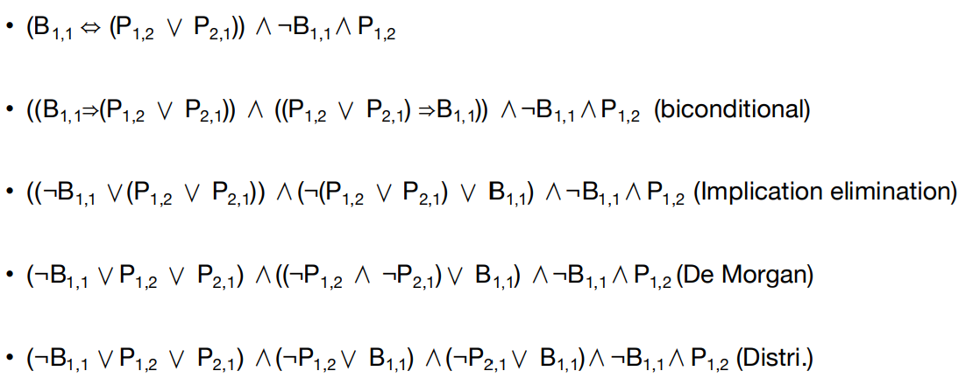

Another Example

• Resolution proof

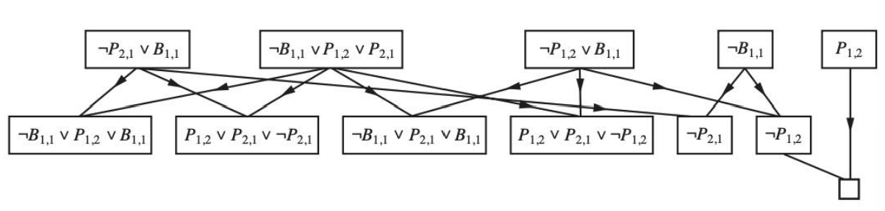

Completeness of Resolution

• **Rosolution closure (RC):** the set of all clauses derivable by repeated application of the resolution rule to clauses in S or their derivatives

• **Ground resolution theorem**: If a set of clauses is unsatisfiable, then the resolution closure of those clauses contains the empty clause

• Proof by **contrapositive**: if the closure RC(S) does not contain the **empty clause**, then S **is satisfiable**.

Completeness of Resolution

• Construct a **model** for S with **suitable truth values** for P1, ...,Pk

For i from 1 to k,

- If a clause in **RC(S)** contains the literal ¬Pi and all its other literals are **false** under the assignment chosen for P1 , ..., Pi-1,then assign **false** to Pi.

- Otherwise, assign true to Pi. This assignment to P1 ,...,Pk is a **model** of S.

Completeness of resolution

• **Assume** at some stage i in the construction, assigning Pi causes some C to be false.

• C must look like (false ∨ false ..., ∨Pi) or (false ∨false..., ∨¬Pi)

• C can only be falsified **if both of these clauses** are in RC(S)

• RC(S) will contain **resolven**t of these two clauses (already falsified)

• **Contradiction**.

Horn clauses and Definite Clauses

• **Definite clauses**: a disjunction of literals of which exactly one is positive

• ¬L1,1 ∨¬P1,2 ∨ B1,1,

• **Horn clauses**: a disjunction of literals of which at most one is positive

• Horn clauses are closed under resolution

**Horn clauses and Definite Clauses**

• Every **definite clause** can be written as an implication whose premise is a conjunction of positive literals and whose conclusion is a single positive literal.

• (L1,1 ∧P1,2 ) ⇒ B1,1,

• Inference with Horn clauses can be done through the **forward-chaining** and **backward-chaining** algorithms

• Deciding entailment with **Horn clauses** can be done in time that is **linear** in the size of the knowledge base

Forward Chaining

• From **facts** to **conclusions**

• It begins **from known** facts (positive literals) in the knowledge base

• If all the **premises** of **an implication** are known, then its **conclusion** is added to the set of known facts

• Given (L1,1 ∧ P1,2 ) ⇒ B1,1 , If L1,1 and P1,2 , then B1,1 can be added to the knowledge base

Forward Chaining

• It begins from **known facts** (positive literals) in the knowledge base

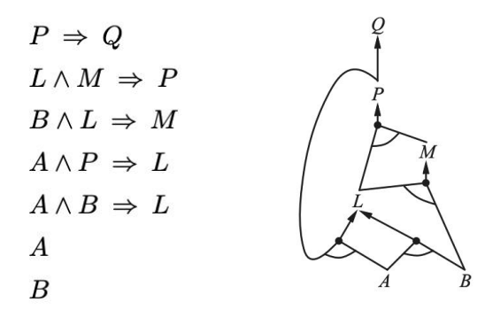• If all the **premises** of an **implication** are known, then its **conclusion** is added to the set of known facts

Forward Chaining

**• Sound:** every inference is essentially an application of Modus Ponens

• **Complete**: every entailed atomic sentence will be derived.

Backward Chaining

• From **goal** to **data**

• Assume the **query q is true** and works **backward**

• If all the premises of one of those implications can be proved true (by backward chaining), then q is true

Propositional logic is a weak language

• Hard to identify “**individuals”** (e.g., Mary, 3)

• Can’t directly talk about **properties** of individuals or **relations** between individuals (e.g., “Bill is tall”)

• **Generalizations, patterns, regularities** can’t easily be represented(e.g., “all triangles have 3 sides”)

Length of Resolution Proof

Consider **Pigeon-Hole (PH) problem**: Formula encodes that you cannot place n+1 pigeons in n holes (one per hole). PH takes **exponentiall**y many steps (no matter in what order)!PH hidden in many practical problems. Makes theorem proving expensive.

Pigeon-Hole Principle

Pi,j for Pigeon i in hole j.

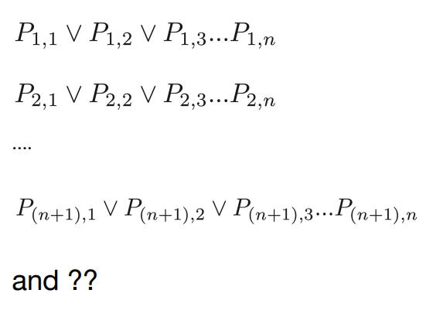

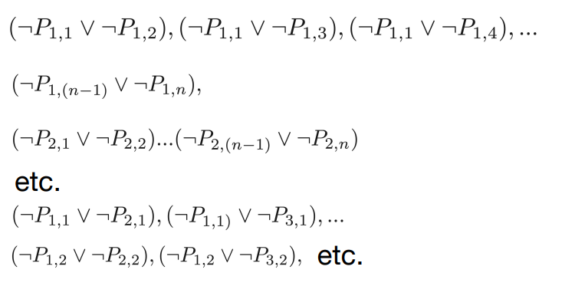

Pigeon-Hole Principle

Resolution proof **of inconsistency** requires at least an **exponential** number of clauses, no matter in what order you resolve things!

A More Concise Formulation

∀x ∃y (x∈Pigeons) ( y∈Holes) IN(x, y)

∀x∀x'∀y(IN(x,y) ∧ IN(x' , y) ... ??

∀x∀y∀y'(IN(x,y) ∧ IN(x, y') ... ??

Pigeons = {p1 , p2 , ..., pn+1 },

Holes = {h1 , h2 , ..., hn }

We **have first-order logic** with some set-theory notation.

**Knowledge Representation and Reasoning**

Summary of Propositional Logic

• **Syntax** • literals • Connectives • Clauses • CNF

• **Semantics** • Model

• **Inference**

• Semantically: Model Checking

• Syntactically: Inference rules and axioms • Modus Ponens • Resolution

Agent Based on Propositional Logic

• Construct Wumpus world agents that **use propositional logic**.

• Enable the agent **to deduce**, to the extent possible**, the state of the world** given its percept history.

The Wumpus World

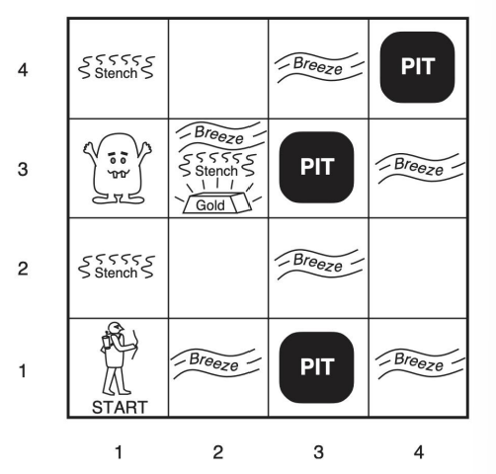• Performance measure: • gold +1000, death -1000 • -1 per step, -10 for using the arrow

• Environment

• Squares adjacent to Wumpus are **smelly**

• Squares adjacent to pit are **breezy**

• **Glitter** iff gold is in the same square

• Shooting kills Wumpus if you are facing it

• Shooting uses up the only arrow

• Grabbing picks up gold if in same square

• Releasing drops the gold in same square

• Actuators: Left turn, Right turn, Forward, Grab, Release, Shoot

• Sensors: Stench, Breeze, Glitter, Bump, Scream (shot Wumpus).

Wumpus world characterization

• **Fully Observable?** • No – only local perception

• **Deterministic?** • Yes – outcomes exactly specified

• **Episodic?** • No – sequential at the level of actions

• **Static?** • Yes – Wumpus and Pits do not move

• **Discrete?** • Yes

• **Single-agent?** • Yes – Wumpus is essentially a natural feature.

The Wumpus World

• A decision-maker needs to represent **knowledge** of the world and **reason** with it in order to safely explore this world.

• **Principle Difficulty**: agent is initially ignorant of the configuration of the environment – going to have to reason to figure out where the gold is without getting killed!

• Define **the propositional symbols**:

• Px,y : true if there is **a pit** in [x,y]

• Wx,y : true if there is a **Wumpus** in [x, y], dead or alive

• Bx,y : true if the agent perceives a **breeze** in [x ,y]

• Sx,y : true if the agent perceives a **stench** in [x,y]

Knowledge Base

• Build **the knowledge base**:

• There is no pit in [1,1]: • R1: ¬P1,1

• For each square, it knows that the square is **breezy** if and only if a neighboring square has a **pit**; • R2: B1,1 ⇔ (P1,2 ∨ P2,1 ) • R3: B2,1 ⇔ (P1,1 ∨ P2,2∨ P3,1 )

• Percepts: • R4: ¬B1,1 • R5: B2,1

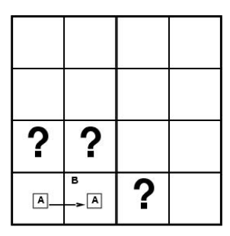Entailment in the Wumpus World

• Situation after detecting nothing in [1,1], moving right **breeze** in [2,1]

• Consider possible models for KB assuming **only pits**

• 3 **Boolean** choices ⇒ 8 possible models

Wumpus possible models

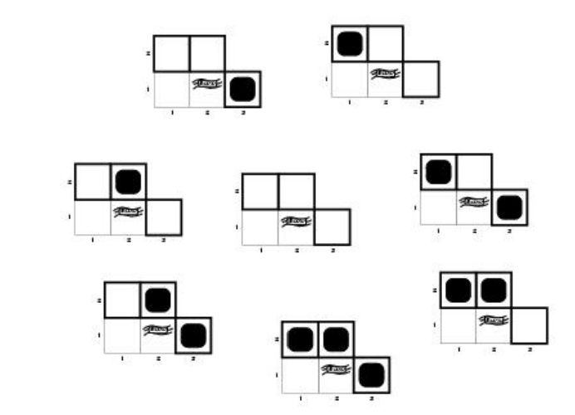

Wumpus models: KB = Wumpus-world rules + observations

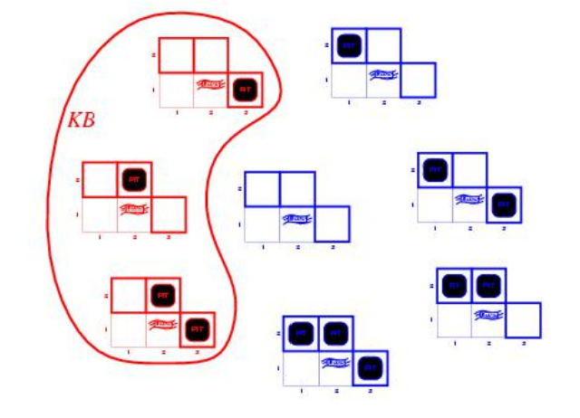

Wumpus models

• KB = Wumpus-world rules + observations

• α1 = “there is no pit in [1,2]" , KB ╞ α1 , proved by model checking

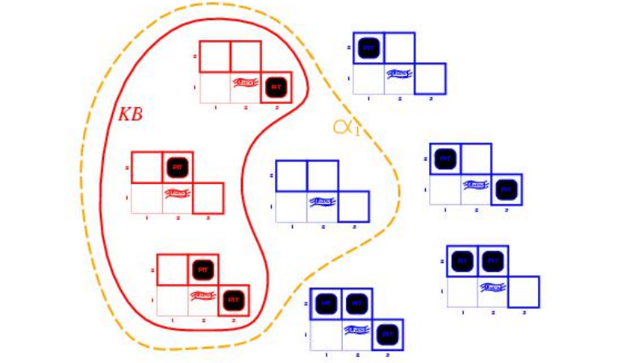

Wumpus models

• KB = Wumpus-world rules + observations

• α2 = “there is no pit in [2,2]"

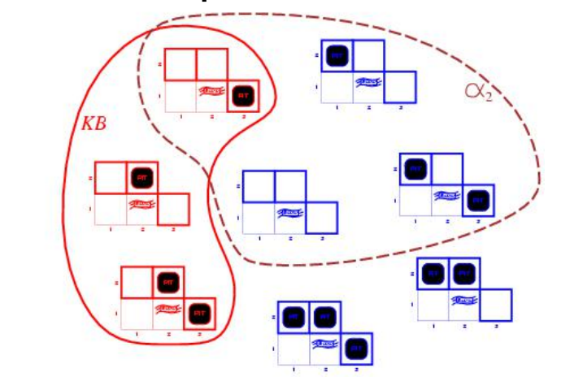

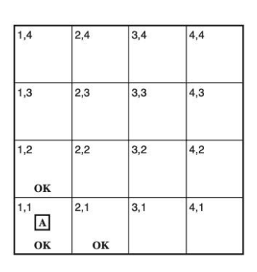Inference

**• Proof ¬P1,2 and ¬P2,1**:

• R2: B1,1 ⇔ (P1,2 ∨ P2,1)

• R6: (B1,1 ⇒ (P1,2 ∨ P2,1) ) ∧((P1,2 ∨ P2,1) ⇒ B1,1)

• R7: (P1,2 ∨ P2,1) ⇒ B1,1 And elimination

• R8: ¬B1,1⇒ ¬(P1,2 ∨ P2,1) Contrapositive

• R9: ¬(P1,2 ∨ P2,1) Modus Ponens

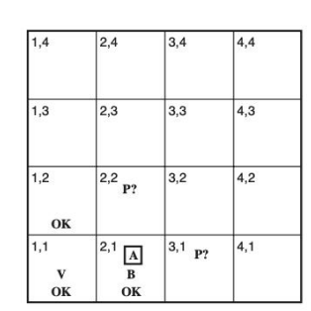• R10: ¬P1,2 ∧¬P2,1 De Morgan

Action and Percept

• Move to [2, 1]

• B2,1 is True

• There is a pit in [2,2] or [3,1]

Inference

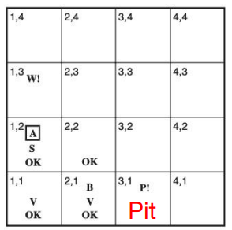• The agent return from [2,1] to [1,1] and then moves to [1, 2]

• R11: ¬B1,2 • R12: B1,2 ⇔ (P1,1 ∨ P2,2 ∨ P1,3)

• R13: ¬P2,2 • R14: ¬P1,3 • R3: B2,1 ⇔ (P1,1 ∨ P2,2∨ P3,1)

• R5: B2,1 → R15: P1,1 ∨ P2,2 ∨ P3,1 • R16: P1,1 ∨ P3,1 (**resolve** R13 with R15)

• R17: P3,1 （**resolve** R1 with R16)

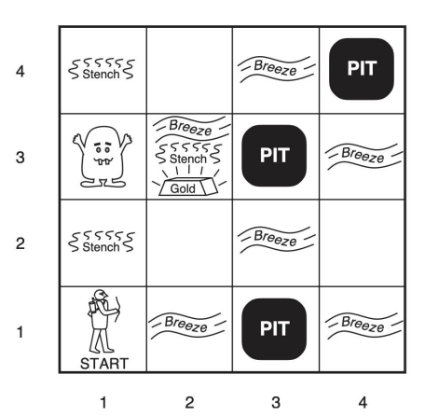The current state of the world

• Collecting **axioms:**

• ¬P1,1 • ¬W1,1

• For each square, it knows that the square is **breezy** if and only if a neighboring square has a **pit**: • B1,1 ⇔ (P1,2 ∨ P2,1) • ...

• Square is **smelly** if and only if a neighboring square has a **Wumpus**. • S1,1 ⇔ (W1,2 ∨W2,1)

The current state of the world

• There is exactly one Wumpus

• W1,1 ∨ W1,2 ∨ ..., W4,3 ∨ W4,4

• There is at most one Wumpus • ¬W1,1 ∨ ¬W1,2 • ¬W1,1 ∨ ¬W1,3 • ... • ¬W4,3 ∨ ¬W4,4

The current state of the world

• **Fluent:** associating propositions with time steps extends to any aspect of the world **that changes over time** • L0 1,1 : the agent is at square [1,1] at time 0

• Consider **time stamp for percepts** • ¬Stench3 • Stench4

The current state of the world

• For any time step t and any square [x, y], we have

• Lt x,y ⇒ (Breezet ⇔ Bx,y ) • Lt x,y ⇒ (Stencht ⇔ Sx,y )

**The current state of the world**

• **Proposition symbols** for the occurrences of actions• Forward0

• The **percept** for a given time step happens first, followed by the **action** for that time step, followed by a **transition** to the next time step.

The current state of the world

• *Effect axioms*: describe how the world changes,

• L0 1,1 ∧ FaceEast0 ∧ Forward0 ⇒ (L1 2,1 ∧¬L1 1,1 )

• Need to specify for each **action, time step, location and orientation**.

The current state of the world

• **Frame problem**:

• ASK(KB, HaveArrow1)

• The information has been lost because the effect axiom fails to state what remains unchanged as the result of an action

• Add **frame axioms**:

• Forwardt ⇒ (HaveArrowt ⇔ HaveArrowt+1)

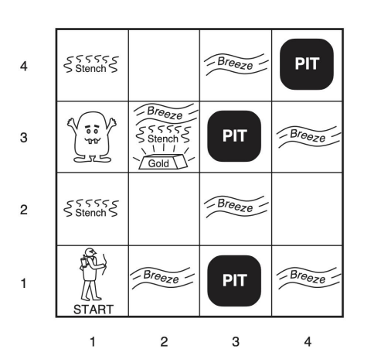• Frowardt ⇒ (WumpusAlivet ⇔ WumpusAlivet+1)

• For m **actions** and n **fluent**, needs O(mn)

• Writing axioms about **fluen**t

• **Successor-state axiom**:

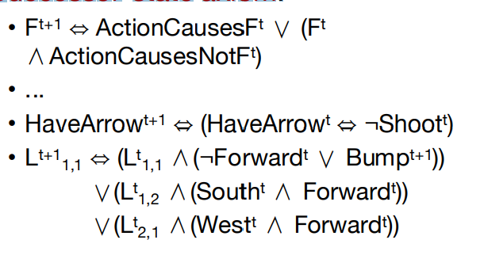

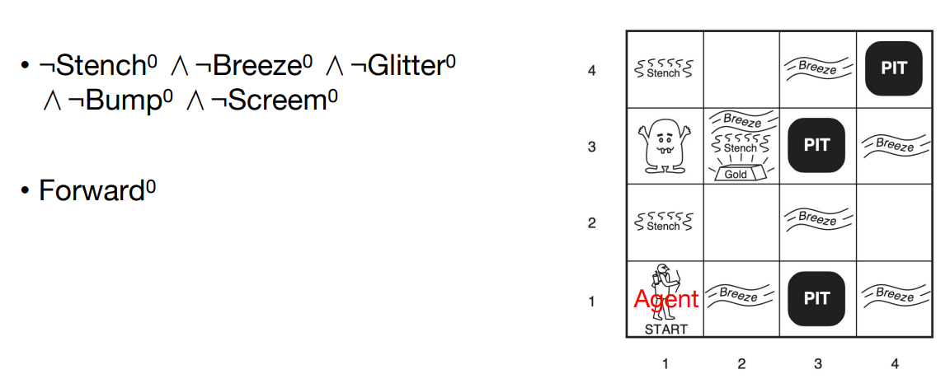

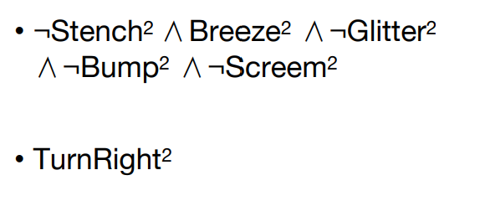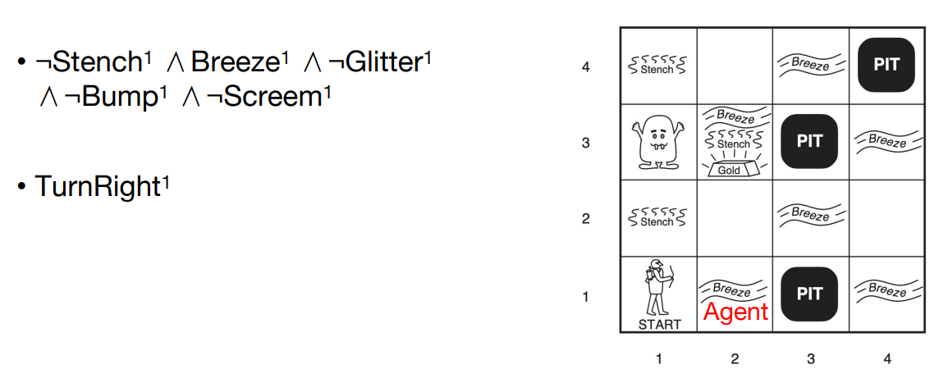

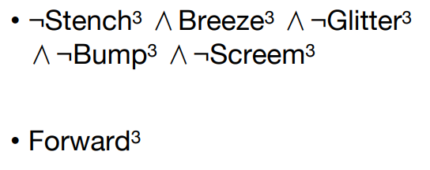

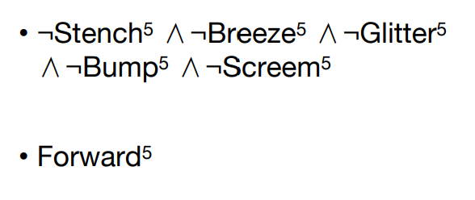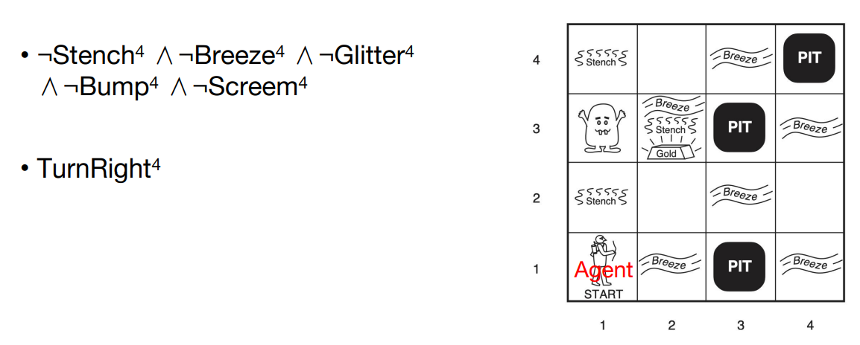

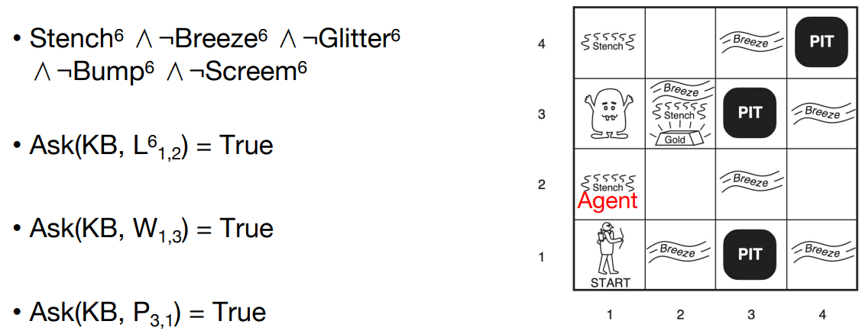

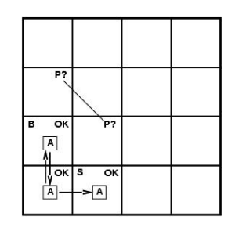The current state of the world

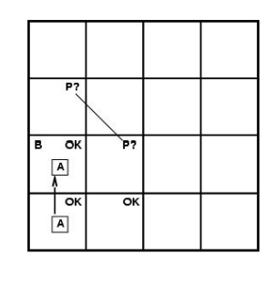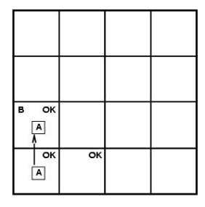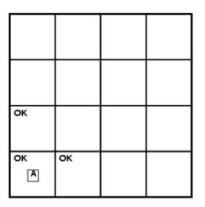

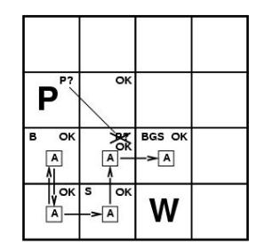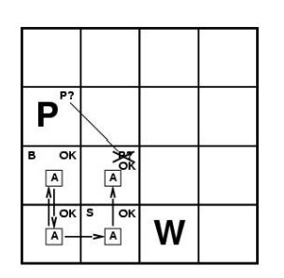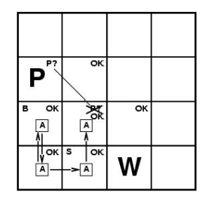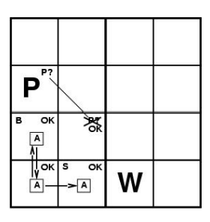

• In each case where the agent draws a conclusion from the available Information**, that conclusion is guaranteed to be correct if the available Information is correct**.

• This is a fundamental property of logical reasoning

A Hybrid Agent

• The agent program maintains and updates a **knowledge base** as well as a **current plan**.

• A∗ search

• First, if there is a glitter, the program **constructs a plan** to grab the gold, follow a route back to the initial location.

• Otherwise, if there is no current plan, the program plans a route to **the closest safe square** that it has not visited yet, making sure the route goes through only safe squares.

Logical State Estimation

• Constant update time of the knowledge base • Using **a cache** to store the results of inference.

• **Belief state**:

• the **short-term memory** of the agent.

• all of the information the agent has remembered from the previous time at time t

• every possible set of physical states.

• The set of states of at time 1:

• Wumpus Alive ∧ L1 2,1 ∧ B2,1 ∧(P2,1 ∨ P2,2 )

• **State estimation** • The process of updating the belief state as new percepts arrive

Logical State Estimation

• Approximate state estimation

• represent belief states as conjunctions of literals, that is, 1-CNFformulas

• Prove Xt and ¬Xt for each symbol Xt given the belief state at t-1

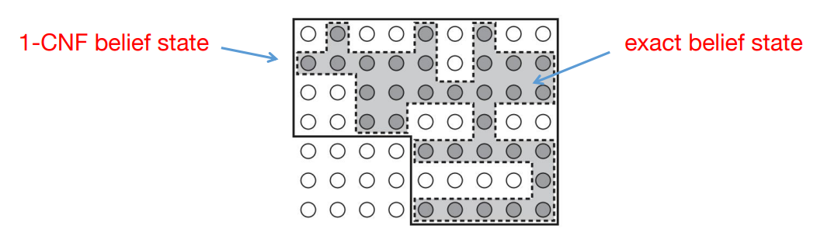

Example

• Which of the following is correct?

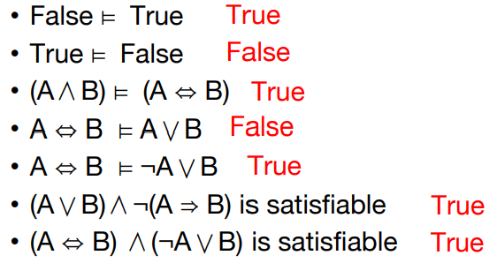

Example

• Consider a vocabulary with only four propositions, A, B, C, D. How many **models** are there for the following sentences?

• B ∨ C **12**

• ¬A∨¬B ∨¬C ∨¬D **15**

Example

• Prove, or find a counterexample to, each of the following assertions

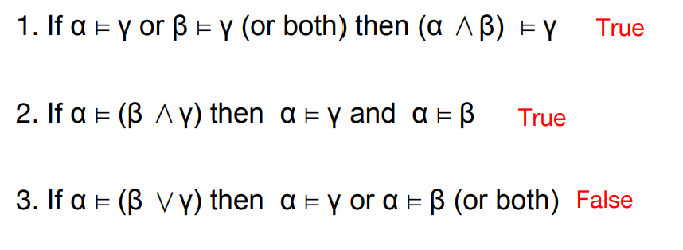

Example

• A propositional **2-CNF** expression is a conjunction of clauses, each containing exactly 2 literals, e.g., (A∨B) ∧( ¬A∨C) ∧( ¬B∨D) ∧( ¬C∨G) ∧( ¬D∨G)

1. Prove using **resolution** that the above sentence entails G

• Add ¬G. Resolve with the last two clauses to produce ¬C and ¬D.

• Resolve with the second and third produce ¬A and ¬B

• Resolve with the first clause to produce the **empty clause**.

2. Two clauses are **semantically distinct** if they are not logically equivalent. How many semantically distinct 2-CNFclausescanbeconstructed from **n** proposition symbols?

• There are C(2n, 2) = (2n)(2n-1)/2 = 2n2-n clauses **with two different literals**

• ¬A∨A ... are equivalent. So we have 2n2-2n+1

• Add A∨A ..., so we have 2n2+1.

**Predicate Logic**

Propositional logic is a weak language

• Hard to identify “**individuals”** (e.g., Mary, 3)

• Can’t directly talk about **properties** of individuals or **relations** between individuals (e.g., “Bill is tall”)

• **Generalizations, patterns, regularities** can’t easily be represented(e.g., “all triangles have 3 sides”).

Length of Resolution Proof

Consider **Pigeon-Hole (PH)** problem: Formula encodes that you cannot place n+1 pigeons in n holes (one per hole).

PH takes **exponentially** many steps (no matter in what order)!

PH hidden in many practical problems. Makes theorem proving expensive.

Pigeon-Hole Principle

Pi,j for Pigeon i in hole j.

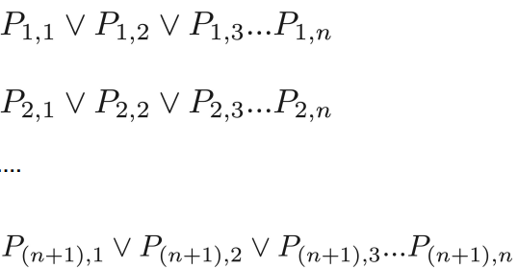

And?

Pigeon-Hole Principle

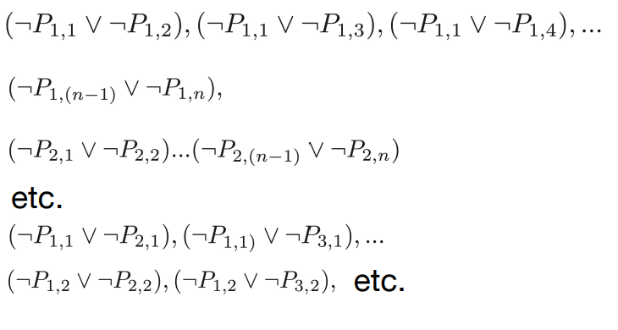

Pigeon-Hole Principle

Resolution proof of **inconsistency** requires at least an **exponential** number of clauses, no matter in what order you resolve things!

A More Concise Formulation

∀x ∃y (x∈Pigeons) ( y∈Holes) IN(x, y)

∀x∀x'∀y(IN(x,y) ∧ IN(x' , y) ... ??

∀x∀y∀y'(IN(x,y) ∧ IN(x, y') ... ??

Pigeons = {p1 , p2 , ..., pn+1 },

Holes = {h1 , h2 , ..., hn }

We have first-order logic with some set-theory notation.

Predicate Logic

• **Predicate logic (or first-order logic)** is an extension of propositional logic that **permits concisely** reasoning about whole classes **of entities and relations**.

• **Propositional logic** treats simple propositions (sentences)as atomic entities

• In contrast, **predicate logic** distinguishes the **subject** of a sentence from its **predicate**.

Predicate Logic

• Plato is a philosopher

• Socrates is a philosopher

• **Propositional logic**: • P: Plato is a philosopher • Q: Socrates is a philosopher

• **Predicate logic**: • Variable: a • Predicate: “is a philosopher”

Subjects and Predicates

• In the sentence “The dog is sleeping”:

• The phrase “the dog” denotes the **subject** - the **entity/object** that the sentence is about

• The phrase “is sleeping” denotes **the predicate** - **a property** that is true of the subject.

• In predicate logic, a predicate is modeled as a **function** P(·)from **objects to propositions**

- P(x) = “ x is sleeping” where x is any object

**More About Predicates**

• Convention: Lowercase variables x, y, z... denote **objects/entities**; uppercase variables P, Q, R…denote **propositional functions** (predicates).

• The result of applying a predicate P to an object x is the proposition P(x). But P itself (e.g. P=''is sleeping'') is not a proposition (not a complete sentence).

- E.g. if P(x) = “ x is primer number” , P(3) is the proposition “3 is a prime number.”

Propositional Functions

• **Predicate logic** generalizes the grammatical notion of a predicate to also include **propositional function**s of any number of arguments, each of which may take any grammatical role that a noun can take

- E.g. let P(x, y, z) = “ x gave y the grade z ” ,

then if x = “Mike” , y = “Mary ” , z = “A” ，then P(x, y, z)=“Mike gave Mary the grade A”.

Symbols

• **Constant symbols**: objects e.g., Richard, John

• **Predicate symbol**: relations e.g., IsPhilosopher(x), Brother(x, y), OnHead(x, y)

• **Function symbols**: functions e.g., LeftLeg(x) f(x): the father of x

Term

•A **term** is a logical expression that refers to **an object**

• Constant symbols

• Function symbols: • LeftLeg(John)

Atomic sentences

• Formed from a **predicate symbol** optionally followed by a parenthesized list of **terms**

• Brother (Richard, John). • Married(Father (Richard), Mother (John))

Complex sentences

• Connectives: build **sentences** from atomic sentences, using connectives

∧, ∨, ¬ , ⇒, ⇔ (and / or / not / implies / equivalence (biconditional))

• We can use **logical connectives** to construct more complex sentences

e.g., ¬Brother (LeftLeg(Richard), John) Brother (Richard, John) ∧Brother (John, Richard)

**Semantics**

• **Models**: the formal structures that consist **possible world** sunder consideration

• **Domain**: the set of **objects** the model contains

• The **objects** in the model may be related in various ways.

• A **relation** is just the set of **tuples** of objects that are related

• The brotherhood relation



Model

• A model containing five **objects**

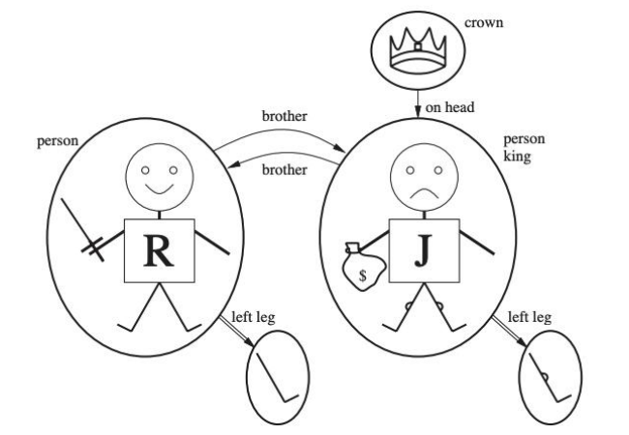

Interpretations

• Each model includes an **interpretation** that specifies exactly which **objects, relations and functions** are referred to by the constant, predicate, and function symbols.

e.g., Richard refers to Richard the Lionheart and John refers to the evil King John.

• There are many possible **interpretations**:

• If there are 5 objects in the model, there are 25 possible interpretation for 2 symbols

Intended Interpretations

• **Richard** refers to **Richard the Lionheart** and **John** refers to the **evil King John**.

• **Brother** refers to the **brotherhood relation**;

• **OnHead** refers to the “**on head**” relation that holds between the crown and King John;

• **Person, King**, **and Crown** refer to the sets of objects that are **persons, kings, and crowns**.

• **LeftLeg** refers to the “**left leg**” function

Interpretations

• All possible models: unbounded

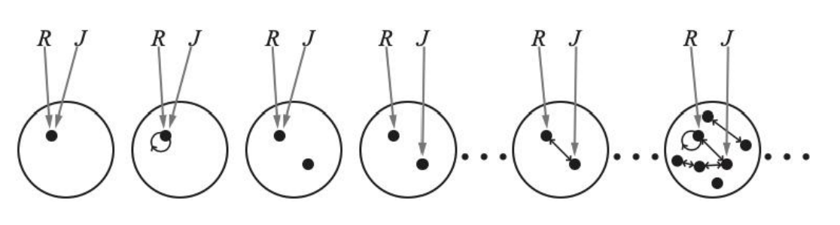

Summary

• A model for predicate logic:

• A set of **objects**

• An interpretation which maps the **constant symbols** to **objects, predicate symbols** to r**elations** on those objects, and **function symbols** to **functions** on those objects.

Universes of Discourse(U.D.)

• The power of distinguishing **objects** from **predicates** is that it lets you state things about many objects at once.

• E.g., let P(x) = “x+1 > x”. We can then say, “For all number x, P(x) is true” instead of (0+1>0) ∧(1+1>1) ∧(2+1>2) ∧...

• The collection of values that a variable x can take is called x ’s **universe of discourse**.

Quantifier Expressions

**• Quantifiers** provide a notation that allows us to quantify(count)how many objects in the u.d. satisfy a given predicate.

• “∀” is the **FOR ALL** or **universal quantifier**. ∀x P(x) means for all x in the u.d., P holds

• “∃” is the **EXISTS o**r **existential quantifier**. ∃x P(x) means there exists an x in the u.d. (that is, 1or more)such that P(x) is true.

The Universal Quantifier∀

• Example:

Let the u.d. of x be parking spaces at UTD.

Let P(x) be the predicate “x is full”.

Then the **universal quantification** of P(x), ∀x P(x), is the proposition:

- “All parking spaces at UTD are full”

- i.e., “Every parking space at UTD is full.”

- i.e., “For each parking space at UTD, that space is full.”

**The Universal Quantifier∀**

• Example

• All kings are persons • ∀x King(x) ⇒ Person(x)

• Extended interpretation:

• x → Richard the Lionheart • x → King John • x → Richard’s left leg • x → John’s left leg, • x → the crown.

The Universal Quantifier∀

• ∀x King(x) ⇒ Person(x) is true if the sentence King(x) ⇒Person(x) is true under each of the **five extended interpretations**

• Richard the Lionheart is a king ⇒ Richard the Lionheart is a person

• **King John is a king ⇒ King John is a person.**

• Richard’s left leg is a king ⇒ Richard’s left leg is a person.

• John’s left leg is a king ⇒ John’s left leg is a person

• The crown is a king ⇒ the crown is a person

The Universal Quantifier∀

• A common mistake using ∀ • ∀x King(x)∧Person(x)

• “Richard the Lionheart is a king ∧Richard the Lionheart is a person”

• “King John is a king ∧ King John is a person”

• “Richard’s left leg is a king ∧Richard’s left leg is a person”• ...

The Existential Quantifier∃

• Example: Let the u.d. of x be parking spaces at UTD. Let P(x) be the predicate “x is full”. Then the **existential quantification** of P(x), ∃x P(x), is the proposition:

- “Some parking spaces at UTD are full”

- i.e., “There is a parking space at UTD is full.”

- i.e., “At least one parking space at UTD is full.”

The Existential Quantifier∃

• Example

• King John has a crown on his head

• ∃x Crown(x) ∧ OnHead(x, John)

• At least one of the following is true:

• Richard the Lionheart is a crown ∧ Richard the Lionheart is on John’s head;

• King John is a crown ∧ King John is on John’s head

• Richard’s left leg is a crown ∧ Richard’s left leg is on John’s head;

• John’s left leg is a crown ∧ John’s left leg is on John’s head;

• The crown is a crown ∧ the crown is on John’s head

Free and Bound Variables

An expression like P(x) is said to have a **free variable** x (meaning, x **is undefined**).

A quantifier (either ∀ or ∃) operates on an expression having one or **more free variables**, and binds one or more of those variables, to produce an expression having one or more **bound variables**

Example of Binding

• P(x, y) has 2 free variables, x and y

• ∀x P(x, y) has 1 free variable, and one bound variable.[**Which is which**?]

• “P(x), where x = 3” is another way to bind x.

• An expression with **zero free variable is a proposition**.

• An expression with **one or more free variables** is still a predicate: e.g. Let Q(y) = ∀x P(x, y).

Nesting of Quantifiers

• Example: Let the u.d. of x & y be people.

• Let L(x, y) = “x likes y” (how many free vars?)

• Then ∃y L(x, y) = “There is someone whom x likes.” (how many free vars are there?)

• The ∀x(∃y L(x, y)) = “Everyone has someone whom they like.”(how many free vars are there?).

Quantifier Exercise

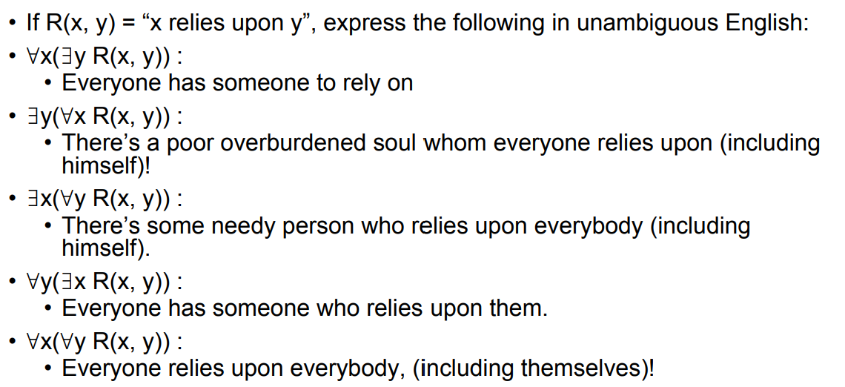

More to Know About Binding

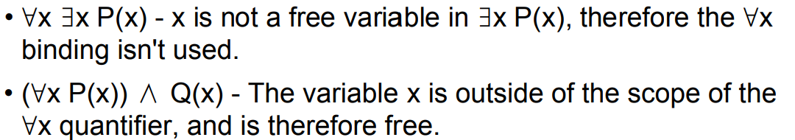

• Not a complete proposition!

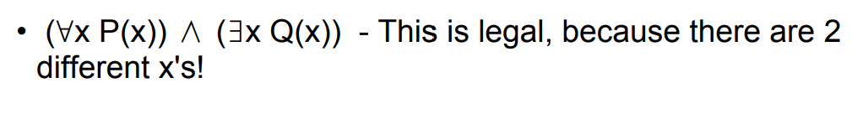

Quantifier Equivalence Laws

• Definitions of quantifiers: If u.d. = a, b, c, ...

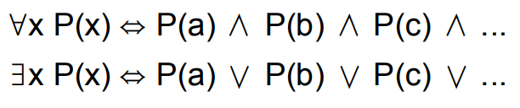

• “Everyone likes ice cream” means “there is no one who does not like ice cream” :



Quantifier Equivalence Laws

• Definitions of quantifiers: If u.d. = a, b, c, ...



• From those, we can prove the laws:

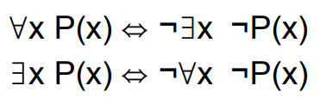

Which propositional equivalence laws can be used to prove this ?De Morgan's

Logic Equivalence

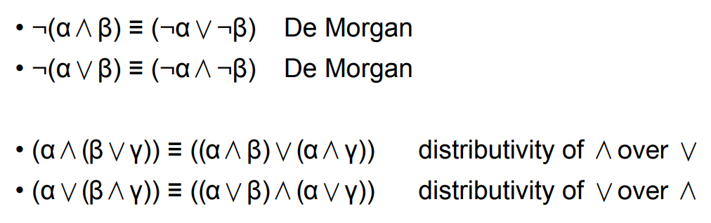

Quantifier Equivalence Laws

• Definitions of quantifiers: If u.d. = a, b, c, ...



• From those, we can prove the laws:



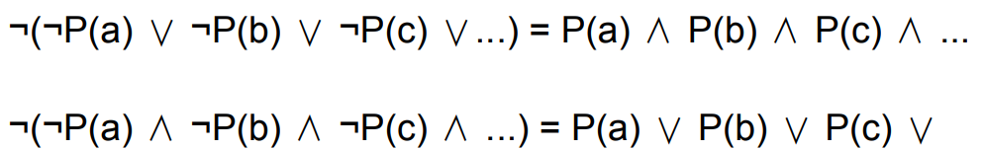

Equality

• Another way to make atomic sentences,

• Father (John) = Henry

• The **negation of equality** can be used to insist that two terms are not the same object



Use of First-order Logic

• Sentences are added to a knowledge base using **TELL**

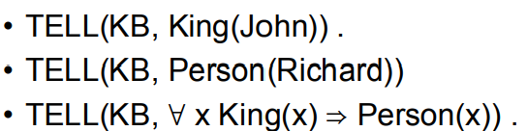

• We can ask questions using **ASK**

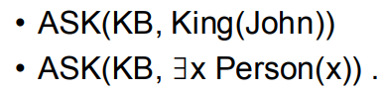

Use of First-order Logic

• The value of x makes the sentence true

• **ASKVARS**(KB, Person(x))

• **Binding list** • {x/John} • {x/Richard}.

• Cannot be always achieved

• King(John) ∨ King(Richard) is true

• No binding for x for the query ∃x King(x)

Constructing Natural Numbers

• **Peano Axioms** • Predicate: NatNum(x) • Constant symbol: 0 • Function symbol: S (successor)

Constructing Natural Numbers

• **Peano Axioms** • NatNum(0) • ∀n NatNum(n) ⇒ NatNum(S(n))

• S(n) is the **successor function**

• ∀n 0 ≠ S(n)

• ∀m, n m ≠ n ⇒ S(m) ≠ S(n).

• Addition

• ∀ m NatNum(m) ⇒ +(0, m) = m .

• ∀ m, n NatNum(m) ∧ NatNum(n) ⇒ + (S(m), n) = S(+(m, n)) .

• ∀ m, n NatNum(m) ∧ NatNum(n) ⇒ (m + 1) + n = (m+n) +1.

**Predicate Logic**

KR Language: Predicate Logic

• Gives us a more **concise** formulation.

• Essentially equivalent to propositional logic in finite domains.

• Extends **propositional logic** with variables, predicates, symbols, functions, and quantifiers (∀, ∃).

• Key properties from propositional case carry over: model-theoretic semantics, sound and complete proof theory, sound and refutation complete resolution.

Inference in Predicate Logic

• How do we **reason** with predicate (first-order) logic? Derive new info?

• We can **use resolution** as in propositional case:

From 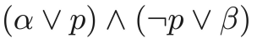

conclude 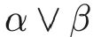 until you reach contradiction

• First-order inference can be done by converting the knowledge base to propositional logic

• But we need some extra “tricks” to deal with quantifiers and variables.

Inference Rules for Quantifiers

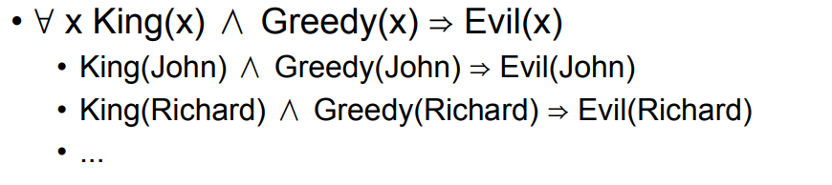

• Universal Instantiation (UI): we can infer any sentence obtained by substituting a ground term g (a term without variables) for the variable v.

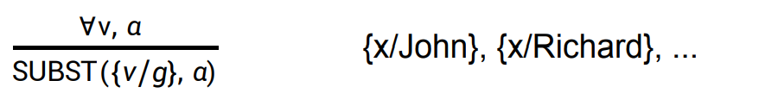

Inference Rules for Quantifiers

• ∃ x Crown(x) ∧ OnHead(x, John)

• Existential Instantiation: the variable is replaced by a single new constant symbol k

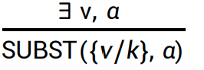

• k that does not appear elsewhere in the knowledge base (a **Skolem** constant)

• Crown(C1) ∧ OnHead (C1, John)

Inference rules for quantifiers

• Universal Instantiation can be applied many times to produce **many** propositions

• Existential Instantiation can be applied **once**, and then the existentially quantified sentence can be discarded

• Once we add Crown(C1) ∧ OnHead(C1, John), we don't need ∃ x Crown(x) ∧ OnHead(x, John)

Reduction to Propositional Inference

• Knowledge base:

• ∀ x King(x) ∧ Greedy(x) ⇒ Evil(x)

• King(John) • Greedy(John)

• Brother (Richard, John)

• A **universally quantified** sentence can be replaced by the set of all possible instantiations

• King(John) ∧ Greedy(John) ⇒ Evil(John)

• King(Richard) ∧ Greedy(Richard) ⇒ Evil(Richard) ,

**Propositionalizing**.

Reduction to Propositional Inference

• The set of possible ground-term substitutions is **infinite** if there is a function symbol

• Father (Father (Father (John)))

• Theorem: If a sentence is entailed by the original, first-order knowledgebase, then there is a proof involving just a **finite subset** of the propositionalized knowledge base.

• First-order inference via propositionalizing that is **complete**

• What happens when the sentence is not entailed? • Cannot determine if a sentence is not entailed

Reduction to Propositional Inference

• Can be inefficient

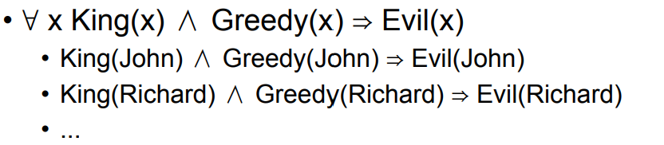

• To infer **Evil(John)** there is need to generate King(Richard) ∧Greedy(Richard) ⇒ Evil(Richard)

Lifting

• ∀ x King(x) ∧ Greedy(x) ⇒ Evil(x)

• Find substitution θ that makes **each** of the conjuncts of the premise of the implication identical to sentences already in the knowledge base, then we can assert the conclusion of the implication

• {x/John} achieves the aim

Lifting

• ∀ x King(x) ∧ Greedy(x) ⇒ Evil(x)

• If we know ∀y Greedy(y)

• We need to find a substitution both for the variables in the **implication sentence** and for the variables in the sentences that are in the knowledge base

• {x/John, y/John} achieves the aim

Lifting

• Generalized Modus Ponens

• For atomic sentences pi, pi' and q, where there is a substitution θ such that SUBST( θ, pi') = SUBST(θ, pi) for all i,

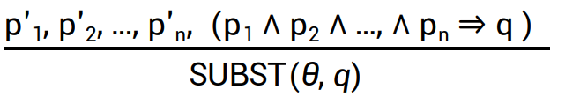

There n+1 premises: the n atomic sentences pi' and one implication.

Lifting

• In our example:

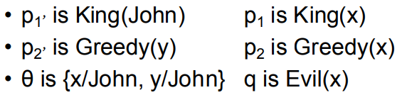

• SUBST(θ ,q) is Evil(John)

• Generalized Modus Ponens is sound

• Generalized Modus Ponens is a lifted version of Modus Ponens.

Unification – Purpose

Given: Know(John, x) → Hates(John, x) Knows(John, Jim)

Derive: Hates(John, Jim)

Need **unifier** {x/Jim} for **resolution** to work. (simplest case)

Unification (example)

one rule: Know(John, x) → Hates(John, x)

facts: Knows(John, Jim)

Knows(y, leo)

Knows(z, Mother(z))

Knows(x, Jane)

Who does John hate?

Most General Unifier

In cases where there is more than one substitution choose the one that makes the **least commitment** (most general) about the bindings.

UNIFY (Knows(John, x), Knows(y, z))

= {y/John, x/z}

or {y/John, x/z, z/Freda}

or {y/John, x/John, z/John}

or ... See R&N for general unification algorithm

**Unification**

• Finding **substitutions** that make different logical expressions look i**dentical**

• UNIFY(Knows(John, x), Knows(x, Elizabeth)) • fail

• The problem can be avoided by **standardizing apart** one of the two sentences being unified, which means renaming its variables to avoid **name clashes**.

• UNIFY(Knows(John, x), Knows(x17 , Elizabeth)) = {x/Elizabeth, x17/John}

Resolution

I. put KB in CNF form **all variables universally quantified**

main trick: “**skolemization**” to remove **existential**s

idea: invent names for unknown objects known to exist

II. use unification to match atomic sentences

III. apply resolution rule to the CNF combined with negated goal. Attempt to generate **empty clause**.

**Converting more complicated axioms to CNF**

Axiom:

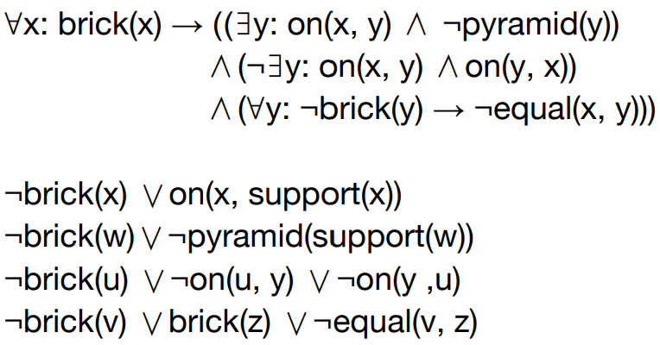

1. Eliminate implications

Substitute ¬E1∨E2 for E1→E2

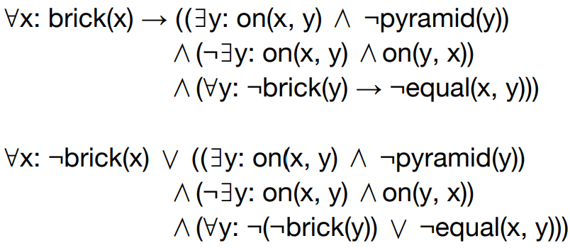

2. Move negations down to the atomic formulas

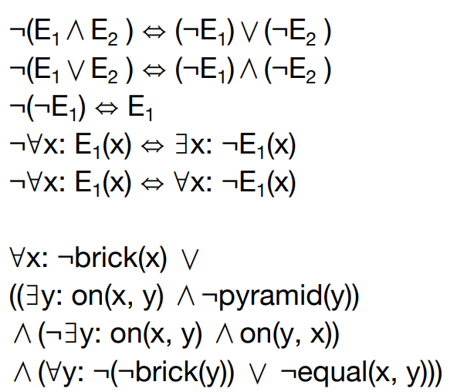

3. Eliminate existential quantifiers

**Skolemization**

Harder cases: ∀x: ∃y: father(y, x) become ∀x: father(S1(x), x)

There is one argument for each **universally quantified variable** whose scope contains the Skolem function.

Easy cases:

∃x: President(x) becomes President(S2)

∀x: ¬brick(x)∨(( ∃y: on(x, y) ∧¬pyramid(y)) ∧…

4. Rename variables as necessary

We want no two variables of the same name.

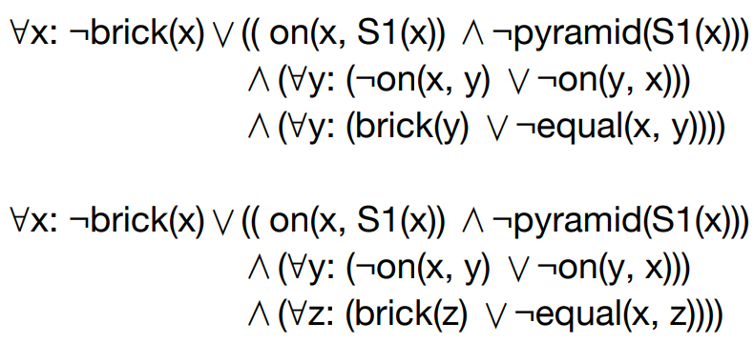

5. Move the universal quantifiers to the left

This works because each quantifier uses a unique variable name.

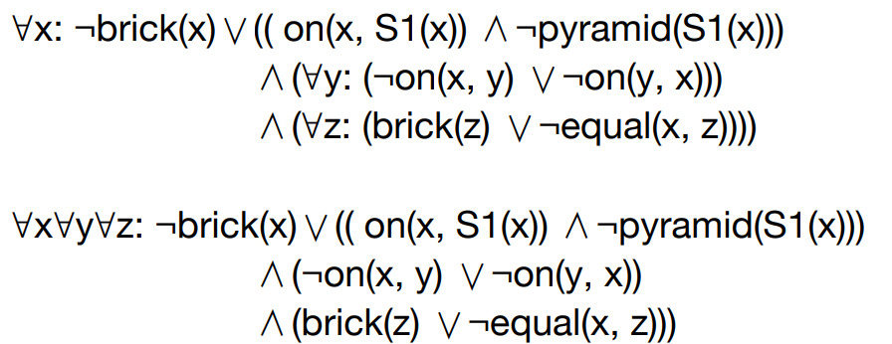

6.Move disjunctions down to the literals

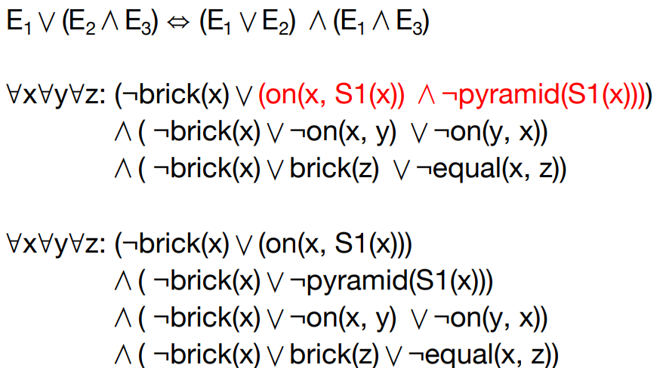

7.Eliminate the conjunctions

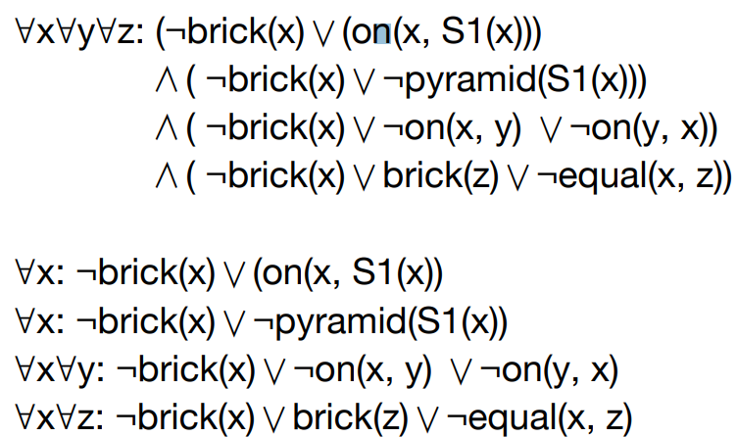

8.Rename all variables, as necessary, so no two have the same name

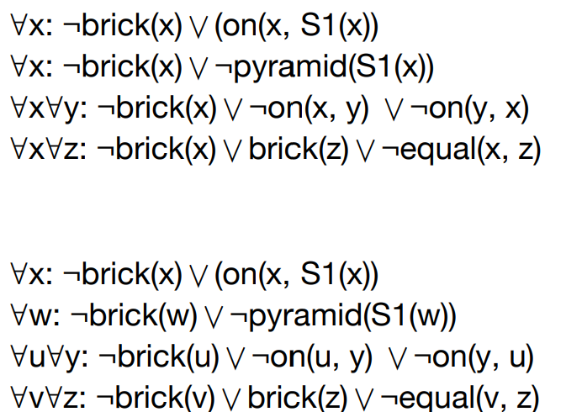

9.Eliminate the universal quantifiers

At this point, all remaining variables must be universally quantified.

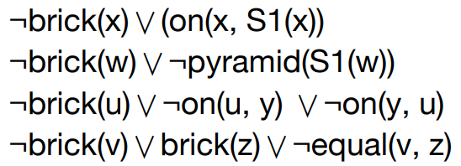

Algorithm: Putting Axioms in to CNF

• Eliminate the implications.

• Move the negations down to the atomic formulas.

• Eliminate the existential quantifiers.

• Rename the variables, if necessary.

• Move the universal quantifiers to the left.

• Move the disjunctions down to the literals.

• Eliminate the conjunctions.

• Rename the variables, if necessary.

• Eliminate the universal quantifiers.

Example

• Everyone who loves all animals is loved by someone

• ∀x [∀y: Animal(y) ⇒ Loves(x, y)] ⇒ [∃y Loves(y, x)]

Eliminate the implications

• ∀x [∀y: Animal(y) ⇒ Loves(x, y)] ⇒ [∃y Loves(y, x)]

• ∀x [ ¬∀y: ¬Animal(y) ∨ Loves(x, y)] ∨[∃y Loves(y, x)]

Move ¬Inwards

• ∀x [∀y: Animal(y) ⇒ Loves(x, y)] ⇒ [∃y Loves(y, x)]

• ∀x [ ¬∀y: ¬Animal(y) ∨ Loves(x, y)] ∨[∃y Loves(y, x)]

¬∀x P(x) ⇔ ∃x ¬P(x)

¬∃x P(x) ⇔ ∀x ¬P(x)

1. ∀x [ ∃y: ¬(¬Animal(y) ∨ Loves(x, y))] ∨[∃y Loves(y, x)]
2. ii. ∀x [ ∃y: ¬¬Animal(y) ∧ ¬Loves(x, y)] ∨[∃y Loves(y, x)]
3. iii. ∀x [ ∃y: Animal(y) ∧ ¬Loves(x, y)] ∨[∃y Loves(y, x)]

Standardize Variables

• ∀x [∀y: Animal(y) ⇒ Loves(x, y)] ⇒ [∃y Loves(y, x)]

• ∀x [ ¬∀y: ¬Animal(y) ∨ Loves(x, y)] ∨[∃y Loves(y, x)]

• ∀x [ ∃y: Animal(y) ∧ ¬Loves(x, y)] ∨[∃y Loves(y, x)]

• ∀x [ ∃y: Animal(y) ∧ ¬Loves(x, y)] ∨[∃z Loves(z, x)]

Skolemize

• ∀x [∀y: Animal(y) ⇒ Loves(x, y)] ⇒ [∃y Loves(y, x)]

• ∀x [ ¬∀y: ¬Animal(y) ∨ Loves(x, y)] ∨[∃y Loves(y, x)]

• ∀x [ ∃y: Animal(y) ∧ ¬Loves(x, y)] ∨[∃y Loves(y, x)]

• ∀x [ ∃y: Animal(y) ∧ ¬Loves(x, y)] ∨[∃z Loves(z, x)]

• ∀x [ Animal(F(x)) ∧ ¬Loves(x, F(x))] ∨[Loves(G(z), x)] • Skolem functions: F and G

**Drop universal quantifiers**

• ∀x [∀y: Animal(y) ⇒ Loves(x, y)] ⇒ [∃y Loves(y, x)]

• ∀x [ ¬∀y: ¬Animal(y) ∨ Loves(x, y)] ∨[∃y Loves(y, x)]

• ∀x [ ∃y: Animal(y) ∧ ¬Loves(x, y)] ∨[∃y Loves(y, x)]

• ∀x [ ∃y: Animal(y) ∧ ¬Loves(x, y)] ∨[∃**z** Loves(**z**, x)]

• ∀x [ Animal(F(x)) ∧ ¬Loves(x, F(x))] ∨[Loves(G(z), x)]

• [Animal(F(x)) ∧ ¬Loves(x, F(x))] ∨[Loves(G(z), x)]

Distribute ∨over ∧

• ∀x [∀y: Animal(y) ⇒ Loves(x, y)] ⇒ [∃y Loves(y, x)]

• ∀x [ ¬∀y: ¬Animal(y) ∨ Loves(x, y)] ∨[∃y Loves(y, x)]

• ∀x [ ∃y: Animal(y) ∧ ¬Loves(x, y)] ∨[∃y Loves(y, x)]

• ∀x [ ∃y: Animal(y) ∧ ¬Loves(x, y)] ∨[∃z Loves(z, x)]

• ∀x [ Animal(F(x)) ∧ ¬Loves(x, F(x))] ∨[Loves(G(z), x)]

• [Animal(F(x)) ∧ ¬Loves(x, F(x))] ∨[Loves(G(z), x)]

• [Animal(F(x)) ∨ Loves(G(z), x)] ∧[ ¬Loves(x, F(x)) ∨[Loves(G(z),x)]

• Now the KB is in CNF

The resolution inference rule

• Two clauses, which are assumed to be **standardized apart** so that they share no variables, can be resolved if they contain **complementary literals**

• First-order literals are complementary if one unifies with the negation of the other.

• From l1∨l2 , ...,∨lk and m1∨m2 ... ∨mn , if **UNIFY**(l i, ¬mj) =θ, we have



The resolution inference rule

• Example:

• [Animal(F(x)) ∨ Loves(G(x), x)]

• [¬Loves(u, v) ∨ ¬Kills(u, v)]

• Resolve by eliminating the **complementary literals** Loves(G(x),x)and ¬Loves(u, v), with unifier **θ = {u/G(x), v/x}**,

• We have the resolvent [Animal(F(x)) ∨¬Kills(G(x), x)] .

Completeness

• Resolution with unification applied to CNF a complete inference procedure.

• In practice, still a significant search problem!

• Many different search strategies: **resolution strategies**.

Strategies for Selecting Clauses

• Unit-preference strategy: Give preference to resolutions involving the **clauses** with the smallest number of literals. • More likely to produce empty clause

• Set-of-support strategy: Try to resolve with the negated theorem or a clause generated by resolution from that clause.

• **Subsumption**: Eliminates all sentences that are subsumed (i.e., more specific than) an existing sentence in the KB

• If P(x) is in the KB, then there is no need to have P(A).

Logic programming

• Expressing knowledge in **a formal language** and that problem is solved by running **inference**

• Algorithm = Logic + Control

• Prolog:

• The most widely used logic programming language

• Different notations from predicate logic

• A ∧ B ⇒ C → C : - A, B

• The execution of Prolog programs is based on inference

**Probabilistic Reasoning and Methods**

Uncertainty

• General situation:

• Observed variables (evidence): Agent knows certain things about the state of the world (e.g., sensor readings or symptoms)

• Unobserved variables: Agent needs to reason about other aspects(e.g. where an object is or what disease is present)

• Model: Agent knows something about how the known variables relate to the unknown variables

Probability

• By far the most universally accepted and used formalism for **uncertainty.**

• Well-developed **semantics** and **theory** and **proofs** and **examples** and **software** and **education**.

• But how good is it for representing large amounts of general purpose knowledge about an uncertain world?

• What are the computational issues?

• We’ll come back to this at the end. But for now let’s steam ahead with the world of..... ....probability.

Sample Space

• **Sample space**: • The set of all possible outcomes Ω

• Examples: • Tossing a coin: {Head, Tail} • Tossing a dice: {1, 2, 3, 4, 5, 6}

Events

• Events:

• A set of outcomes based on the **sample space**

• We say the event A occurs if the outcome of the experiment is in the set A

• Examples:

• Tossing a coin: • Events: { {}, {Head}, {Tail}, {Head, Tail}}

• Tossing a dice: {1, 2, 3, 4, 5, 6} • Events: { {}, {1}, {1,2}, {1,2,3}..., {1,2,3,4,5,6} }

The fundamental rules of probability

• Let A be **an event**, the occurrence of which we are uncertain about.

• The axioms of probability:

• 0 <= P(A) • P(A) <= 1 P(Ω) = 1 • P (A∪B) = P(A) + P(B) if A ∩ B = ∅

Another fact about probability theory

• P(~A) = P(Ω - A) = 1 - P(A)

• This can be deduced from the axioms we just saw:

• 0 <= P(A) • P(A) <= 1 P(Ω) = 1

• P (A∪B) = P(A) + P(B) if A ∩ B = ∅• How?

Another fact

• P(B) = P(B ∩ A) + P(B ∩ ~A)

• Why?

• B = {B ∩ A}∪{B ∩ ~A}

• P(B) = P({B ∩ A} ∪{B ∩ ~A}) = P(B ∩ A) + P(B∩~A)

• Since B ∩ A and B ∩ ~A are **disjoint**.

Another fact

• P(B) = P(B ∩ A) + P(B ∩ ~A)

• More generally (prove by induction):

If P(A1 ∪ A2 ∪ ... An) = 1, and for all i, j unequal, P(Ai ∩Aj)= 0) THEN we know:

P(B) = P(B ∩ A1) + P(B ∩ A2) + ... + P(B∩An)

Another fact

• P(A∪B) = P(A) + P(B) - P(B ∩ A) (inclusion–exclusion principle)

• A∪B = A∪ (B ∩~A)

• P(A∪B) = P(A) + P(B∩~A) = P(A) + P(B) - P(B∩A)

Conditional probability

• P(A | B) denotes the probability of **A given that B’s occurrence is known**.

• P(Cavity) = 0.04 “There’s a 4% chance at any time that you have a cavity”

• P(Cavity | Toothache) = 0.8 “If you have a toothache, there’s an 80% chance you have a cavity”

P(B|A) = 1 is equivalent to A => B

P(B|A) = 0.95 is a bit like a “soft fuzzy” version of A=>B.

Conditional Probability

**• Prior probability**: the degrees of belief in propositions in the absence of any other information

• P(cavity)

• **Evidence**: has already been revealed P(toothache)

• **Posterior probability**: P(cavity |toothache=True)

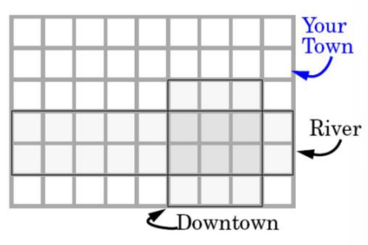Lunar Lander Example

A lunar lander crashes somewhere in your town (one of the cells at random on the grid). The crash point is **uniformly random**. R is the event that it crashes in the river. D is the event that it crashes downtown

• What are P(R), P(D), P(D ∩ R) ?

• What is P(D | R) ?

• What is P(R | D) ?

• What is P(R ∩ D) / P(D) ?

Conditional Probability

• Useful to remember “the chain rule”:

P(A ∩ B) = P(A | B) P(B) (product rule).

Exercise: Prove that P(A ∩ B) <= P(A) for any events A and B.

P(W) = 0.001

P(S | W) = 0.5

P(L | S ∩ W) = 0.1

What is P(W ∩ S ∩ L)?

Combining what we know

If P(A1 ∪ A2 ∪ ... An) = 1, and for all i, j unequal, P(Ai ∩Aj)=0

THEN we know:

P(B) = P(B ∩ A1) + P(B ∩ A2) + ... + P(B∩An)

P(B∩A) = P(B|A) P(A)

• So ... • P(B) = P(B|A1)P(A1) + P(B|A2)P(A2) + ... + P(B|An) P(An)

Example

My mood can take one of two values: **Happy, Sad**.

The weather can take one of three values: **Rainy, Sunny, Cloudy**.

My knowledge base says.

• P(Mood=**Happy** and Weather=**Rainy** ) = 0.2

• P(Mood=**Happy** and Weather=**Sunny** ) = 0.1

• P(Mood=**Happy** and Weather=**Cloudy** ) = 0.4

• Can I compute P(Mood=**Happy**)?

• Can I compute P(Mood=**Sad**)?

• Can I compute P(Weather=**Rainy**) ?

**Random Variable**

• A **random variable** is some aspect of the world about which we(may) have uncertainty

• R = Is it raining?

• T = Is it hot or cold?

• D = How long will it take to drive to work?

• We denote **random variables** with capital letters X

• Like variables in a CSP, random variables have domains

• R in {true, false}

• T in {hot, cold}

• D in [0, infinity)

Random Variable

• A **random variable** X is **a function** from the sample space Ω into the real numbers

• **Probability function**: PX(X = xi) = P( {sj ∈Ω : X(sj) = xi})

• Example:

• Toss two coins:

• Define a random variable X to be the number of heads obtained

• [H, H], [H,T], [T, T,] [T, H]

• P(X = 1) = P({[H, T], [T, H]}) = P([H, T]) + P([H, T]) =1/2

Probability Distributions

• Three coin tosses

• Define random variable X as the number of heads

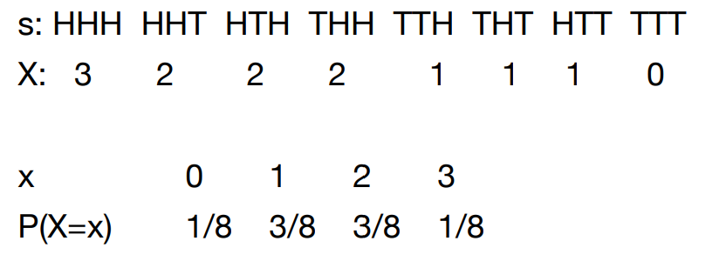

Probability Distributions

• Associate a probability with each value

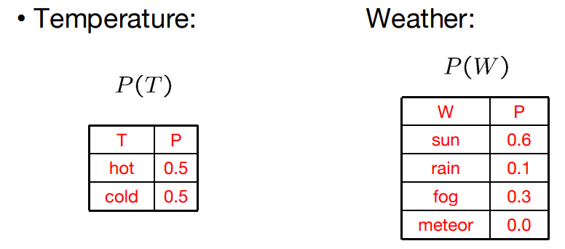

Probability Mass Function

• The probability mass function of a discrete random variable is defined as,

fX(x) = P(X=x) for all x

**Bernoulli distribution:**

Takes the value 1 with probability p and thevalue0withprobability q=1-p

fX(x;p) = p if x = 1 or q if x = 0

Bayes Rule

• Named after Thomas Bayes, describes the probability of an event, based on prior knowledge of conditions that might be related to the event.

**Prior + Likelihood -> Posterior**

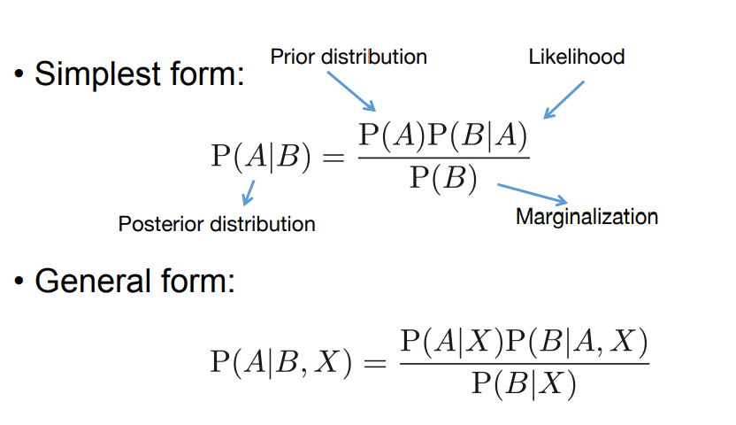

Generalizing Bayes Rule

• If we know that exactly one of A1 , A2, ..., An are true, then:

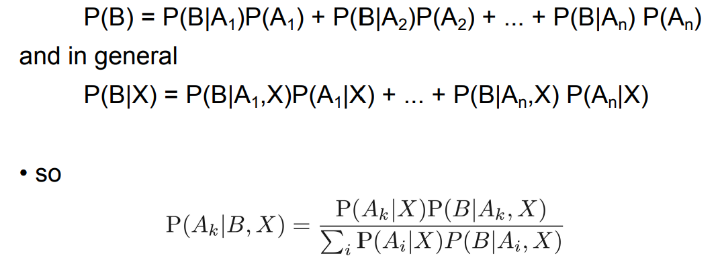

Medical Diagnosis

A doctor knows that meningitis causes a stiff neck **50%** of the time.

The doctor knows that if a person is randomly selected from the US population, there’s a **1/50,000** chance the person will have meningitis.

The doctor knows that if a person is randomly selected from the US population, there’s a **5%** chance the person will have a stiff neck.

You walk into the doctor complaining of the **symptom** of a stiff neck. What’s the probability that the underlying cause is meningitis?

Example

• I have three identical boxes labeled H1, H2 and H3.

**• Into H1 I place 1 black bead, 3 white beads.**

**• Into H2 I place 2 black beads, 2 white beads.**

**• Into H3 I place 4 black beads, no white beads.**

I draw a box at random. I remove a bead at random from that box. What can I deduce from the color of the bead as to which box I drew?

If I replace the bead, then redraw another bead at random from the same box, how well can I predict its color before drawing it?

• These two questions are the foundations of reasoning with **uncertainty** and **machine learning**.

Bayesian Rule

A nice way to look at this

H1 , H2 and H3 were my prior models of the world. The fact that P(H1) =1/3, P(H2)= 1/3, P(H3) = 1/3 was my **prior distribution**.

The color of the bead was a piece of **evidence** about the true model of the world.

The use of Bayes’ rule was a piece **of probabilistic inference**, giving me a posterior distribution on possible worlds. Learning is prior + evidence ---> posterior

•A piece of evidence decreases my ignorance about the world.

•Distributions are good ways of describing your **state of knowledge**. Knowledge that includes uncertainty measure can mean much better decision-making.

Joint Probability Distribution

• Given two random variables, the joint probability distribution is the corresponding probability distribution on all possible pairs of output

• E.g., tossing two coins P(A) = 1/2 for A ∈ {0, 1} P(B) = 1/2 for B ∈ {0, 1} P(A=1, B=1) = ¼

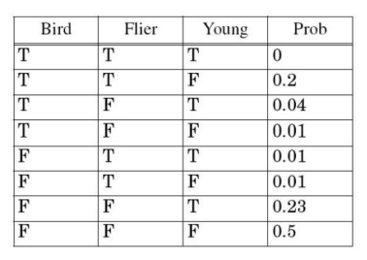Another example

• Suppose we will wish to reason about **flying ability, birdhood** and **youth in animals**

• We can set up or knowledge base as a probability distribution before we receive any information about an animal

• Each row is a prior hypothesis about the state of the animal.

Marginalizing

• Joint Probability Distribution:

• Its probabilities must add up to 1. It defines all basic conjunctive probabilities,

e.g: P(Bird = T, Flier=F, Young=T) = 0.04

• We can compute **marginal probabilities** (probabilities for subsets of variables taking specified values) easily...

e.g. P(Bird =T, Young=F)

• Marginalization,

P(Y) = Σz∈Z P(Y, z),

Marginalizing

• **Handy tip**: For P(expression), just find the rows that match the expression, and add up the associated probabilities.

• We can compute conditional probabilities with ease. e,g,.: P(Y|B and ~F)=

• **Handy tip**: For P(this|that), just do two marginals: P(this and that) and P(that). Then compute their ratio!

Conditional probabilities from the joint distribution

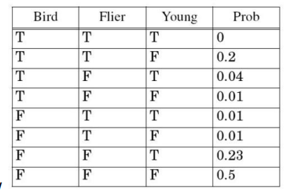• Let x1 , x2... be values True or False

• P(X1=x1 ,X2=x2,...,Xn=xn, |Xn+1=xn+1,...,Xn+k = xn+k) =

sum of all entries for which X1=x1 ,X2=x2,...,Xn+k=xn+k / sum of all entries for which Xn+1=xn+1 ,...,Xn+k=xn+k

• P(B=False | F=True, Y=False) = P(B=False, F=True, Y=False) / P(B=True, F=True, Y=False) + P(B=False, F=True, Y=False) = 0.1/0.21 = 1/21

Another Example

• Three Boolean variables

• **Toothache**: the patient has a toothache

• **Cavity**: the patient has a cavity

• **Catch**: the dentist catches in the patients tooth with his nasty steel probe

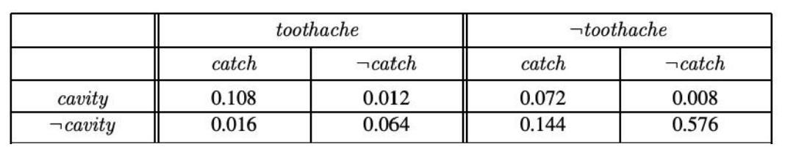

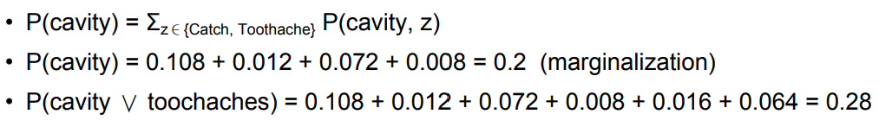

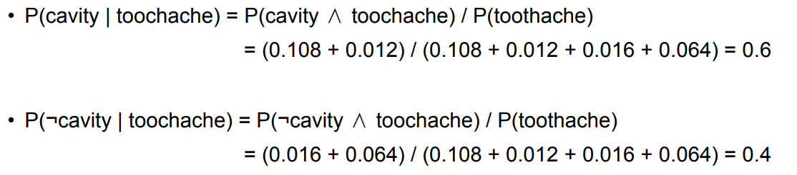

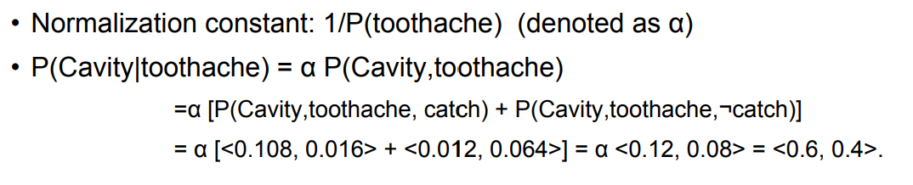

A general inference procedure

• E: the list of **evidence variables**

• e: the list **of observed values** for them,

• Y be the remaining **unobserved variables**

• The query can be computed as: P(X|e) = α P(X, e) = α ΣyP(X, e, y)

The joint probability distribution

• Contains all the **domain knowledge** you’ll need for any conditional probability.

• What’s the probability that it’s young given that it either flies and is a bird?

• I took an animal. I don’t know what they were, but it is definitely young. What’s the chance it is a bird?”

• Joint probability distributions are a great way of describing knowledge.

• Question: What’s the big problem with this?

Using fewer numbers

Suppose there are two events:

**M : Mr. M teaches algebra**

**S : It is sunny**

The joint p.d.f for these events contain **four entries**.

If we want to build the joint p.d.f we’ll have to invent **those four numbers**.

We don’t have to specify with bottom level conjunctive events such as P(not M and S) IF instead it may sometimes be more convenient for us to specify things like: P(M) , P(S).But just P(M) and P(S) don’t derive the joint distribution. So you can’t answer all questions.

**What extra assumption** can you make?

Independence

• “The sunshine levels do not depend on and do not influence who is teaching.”

This can be specified very simply: P(S | M) = P(S)

This is a powerful statement! It required extra domain knowledge. A different kind of knowledge than p.d.f.s

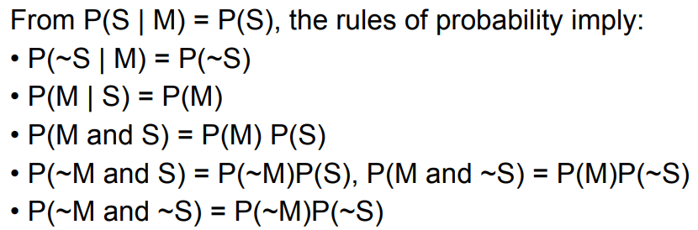

Independence

• We’ve stated P(M) = 0.6, P(S) = 0.3, P(S | M) = P(S) From these two numbers, and an independence assumption, we can derive the full joint pdf.

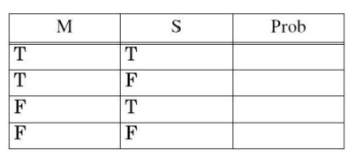

And since we now have the joint pdf, we can make any queries we like.

A more interesting case

Suppose there are three events:

**M: Mr. M teaches algebra (otherwise it's Mr. B)**

**S : It is sunny**

**L : The lecturer arrives slightly late**

Assume both lecturers are sometimes delayed by bad weather. And Mr. B is more likely to arrive late than Mr. M. Let’s begin with writing down knowledge we’re happy about:

P(S | M) = P(S), P(S) = 0.3, P(M) = 0.6

Now**, lateness is not independent of the weather** and **is not independent of the lecturer**. We must choose what else we need to write down.

We know the joint pdf of S and M, so let’s just write down P(L| S=x, M=y) in the 4 cases.

Assume both lecturers are sometimes delayed by bad weather. And Mr.B is more likely to arrive late than Mr. M.

P(S | M) = P(S) P(S) = 0.3 P(M) = 0.6

P(L | M ^ S) = 0.05 P(L | M ^ ~S) = 0.1

P(L | ~M ^ S) = 0.1 P(L | ~M ^ ~S) = 0.2

Now we can derive a full joint p.d.f with **six numbers** instead of **eight**. (Savings are larger for larger numbers of variables).

Question: Express P(L=x ^ M=y ^ S=z) in terms that only need the above expressions, where x, y and z may each be True or False.

**Probabilistic Reasoning and Methods**

Conditional independence

Suppose we have these three events

**M : Lecture taught by Mr. B**

**L : Lecturer arrives late**

**R : Lecture concerns robots**

Suppose Mr. A has **a higher chance of being late** than Mr. B.

Suppose Mr. A has **a higher chance of giving robotics lectures** than Mr.B. What kind of independence can we find?

How about: P(L | M) = P(L) ? P(R | M) = P(R) ? P(L | R) = P(L) ?

Conditional independence

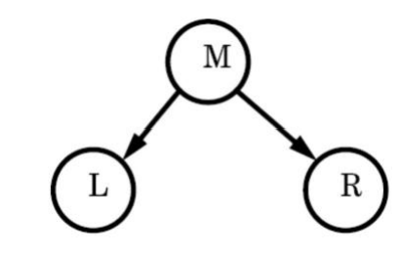• Once you know who **the lecturer** is, then whether they **arrive late** doesn’t affect whether the lecture concerns **robots**.

P(R | M , L) = P(R | M) and P(R | ~M , L) = P(R| ~M)

We express this in the following way: “R and L are **conditionally independent** given M”

Which is also notated by the following diagram.

Given knowledge of M, knowing anything else in the diagram won’t help us with L, etc.

Conditional independence formalized

• R and L **are conditionally independent** given M if

For all x,y,z in {T,F}:

P(R=x | M=y, L=z) = P(R = x | M= y)

Also written as (R⫫L | M)

R and L are **independent events** given M.

Conditional independence formalized

• More generally:

Let S1 and S2 and S3 be **sets of variables**.

Set-of-variables S1 and set-of-variables S2 are **conditionally independent**

given S3 if for all assignments of values to the variables in the sets,

P(S1’s assignments | S2’s assignments and S3’s assignments) =P(S1’s assignments | S3’s assignments)

Factorizing into Marginals

• Can be expressed in slightly different way P(R, L | M) = P(R|L, M)P(L|M) = P(R|M) P(L|M)

• That is **joint distribution** factorizes into product of **marginals**.

Conditional Independence

• We can write down P(M). And then, since we know L is only directly influenced by M, we can write down the values of P(L|M) and P(L|~M) and know we’ve fully specified L’s behavior. Same for R.

• P(M) = 0.6

• P(L | M) = 0.085

• P(L | ~M ) = 0.17

• P(R | M) = 0.3

• P(R | ~M ) = 0.6

‘R and L conditionally independent given M’.

**Conditional Independence:**

• P(R|M , L) = P(R|M) ,

• P(R | ~M , L) = P(R | ~M)

Once again, we can obtain any member of the **joint probability distribution** that we desire:

• P(L, R, M) = ???

A Bayes Net

• **Bayes’ nets**: a technique for describing complex joint distributions (models) using simple, local distributions (**conditional probabilities**)

• More properly **called graphical models**

• We describe how variables locally interact

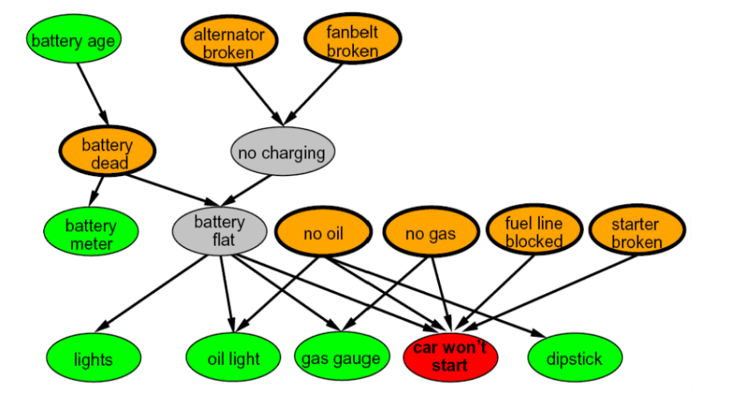• **Local** interactions chain together to **give global, indirect interactions**

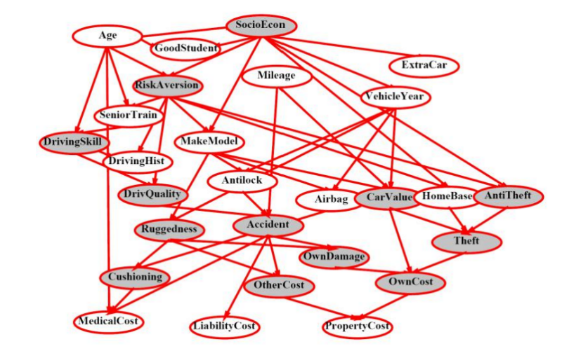

A Bayes Net

• Represents a set **of variables** and their **conditional dependencies** via a **directed acyclic graph**

• **Nodes** represent **variables**,

• Can be assigned (**observed**) or unassigned (**unobserved**)

• **Edges** represent **conditional dependencies**

• Similar to CSP constraints

• Nodes that are not connected represent variables that are **conditionally independent** of each other

• For example, a Bayes network could represent the probabilistic relationships between diseases and symptoms

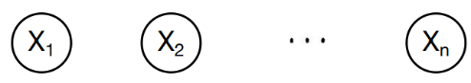Example: Coin Flips

• N **independen**t coin flips.

• No interactions between variables: **absolute independence**.

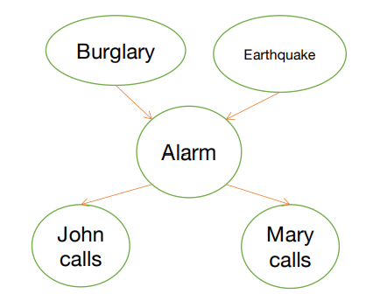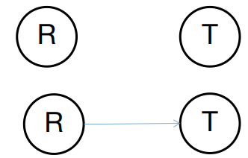Example: Traffic

• Variables:

• R: It rains • T: There is traffic

• Model 1: independence

• Model 2: rain causes traffic

• Why model 2 is better?

Example: Alarm Network

• Variables: • B: Burglary • A: Alarm goes off • M: Mary calls • J: John calls • E: Earthquake!

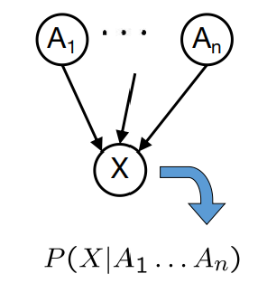Bayes’ Net Semantics

• **Variables**: a set of nodes, one per variable X

• A directed, acyclic graph

• A **conditional distribution** for each node

• A collection of distributions over X, one for each combination of parents’ values

• CPT: conditional probability table

• Description of a noisy “causal” process

• **A Bayes net = Topology (graph) + Local Conditional Probabilities**.

Probabilities in BNs

• Bayes’ nets **implicitly** encode **joint distributions**

• As a product of **local conditional distributions**

• To see what probability a BN gives to a full assignment, multiply all the relevant conditionals together:

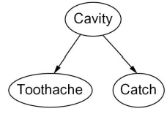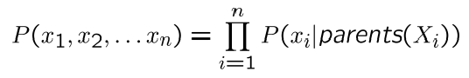

Example:

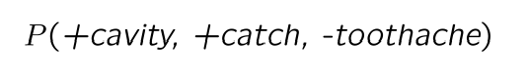

Probabilities in BNs

• Why are we guaranteed that setting



results in **a proper joint distribution**?

• Chain rule (valid for all distributions): 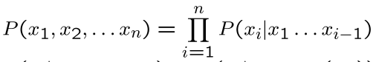

• Assume **conditional independences**: 

• Consequence: 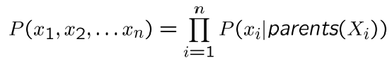

Example: Coin-Flips

**Only distributions whose variables are absolutely independent can be represented by a Bayes’ net with no arcs.**

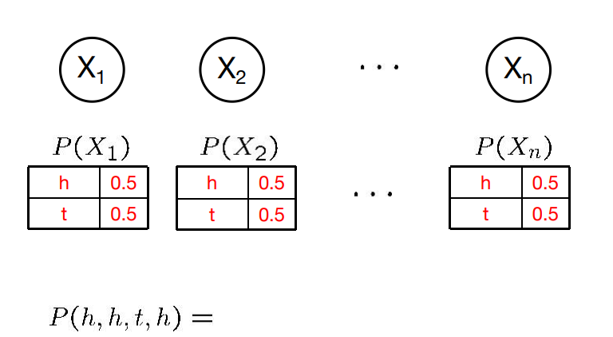

Example: Traffic

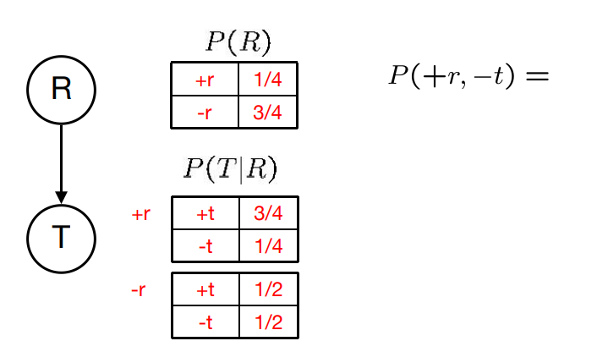

• Causal direction

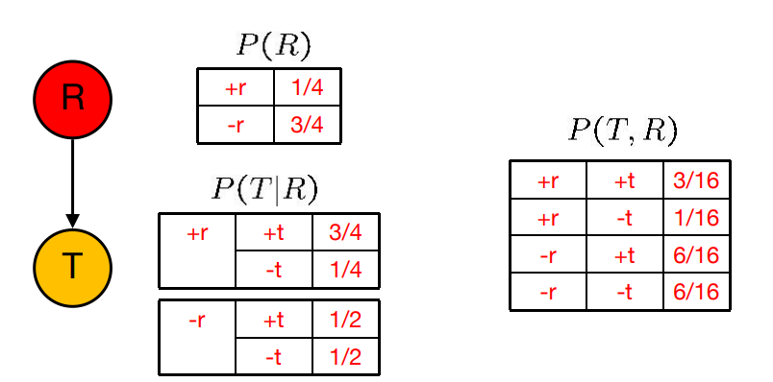

• Reverse causality?

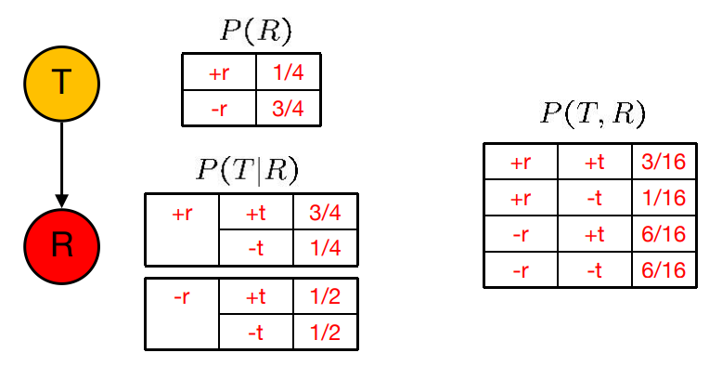

• Reverse causality?

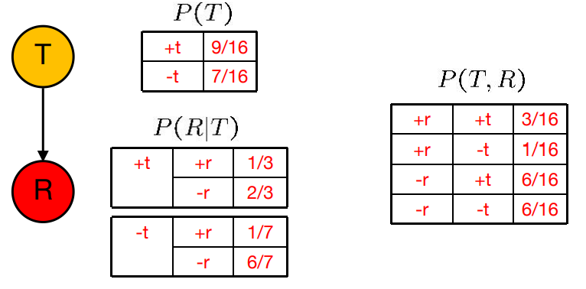

• BNs need not actually be causal

Example: Alarm Network

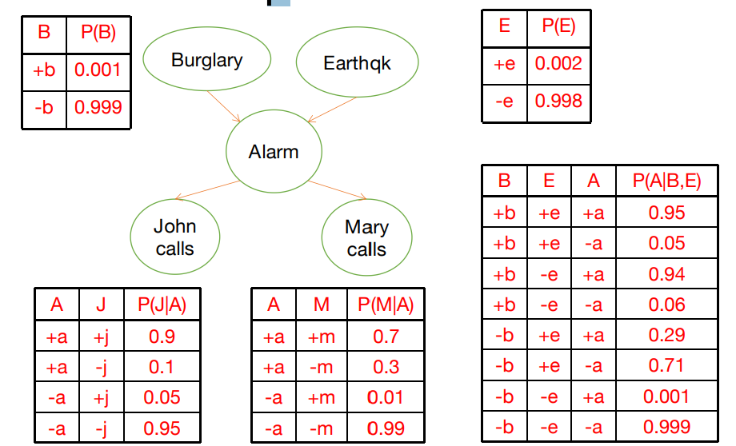

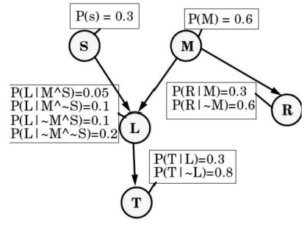A Bayes Net

Suppose:

**T** : The lecture started by 10:35

**L** : The lecturer arrives late

**R** : The lecture concerns robots

**M** : The lecturer is Mr. M

**S** : It is sunny

T only directly influenced by L (i.e. T is **conditionally independent** of R,M,S given L)

L only directly influenced by M and S (i.e. L is **conditionally independent** of R given M & S)

R only directly influenced by M (i.e. R is **conditionally independent** of L, S, given M) M and S are **independent**.

A Bayes Net

• Two **unconnected variables** still can affect each other.

• Each node is **conditionally independent** of anyone earlier in the tree, **given its parents**

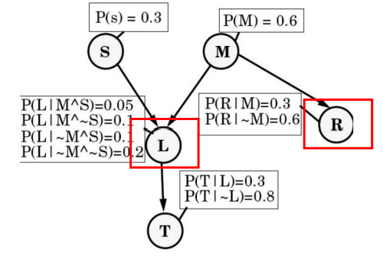• You can deduce many other conditional independence relations from a Bayes net.

Building a Bayes Net

We will place an ordering on nodes (call them X1 , X2 ... Xn ), such that:

X1 has no parents,

Parents(Xi) is a subset of {X1 , X2 , ... Xi-1 }

This can always be done for any **acyclic graph**. There are usually multiple solutions. To make a **Bayes Net,** follow these rules

1. Choose a set of relevant variables.

2. Choose an ordering for them X1 .. Xn

3. While there are variables left:

1. Pick Xi and add a node to the network

2. Set Parents(Xi) to be a **minimal set of already-added nodes** such that we have **conditional independence** of Xi and all other members of {X1 ... Xi-1 } given Parents(Xi)

3. Define the conditional prob. table of P(Xi=x | Assignments of Parents(Xi)).

Computing with a Bayes Net

• The first thing we might want to do is compute an entry in **a joint probability table**

• Given an assignment of truth values to our variables, what is the probability ?

E.g., What is P(S, ~M, L, ~R, T)?

What you should know

• The meanings of **independence** and **conditional independence**

• The definition of a **Bayes net**

• Computing probabilities of assignments of variables(i.e. members of the **joint p.d.f**) with a bayes net

• The method for computing arbitrary conditional probabilities

**Bayesian Networks: Conditional Independencies**

Probability Recap

♣ Conditional probability: 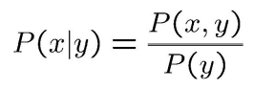

♣ Product rule: 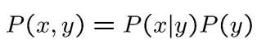

♣ Chain rule: 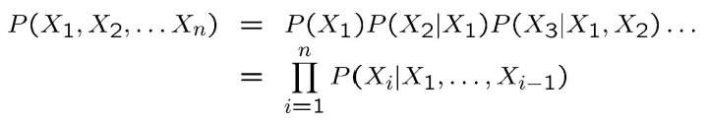

♣ X, Y independent if and only if: 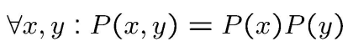

♣ X and Y are conditionally independent given Z if and only if:



A Bayes Net

• A **directed, acyclic** graph, one node per **random variable**

• A **conditional probability table** (CPT) for each node

• A collection of distributions over X, one for each combination of parents’ values

• **Bayes’ nets** implicitly encode **joint distributions**

• As a product of **local conditional distributions**

• To see what probability a BN gives to a full assignment, multiply all the relevant conditionals together: 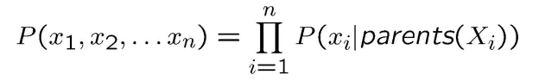

A Bayes Net

Suppose:

**T** : The lecture started by 10:35

**L** : The lecturer arrives late

**R** : The lecture concerns robots

**M** : The lecturer is Mr. M

**S** : It is sunny

T only directly influenced by L (i.e. T is **conditionally independent** of R,M,S given L)

L only directly influenced by M and S (i.e. L is **conditionally independent** of R given M & S)

R only directly influenced by M (i.e. R is **conditionally independent** of L, S, given M) M and S are **independent**.

A Bayes Net

• Two **unconnected variables** still can affect each other.

• Each node is **conditionally independent** of anyone earlier in the tree, **given its parents**

• You can deduce many other conditional independence relations from a Bayes net.

Building a Bayes Net

We will place an ordering on nodes (call them X1 , X2 ... Xn ), such that:

X1 has no parents,

Parents(Xi) is a subset of {X1 , X2 , ... Xi-1 }

This can always be done for any **acyclic graph**. There are usually multiple solutions. To make a **Bayes Net,** follow these rules

1. Choose a set of relevant variables.

2. Choose an ordering for them X1 .. Xn

3. While there are variables left:

1. Pick Xi and add a node to the network

2. Set Parents(Xi) to be a **minimal set of already-added nodes** such that we have **conditional independence** of Xi and all other members of {X1 ... Xi-1 } given Parents(Xi)

3. Define the conditional prob. table of P(Xi=x | Assignments of Parents(Xi)).

Computing with a Bayes Net

• The first thing we might want to do is compute an entry in **a joint probability table**

• Given an assignment of truth values to our variables, what is the probability ?

E.g., What is P(S, ~M, L, ~R, T)?

What you should know

• The meanings of **independence** and **conditional independence**

• The definition of a **Bayes net**

• Computing probabilities of assignments of variables(i.e. members of the **joint p.d.f**) with a bayes net

• The method for computing arbitrary conditional probabilities

What Independencies does a Bayes Net Model?

• In order for a **Bayesian network** to model a probability distribution, the following must be true by definition:

Each variable is conditionally independent of all its non descendants in the graph **given the value of all its parents**.

• This implies: 

• But what else does it imply?

Independence in a BN

• Important question about a BN:

• Are two nodes **independent** given certain **evidence?**

• If yes, can prove using algebra (tedious in general)

• If no, can prove with a counter example

• Example: 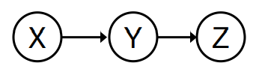

• Question: are X and Z necessarily **independent?**

• Answer: **no**. Example: **Easy exam** causes **Get A**, which causes **Get recommended**.

• X can influence Z, Z can influence X (via Y)

• They could be independent: how?

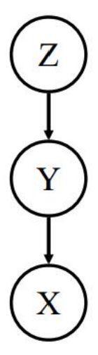Independence in a BN

• Given Y, does learning the value of Z tell us nothing new about X?

I.e., is P(X|Y,Z) equal to P(X|Y)

**Yes**. Since we **know the value of all of X's parents (namely, Y),** and Z is not a descendant of X, X is conditionally independent of Z.

Also, since independence is symmetric, P(Z|Y,X) = P(Z|Y)

Quick proof that independence is symmetric

• Assume: P(X|Y, Z) = P(X|Y)

• Then:

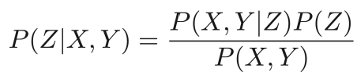 (Bayes Rule)

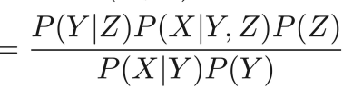 (Chain Rule)

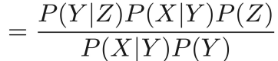 (By Assumption)

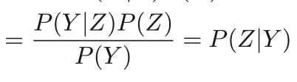 (Bayes Rule)

D-separation

Theorem [Verma & Pearl, 1998]: If a set of **evidence variables E** d-separates **X and Z** in a Bayesian network’s graph, **then (X ⫫ Z | E).**

**D-separation**: a condition / algorithm for **automatically** inferring whether learning the value of one variable might give us any additional hints about some other variable, given what we already know. Study **independence properties** for triples.

Causal Chains

• This configuration is a “causal chain”

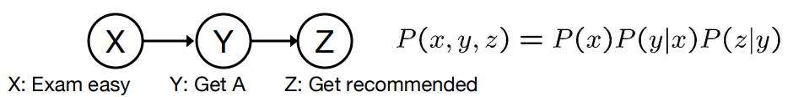

• **Guaranteed X independent of Z ?** No!

• One example set of CPTs for which X is not independent of Z is sufficient to show this independence is not guaranteed.

• Example:

• **Exam easy** causes **Get A** causes **Get recommended.**

• In numbers: P( +y | +x ) = 1, P( -y | -x ) = 1,

P( +z | +y ) = 1, P( -z | -y ) = 1

Causal Chains

• This configuration is a “causal chain”



• **Guaranteed X independent of Z given Y?** Yes!

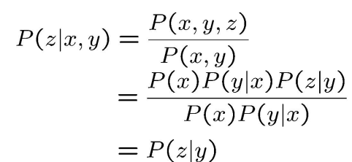

Evidence along the chain “blocks” the influence

Common Cause

• This configuration is a “common cause”

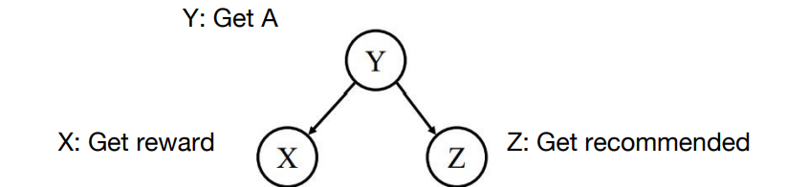

• Guaranteed X independent of Z ? No! 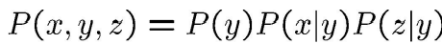

• One example set of CPTs for which X is not independent of Z is sufficient to show this independence is not guaranteed.

• Example:

• **Get A** causes both **Get reward** and **Get recommended**

• In numbers:

• P( +x | +y ) = 1, P( -x | -y ) = 1,

• P( +z | +y ) = 1, P( -z | -y ) = 1

Common Cause

• This configuration is a “common cause”



• Guaranteed X and Z independent given Y? 

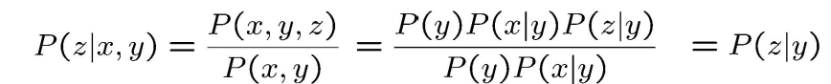

• Observing the cause blocks influence between effects

Common Effect

• Last configuration: two causes of one effect (v-structures)

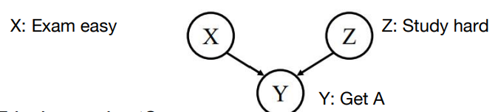

• Are X and Z independent?

• **Yes: Exam easy and Study hard** cause **Get A**, but they are not correlated

• Are X and Z independent given Y?

• **No**: seeing **Get A** puts **Exam easy and Study** **hard** in competition as explanation.

• **This is backwards from the other cases**

• Observing an effect **activates** influence between possible causes

The General Case

• General question: in a given BN, are two variables independent (given evidence)?

• Solution: analyze the graph

• Any complex example can be broken into repetitions of the three canonical cases

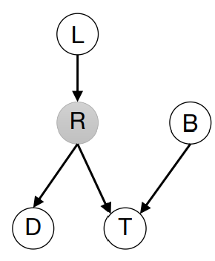Reachability

• Recipe: shade evidence nodes, look for paths in the resulting graph

• Place balls on one of the variables

• If any ball can reach another random variable, then they are not conditionally independent, otherwise they are

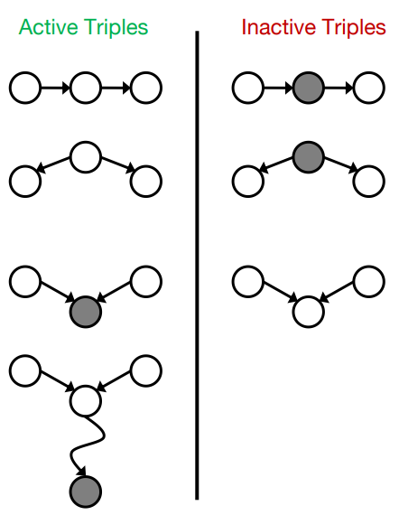Active / Inactive Paths

• **Question:** Are X and Y conditionally independent given evidence variables {Z}?

• Yes, if X and Y “d-separated” by Z

• Consider all (undirected) paths from X to Y

• No active paths = independence!

• A path is **active** if each triple is **active**:

• **Causal chain** A → B → C where B is unobserved (either direction)

• **Common cause** A ← B → C where B is unobserved

• **Common effect** (aka v-structure)

• A → B ← C where B or one of its descendants is observed

**• All it takes to block a path is a single inactive segment**.

Reachability

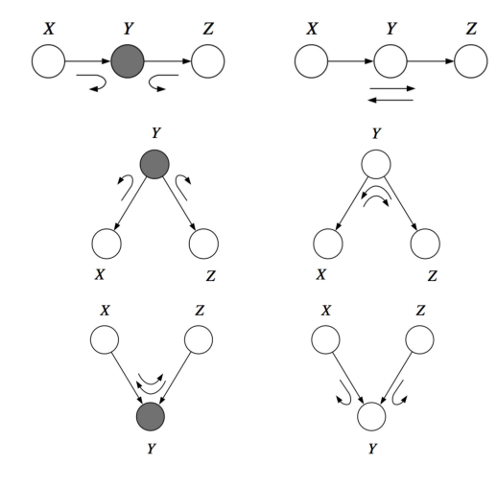

D-Separation

• Query: 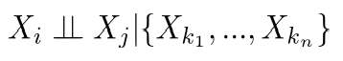

• Check all (undirected!) paths between Xi and Xj.

• If one or **more active**, then **independence** not guaranteed

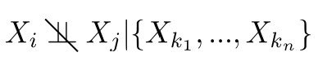

♣ Otherwise (i.e. if all paths are **inactive**), then independence is guaranteed

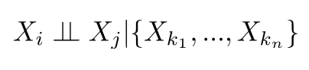

Reachability

• (X1 ⫫ X4 | X2 , X3 ) ?

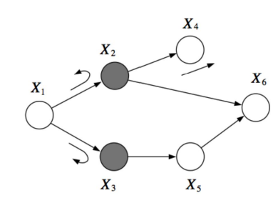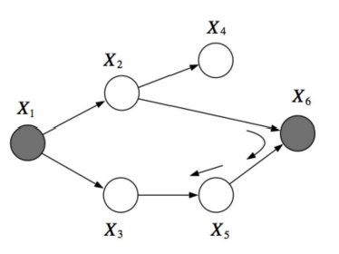

Example

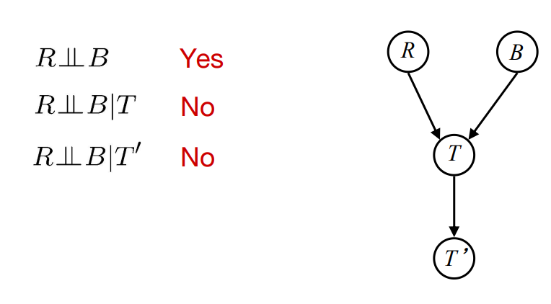

Example

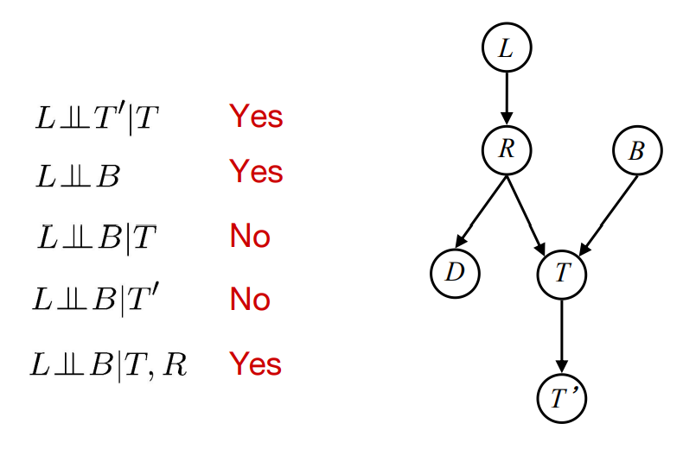

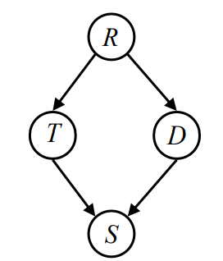Example

• Variables: • R: Raining • T: Traffic • D: Roof drips • S: I’m sad

• Questions:

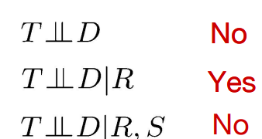

Computing All Independences

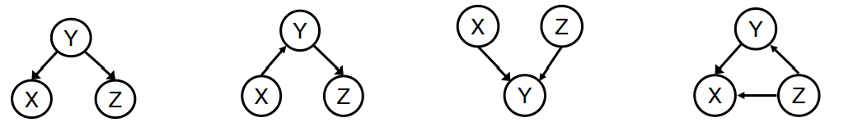

Structure Implications

• Given a Bayes net structure, can run **d-separation** algorithm to build a complete list of conditional independences that are necessarily true of the form

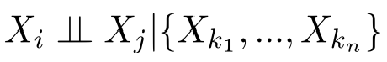

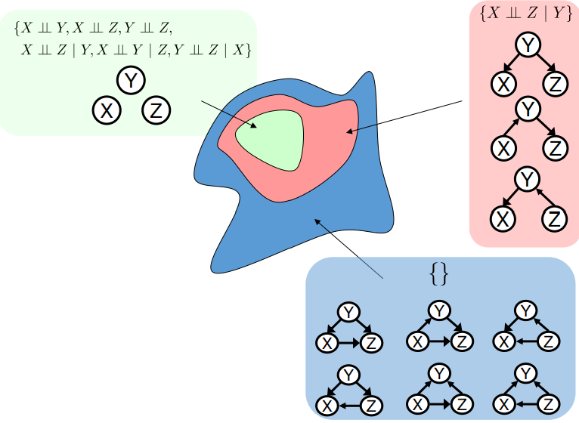• This list determines **the set of probability distributions** that can be represented.

Topology Limits Distributions

• Given some **graph topology G**, only certain joint distributions can be encoded

• **The graph structure guarantees certain (conditional) independences**

• (There might be more independence)

• Adding **arcs** increases the set of distributions, but has several costs

• **Full conditioning can encode any distribution**.

The “Burglar Alarm” example

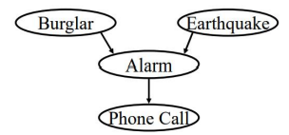

• Your house has a **burglar alarm** that is also sometimes triggered by **earthquakes**

• While you are on vacation, one of your neighbors calls and tells you your home’s burglar alarm is ringing.

• But now suppose you learn that there was a medium-sized earthquake in your neighborhood. Probably not a burglar after all.

• Earthquake **“explains away”** the hypothetical burglar.

• But then it must not be the case that

(Burglar ⫫ Earthquake | Phone Call), even though (Burglar ⫫Earthquake)

More examples

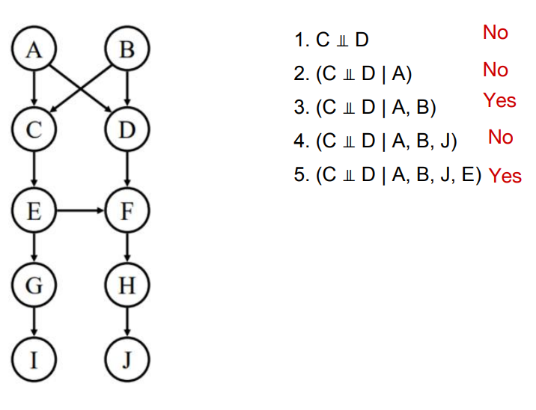

Bayes Nets Representation Summary

• Bayes nets **compactly** encode joint distributions

• Guaranteed independencies of distributions can be deduced from BN graph structure

• **D-separation** gives precise **conditional independence guarantees** from graph alone

• A Bayes’ net’s joint distribution may have further (conditional) independence that is not detectable until you inspect its specific distribution.

**Bayes' Net: Exact Inference**

Bayes Nets Representation Summary

• Bayes nets **compactly** encode joint distributions

• Guaranteed independencies of distributions can be deduced from BN graph structure

• **D-separation** gives precise **conditional independence guarantees** from graph alone

• A Bayes’ net’s **joint distribution** may have further (conditional) independence that is not detectable until you inspect its specific distribution.

Example: Alarm Network

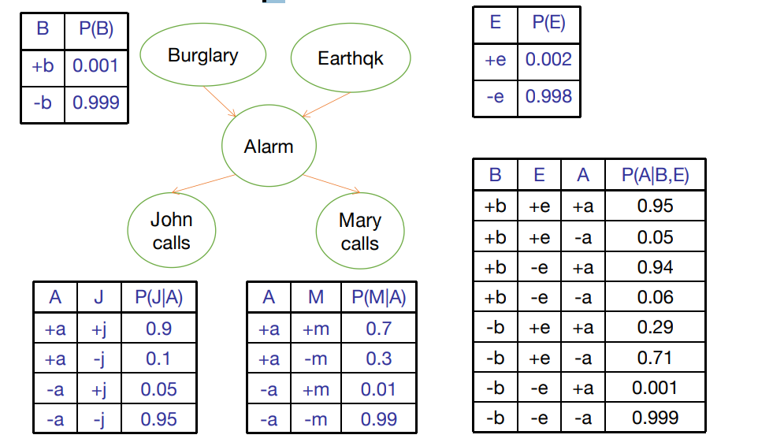

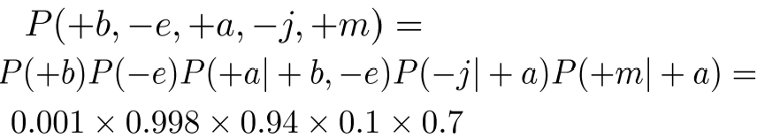

Inference

• Given a Bayesian network, what questions might we want to ask?

• **Conditional probability query**: P(X = x | e)

• Given instantiations for some of the variables (we’ll use e here to stand for the values of all the instantiated variables; it doesn’t have to be just one), what is the probability that node X has a particular value x?

• **Maximum a posteriori probability**: 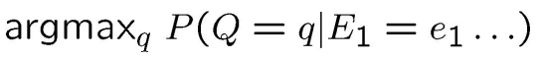

**• General question**: What’s the whole probability distribution over variable X given evidence e, P(X | e)?

Inference

• Probabilistic inference required for P(**outcome|action, evidence**)

• Value of information: which **evidence** to seek next?

• Sensitivity analysis: which probability values are most critical?

• Explanation: why do I need a new starter motor?

Inference

**• Inference**: calculating some useful quantity from a joint probability distribution

• **Exact inference**: • Inference by enumeration • variable elimination

• **Approximate inference**: • Sampling

Inference by Enumeration

• General case:

• Evidence variables: 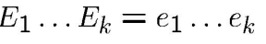

• Query* variable: Q

• Hidden variables: H1, .. Hr

• We want: 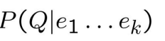

Using the Joint Distribution

• To answer any query involving a conjunction of variables, sum over the variables not involved in the query

• **Marginalization**: 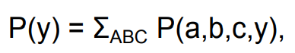

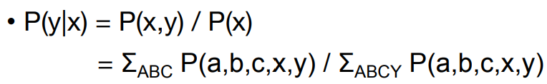

Inference by Enumeration

• Step 1:

• Select the entries **consistent** with the evidence

• Step 2:

• Sum out H to get joint of **Query and evidence** 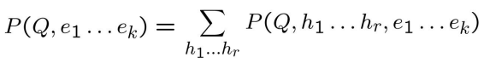

• Step 3:

• Normalize 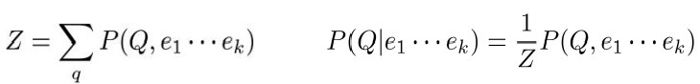

Simple Case

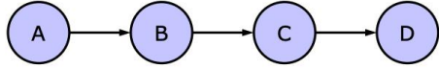

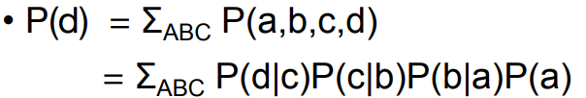

Only need local conditional distributions 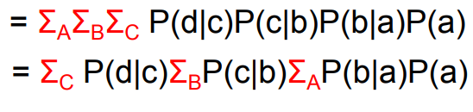

Inference by Enumeration in Bayes’ Net

• Given unlimited time, inference in BNs is easy

• **Inference by enumeration**:

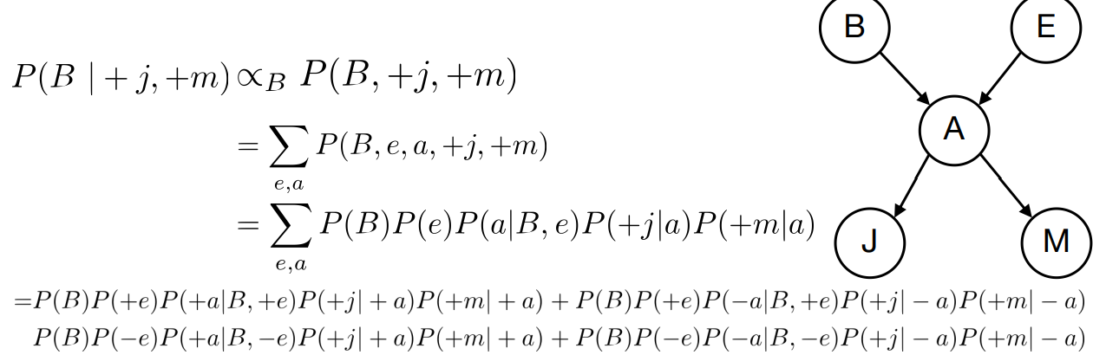

Evaluation tree

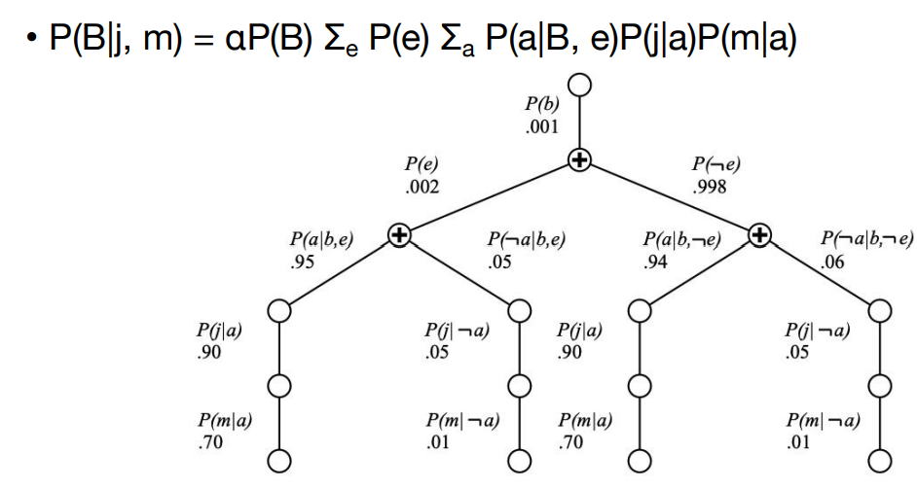

Simple Case



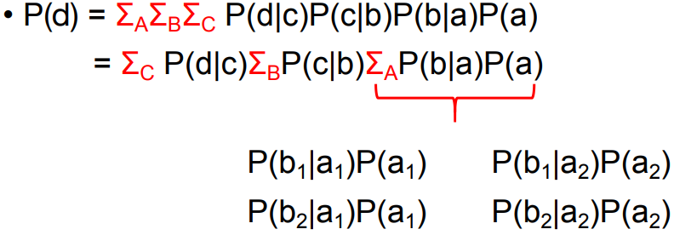

Simple Case

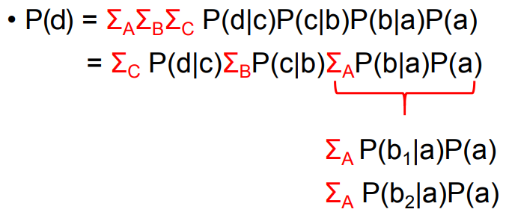

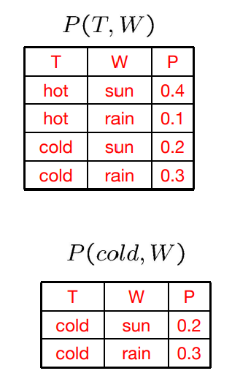Factor

• **Joint distribution**: P(X,Y)

• Entries P(x,y) for all x, y

• Sums to 1

• **Selected joint**: P(x,Y)

• A slice of the joint distribution

• Entries P(x,y) for fixed x, all y

• Sums to P(x)

• Number of capitals = dimensionality of the table.

• **Single conditional**: P(Y|x)

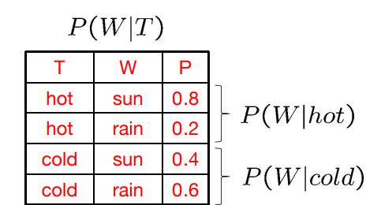• Entries P(y | x) for fixed x, all y • Sums to 1

• **Family of conditionals**: P(X|Y)

• Multiple conditionals

• Entries P(x | y) for all x, y

• Sums to |Y

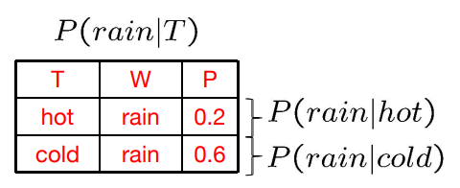• **Specified family**: P( y | X )

• Entries P(y | x) for fixed y, but for all x • Sums to ...

Factor

• In general, when we write P(Y1 …YN | X1 …XM)

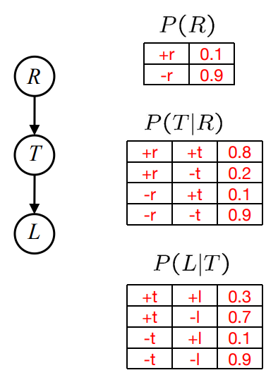• It is a “factor, ” a **multi-dimensional array** • Its values are P(y1 …yN | x1 …xM)

• Any assigned (=lower-case) X or Y is a dimension missing (selected) from the array

Example: Traffic Domain

• Random Variables • R: Raining • T: Traffic • L: Late for class

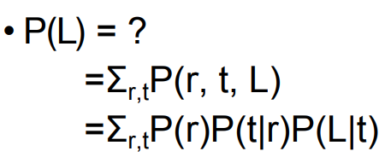

Inference by Enumeration: Procedural Outline

• Track objects called **factors**

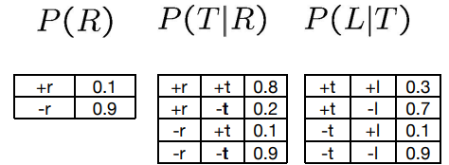• Initial **factors** are local CPTs (one per node)

• Any known values are selected

• E.g. if we know L = +l, the initial factors are

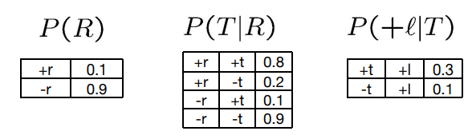

**• Procedure**: Join all factors, then eliminate all hidden variables.

Operation 1: Join Factors

• First basic operation: **joining factors**

• Combining factors:

• **Just like a database join**

• Get all factors over the **joining variable**

• Build a **new factor** over the union of the variables involved

• Example: Join on R

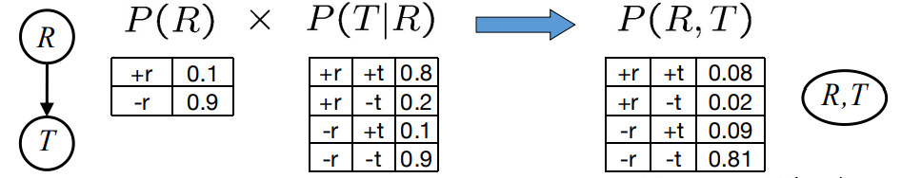

• Computation for each entry: **pointwise products**. 

Example: Multiple Joins

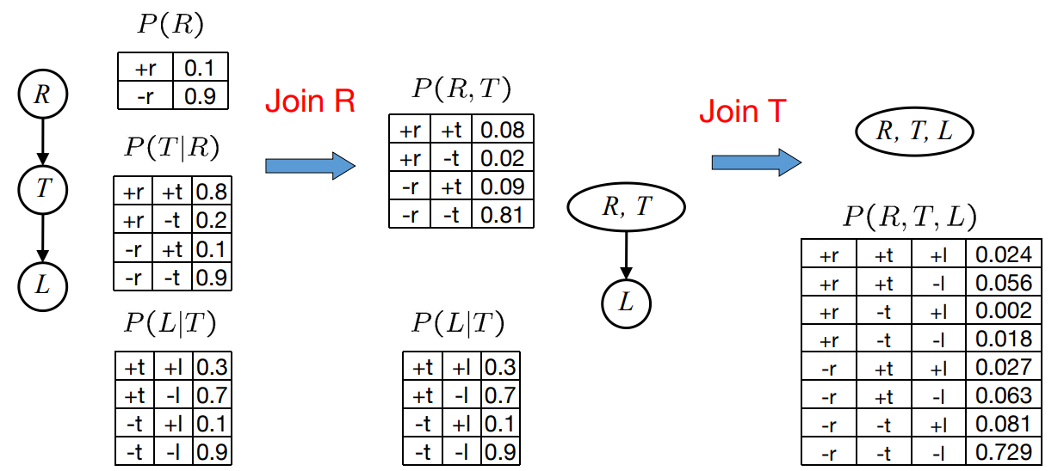

Operation 2: Eliminate

• Second basic operation: **marginalization**

• Take **a factor** and sum out a variable

• Shrinks a factor to a smaller one

• A **projection** operation

• Example: 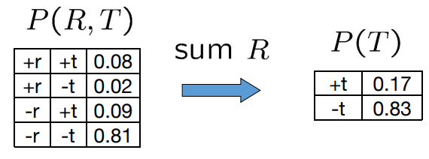

Multiple Elimination

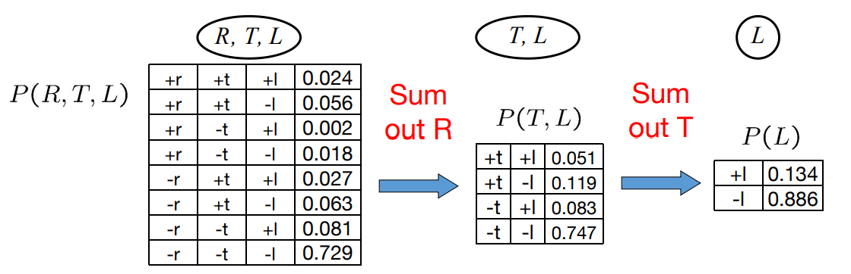

• Multiple Join, Multiple Eliminate (= Inference by Enumeration)

Inference by Enumeration?

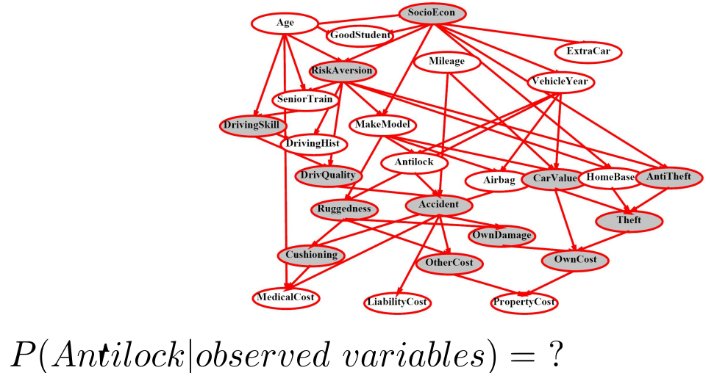

Simple Case

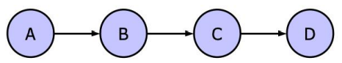

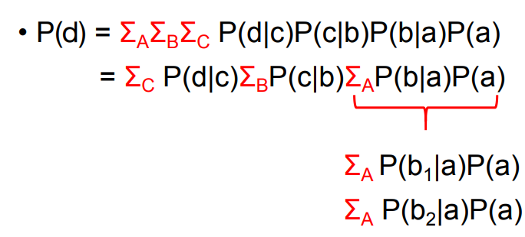

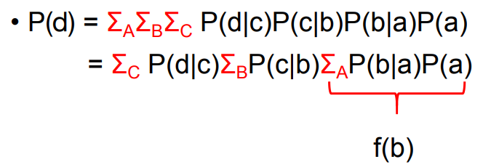

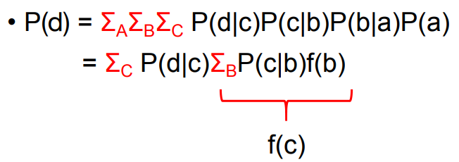

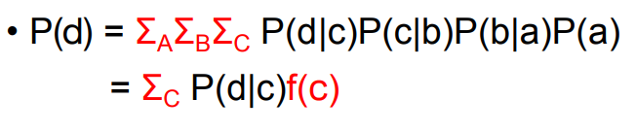

Variable Elimination

• Why is inference by enumeration so slow?

• You join up the whole joint distribution before you sum out the hidden variables

• Idea: interleave joining and marginalizing!

• Called “**Variable Elimination**”

• Still NP-hard, but usually **much faster** than inference by enumeration.

Summary

• Multiple Join, Multiple Eliminate (= Inference by Enumeration)

• Marginalizing Early (= Variable Elimination)

Traffic Domain

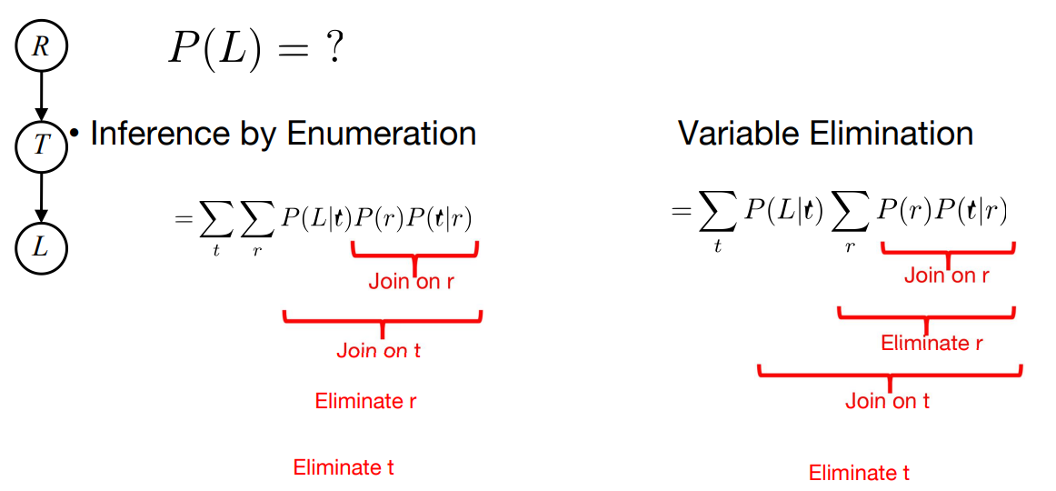

**Bayes' Net: Variable Elimination**

Inference by Enumeration

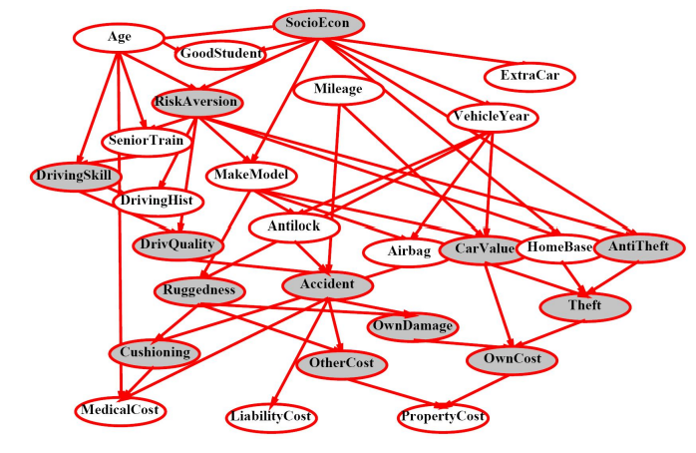

P (Antilock | observed variables) = ?

Variable Elimination

• Why is inference by enumeration so slow?

• **You join up** the whole joint distribution before you sum out the hidden variables

• Idea: interleave joining and marginalizing!

• Called “Variable Elimination”

• Still NP-hard, but usually much faster than inference by enumeration

Factor I

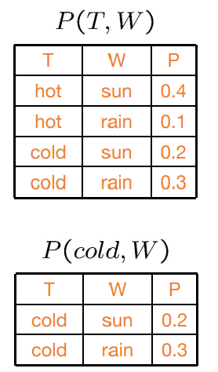• Joint distribution: P(X,Y)

• Entries P(x,y) for all x, y • Sums to 1

• Selected joint: P(x,Y)

• A slice of the joint distribution

• Entries P(x,y) for fixed x, all y • Sums to P(x)

• Number of capitals = dimensionality of the table

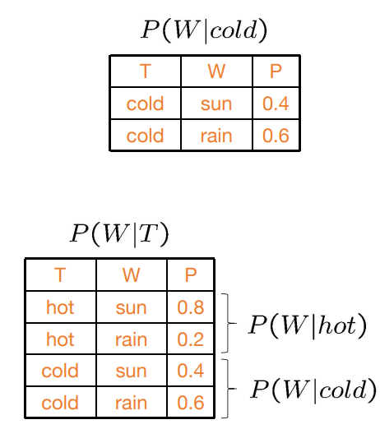Factor II

• Single conditional: P(Y | x)

• Entries P(y | x) for fixed x, all y

• Sums to 1 • Family of conditionals: P(X |Y)

• Multiple conditionals

• Entries P(x | y) for all x, y

• Sums to |Y|

Factor III

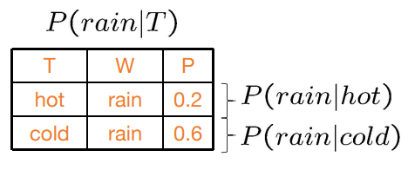• Specified family: P( y | X )

• Entries P(y | x) for fixed y, but for all x

• Sums to … who knows!

Summary

• In general, when we write P(Y1 …YN | X1 …XM)

• It is a “factor, ” a multi-dimensional array

• Its values are P(y1 …yN | x1 …xM)

• Any assigned (=lower-case) X or Y is a dimension missing (selected) from the array.

 Example: Traffic Domain

• Random Variables • R: Raining • T: Traffic • L: Late for class



Inference by Enumeration: Procedural Outline

• Track objects called **factors**

• Initial **factors** are local CPTs (one per node)

• Any known values are selected

• E.g. if we know L = +l, the initial factors are



**• Procedure**: Join all factors, then eliminate all hidden variables.

Operation 1: Join Factors

• First basic operation: **joining factors**

• Combining factors:

• **Just like a database join**

• Get all factors over the **joining variable**

• Build a **new factor** over the union of the variables involved

• Example: Join on R



• Computation for each entry: **pointwise products**. 

Example: Multiple Joins



Operation 2: Eliminate

• Second basic operation: **marginalization**

• Take **a factor** and sum out a variable

• Shrinks a factor to a smaller one

• A **projection** operation

• Example: 

Multiple Elimination



Summary

• Multiple Join, Multiple Eliminate (= Inference by Enumeration)

• Marginalizing Early (= Variable Elimination)

Traffic Domain



Marginalizing Early! (aka VE)

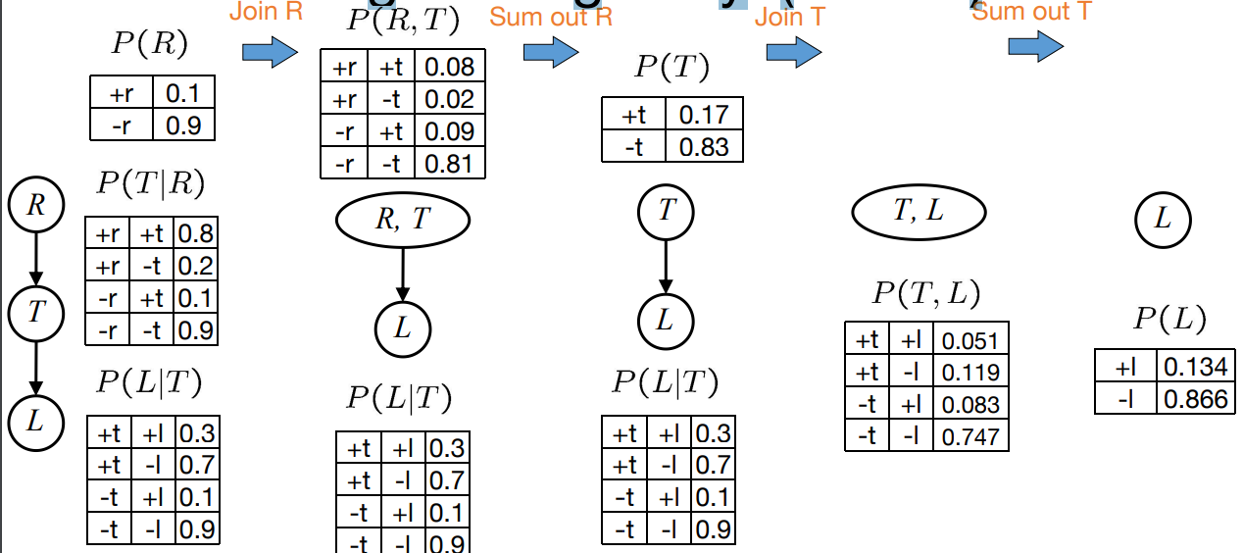

Evidence

• If evidence, start with factors that select that evidence

• No evidence uses these initial factors:

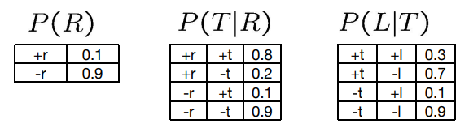

• Computing 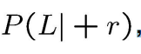 , the initial factors become

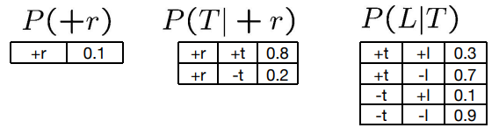

Evidence II

• Result will be a selected joint of query and evidence

• E.g. for P(L | +r), we would end up with:

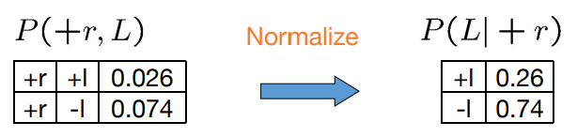

• To get our answer, just normalize this! • That ’s it!

General Variable Elimination

• Query: 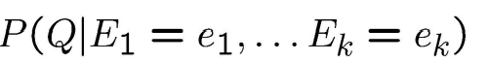

• Start with initial factors:

• Local CPTs (but instantiated by evidence)

• While there are still hidden variables (not Q or evidence):

• Pick a hidden variable H

• Join all factors mentioning H

• Eliminate (sum out) H

• Join all remaining factors and normalize

Example

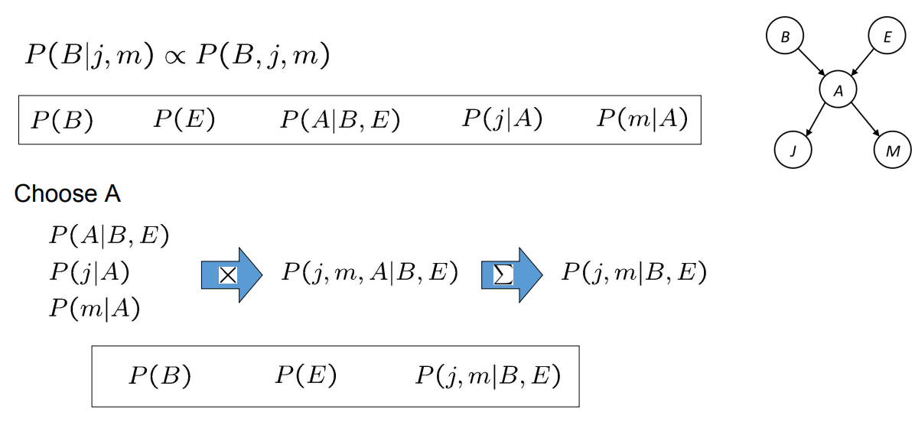

Example

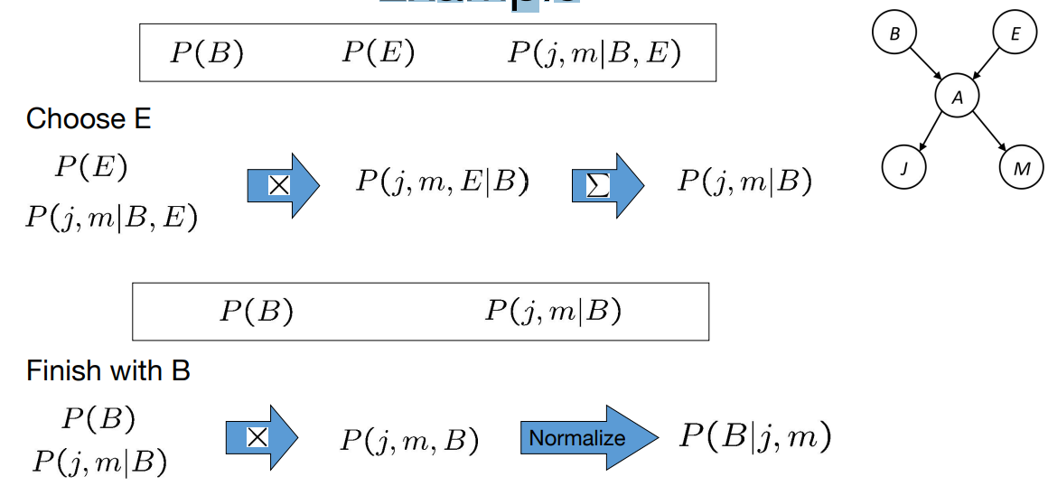

Example 2: P(B|a)

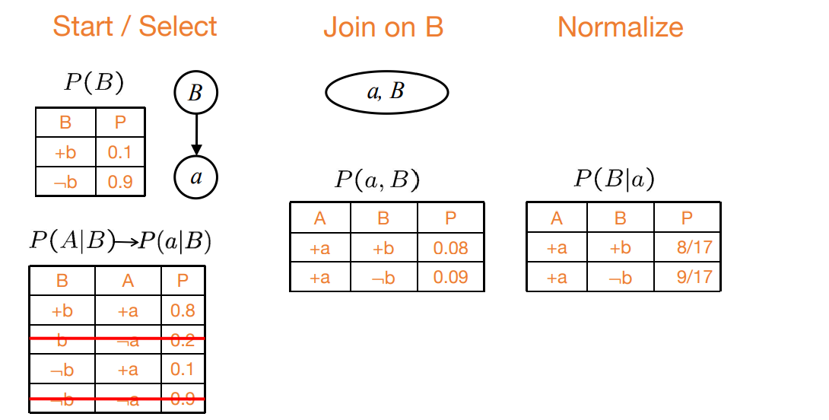

Same Example in Equations

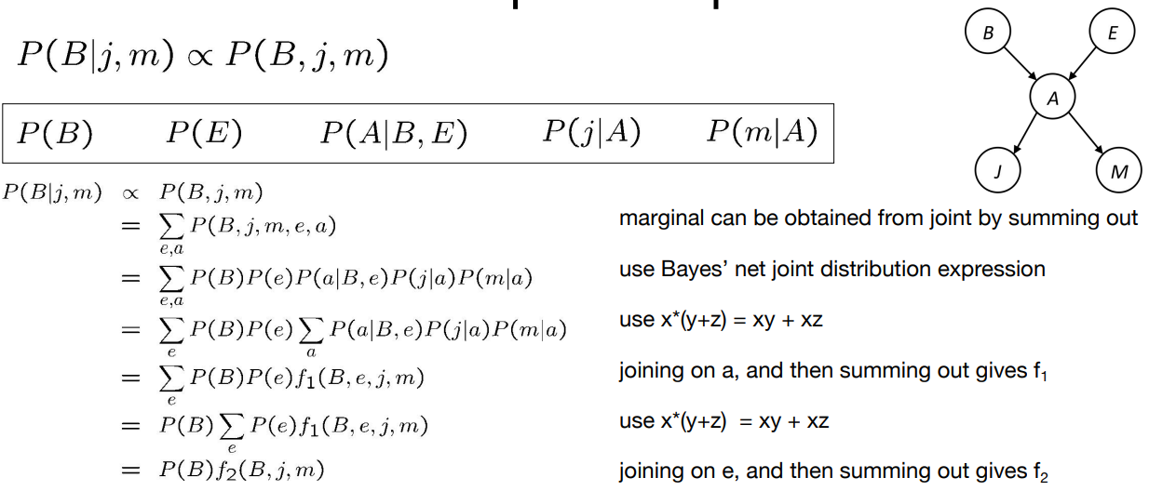

All we are doing is exploiting uwy + uwz + uxy + uxz + vwy + vwz + vxy +vxz = (u+v)(w+x)(y+z) to improve computational efficiency!

Another Variable Elimination Example

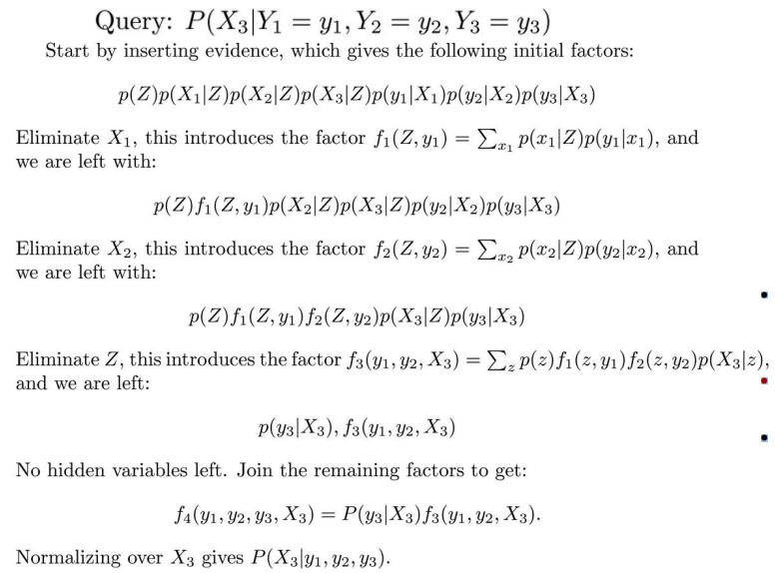

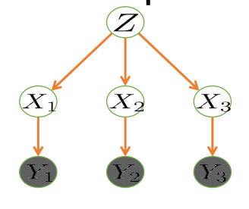

• Computational complexity critically depends on the largest factor being generated in this process.

• Size of factor = number of entries in table.

• In example above (assuming binary) all factors generated are of size2---as they all only have one variable (Z, Z, and X3 respectively).

Variable Elimination Ordering

• For the query P(Xn |y1 ,…,yn ) work through the following two different orderings as done in previous slide: Z, X1 , …, Xn-1 and X1 , …, Xn-1 , Z. What is the size of the maximum factor generated for each of the orderings?

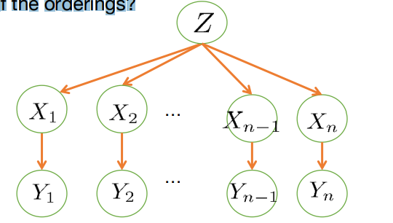

• Answer: 2n+1 versus 22 (assuming binary)

• In general: the ordering can greatly affect efficiency.

VE: Computational and Space Complexity

• **The computational** and **space complexity** of variable elimination is determined by the **largest factor**

• The elimination ordering can greatly affect the size of the largest factor.

• E.g., previous slide’s example 2n+1 vs. 22

• Does there always exist an ordering that only results in small factors? • No!

Worst Case Complexity?

• 3-SAT:

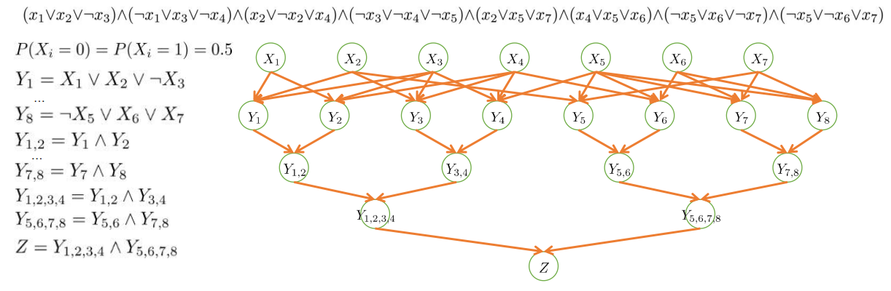

If we can answer P(X1 , X2 , ..., Xn |z=1), we answered whether the 3-SAT problem has a solution.

**Hence inference in Bayes’ nets is NP-hard**. No known efficient probabilistic inference in general.

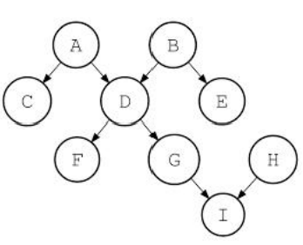Polytrees

• A polytree is a directed graph with no undirected cycles

• For poly-trees you can always find an ordering that is efficient • Try it!!

• Cut-set conditioning for Bayes’ net inference

• Choose set of variables such that if removed only a polytree remains

• Exercise: Think about how the specifics would work out!

Summary: VE

• Time is **exponential in size** of largest factor

• **Bad elimination order** can generate huge factors

• **NP Hard** to find the best elimination order

• There are reasonable heuristics for picking an elimination order(such as choosing the variable that results in the smallest next factor)

• Inference in polytrees (nets with no cycles) is linear in size of the network (the largest CPT)

Probabilistic Reasoning

• Let **p** be a formula. We try to prove it from **available information**(evidence)that is known to be true.

• Let **q1 , . . . , qn** be this evidence. Theorem proving can be used to determine if:

(q1 ˄ q2 ˄ ... ˄ qn ) → p

When the evidence does not imply that p is true it may imply that **p** is false:

(q1 ˄ q2 ˄ ... ˄ qn ) → ¬p

Probabilistic Reasoning

• But in many practical situations the evidence cannot be used to prove that p is either **true** or **false**. Still, it can always be used **for probabilistic reasoning**.

• The optimal Bayes decision rule is:

Take p as true if: P(p | q1 ˄ q2 ˄ ... ˄ qn ) ≥ P(¬p | q1 ˄ q2 ˄ ... ˄ qn )

This is the same condition as:

Take p as true if: P(p | q1 ˄ q2 ˄ ... ˄ qn ) ≥ 0.5

Probabilistic Reasoning: **Generalization of Logical Reasoning**

• Observe that if (q1 ˄ q2 ˄ ... ˄ qn ) →p, then P(p | q1 ˄ q2 ˄ ... ˄ qn ) = 1

So, **probabilistic reasoning generalizes logic reasoning**.

Probabilistic Reasoning

• The optimal Bayes decision rule is:

Take p as true if: P(p | q1 ˄ q2 ˄ ... ˄ qn ) ≥ P(¬p | q1 ˄q2 ˄... ˄qn)

• **Simplification using Bayes Rule**

• Take p as true if： P( q1 ˄ q2 ˄ ... ˄ qn | p) P(p) ≥ P( q1 ˄ q2 ˄ ... ˄qn | ¬p)P(¬p)

Naïve Bayes assumption

• **Simplification using Naïve Bayes assumption**

• The presence of a **particular evidence** is unrelated to **the presence of any other evidences**.

• Take p as true if：

P( **q1 | p**) P(**q2 |p**) ... P(**qn |p**)P(p) ≥ P( **q1 |¬p**) P( **q2 |¬p**) ... P**( q3 |¬p**) P(¬p)

Naïve Bayes assumption

• Classifying documents by their content, for example into **spam** and **non-spam** e-mails

• The **document D** is drawn from a number of classes (topics)

• Each class C is modeled as sets of words, the probability that the i-th word occurs is P(w­ | C)

• The probability of the document D given the classes C is P(D|C) = ∏i p(w­i|C)

**Question:** what is the probability that a given document D belongs to a given class C? P(C|D)

Naïve Bayes assumption

• P(D|C) = P(D ˄ C) / P(C) conditional distribution

• P(C|D) = P(D ˄ C) / P(D) conditional distribution

= P(C)P(D|C) / P(D) product rule

Assume that there two classes: **Spam(S)** and **not Spam(¬S)**

P(D|**S**) = ∏i p(wi|**S**) Assumption

P(D**|¬S**) = ∏i p(wi**|¬S**) Assumption

P(**S**|D) = P(**S**) ∏i p(wi|**S**) / P(D) Bayes rule

P**(¬S**|D) = P**(¬S**) ∏i p(wi**|¬S**) / P(D) Bayes rule

**Assume P(S) = P(¬S) = 0.5**

P(**S**|D) / P**(¬S**|D) = ∏i p(wi|**S**) / p(wi**|¬S**).

**Bayesian Networks: Approximate Inference**

Inference: The Bad News

• Computing the conditional probabilities by enumerate in gall relevant entries in the joint is expensive: **Exponential in the number of variables!**

Possible Solutions

• **Exact methods**

• **Inference by enumeration** and **variable elimination**

• **Approximate methods**

• Approximate the joint distributions by drawing samples

**Sampling**

• **Sampling** is a lot like repeated simulation • tossing a coin, tosing a dice, …

• **Basic idea**

• Draw N samples from a sampling distribution S

• Compute an approximate posterior probability

• Show this converges to the true probability P

• Why:

• **Learning**: get samples from a distribution you don’t know

• **Inference**: getting a sample is faster than computing the right answer(e.g. with variable elimination).

Approximate Methods: Sampling

• **Sampling** = Powerful technique in many probabilistic problems

• General idea:

• It is often difficult to compute and represent exactly the probability distribution of a set of variables

• But, it is often easy to generate examples from the distribution.

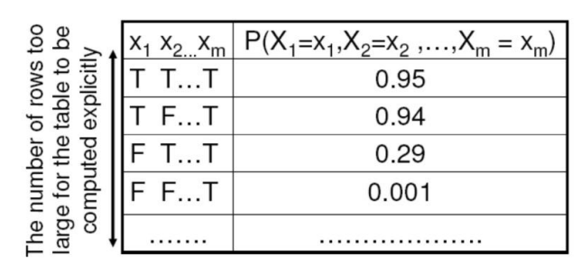

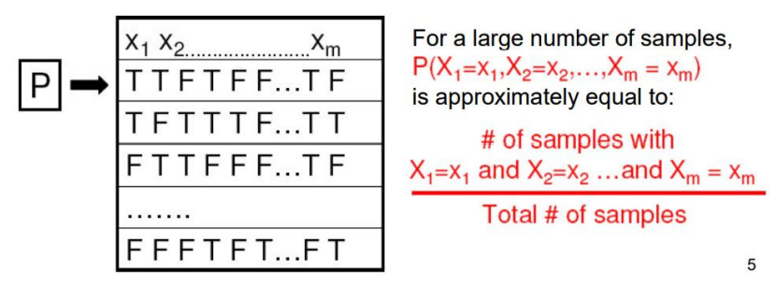

Sampling from given distribution

• **Step 1**: Get sample u from uniform distribution over [0, 1)

• E.g. random() in python

• **Step 2**: Convert this sample u **into an outcome for the given distribution** by having each outcome associated with a sub-interval of [0,1) with sub-interval size equal to probability of the outcome

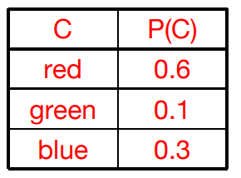• Example • If random() returns u = 0.83, then our sample is C = blue

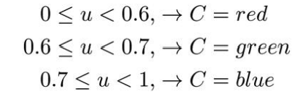

Sampling

• Prior Sampling • Rejection Sampling • Likelihood Weighting • Gibbs Sampling

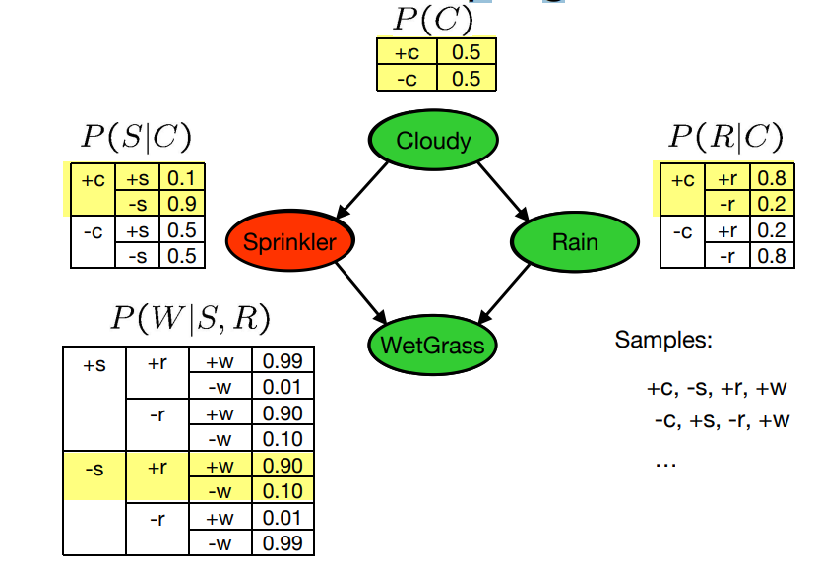Prior Sampling

• For i=1, 2, …, n

• Sample xi from P(Xi | Parents(Xi))

• Return (x1 , x2 , …, xn )

• We’ll get a bunch of samples from the BN:

+c, -s, +r, +w

+c, +s, +r, +w

-c, +s, +r, -w

+c, -s, +r, +w

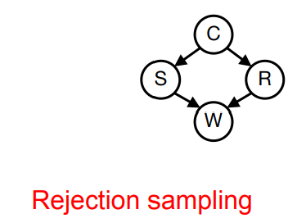-c, -s, -r, +w

• Compute probability:

• We have counts

• Normalize to get P(W) = <+w:0.8, -w: 0.2>

• What about P(C| +w)? P(C| +r, +w)? P(C| -r, -w)?

Sampling: An Example

• The lawn may be wet because the sprinkler was on or because it was raining (or both).

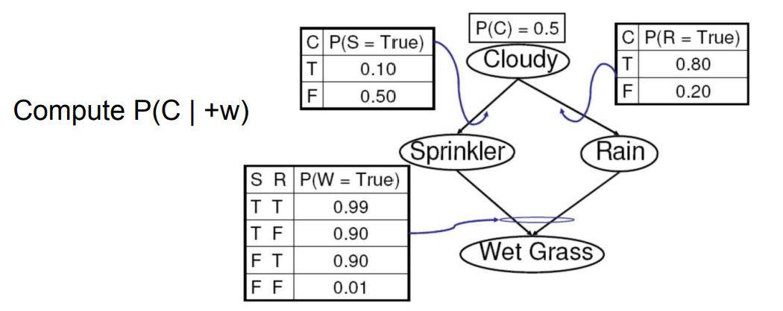

Sampling

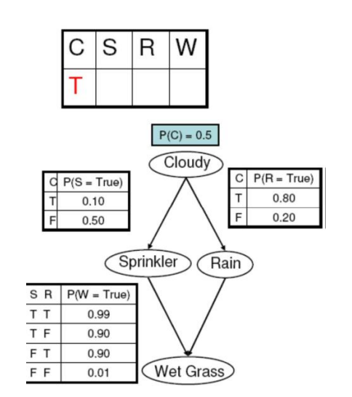1. Randomly choose C. C = True with probability0.5 →**C = True**

2. Randomly choose S. S = True with probability0.10 →**S = False**

3. Randomly choose R. R = True with probability0.80 →**R = True**

4. Random choose W. W= True with probability0.90 →**W= True**

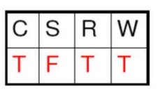+c, -s, +r, +w +c, -s, +r, +w

+c, +s, +r, +w -c, -s, -r, +w

-c, +s, +r, -w

• Compute P(C| +w):

• Gather all the samples with +w • Count +c and-c

Rejection Sampling: Example

• Suppose that we want to compute **P(W = True | C = True)** (In words: How likely is it that the grass will be wet given that the sky is cloudy)

• Compute lots of samples of (C,S,R,W)

- Nc = Number of samples for which C = True

- Ns = Number of samples for which W = True and C = True

- N = Total number of samples

• Nc /N approximates P(C = True)

• Ns /N approximates P(W = True and C = True)

Therefore: Ns /Nc approximates: P(W = True and C = True)/ P(C = True) = P(W = True | C = True)

Rejection Sampling: General Case

• Suppose that we want to compute **P(E1 | E2 )** (In words: How likely is it that the grass will be wet given that the sky is cloudy)

• Compute lots of samples of (C,S,R,W)

- Nc = Number of samples for which C = True

– Ns = Number of samples for which W = True and C = True

– N = Total number of samples

• Nc /N approximates P(E2 )

• Ns /N approximates P(E1 and E2 )

Therefore: Ns /Nc approximates: P(E1 and E2 ) / P(E2 ) = P(E1 | E2 )

Problems with Rejection Sampling

• Probability **is so low** for some assignments of variables that will likely never be seen in the samples (unless a very large number of samples is drawn).

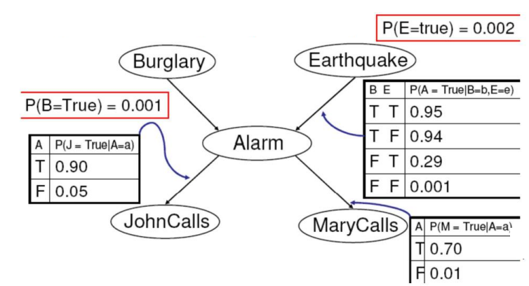

• P(JohnCalls = True | **Earthquake = True**)

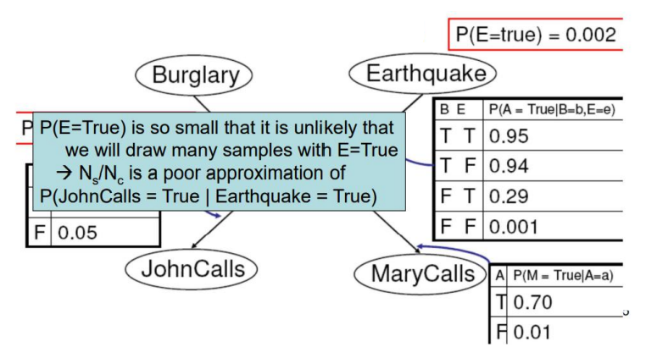

Solution: Likelihood Weighting

• Suppose that E2 contains a variable assignment of the form Xi =v

• Current approach:

Generate samples until **enough of them** contain Xi = v

Such samples are generated with probability

p = P(Xi = v | Parents(Xi))

• **Likelihood Weighting**:

Generate **only** samples with Xi = v

Weight each sample by ω = p

Solution: Likelihood Weighting

• Idea: fix evidence variables, sample only **nonevidence variables**,

• Weight each sample by the likelihood it accords the evidence

• The weights of samples derived from **likelihood of evidence** accumulated during sampling process.

Solution: Likelihood Weighting

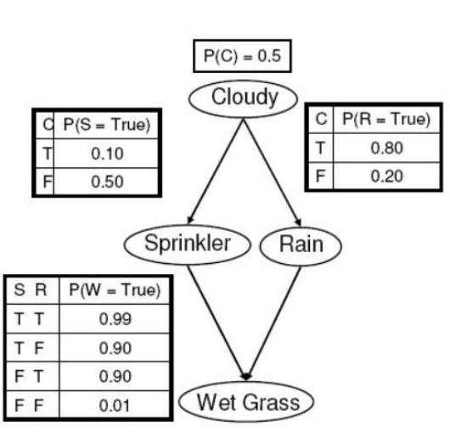• Example: Suppose that we want to compute an inference with

E2 : (**S= True, W=True**).

1. Randomly choose C. C = True with probability0.5→**C = True** 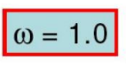

C **is not** one of the evidence variables, so we take a random sample as before

2. Set **S = True**

S is one of the evidence variables, so we fix its value

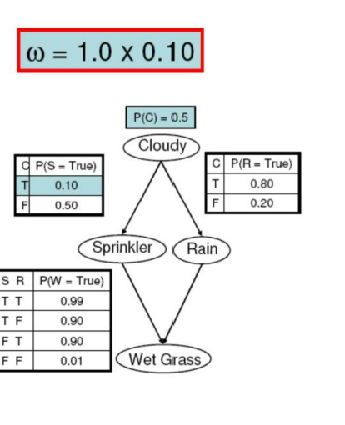 without sampling

3. Randomly choose R. R = True with probability0.80→**R = True**

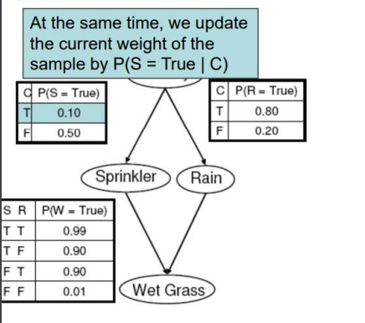

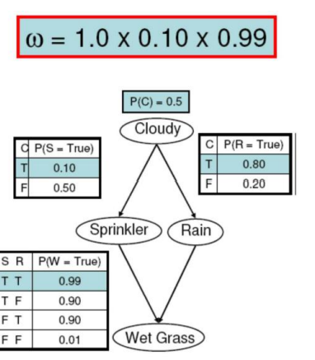4. Set **W= True**

Wis one of the evidence variables, so we fix its value without sampling

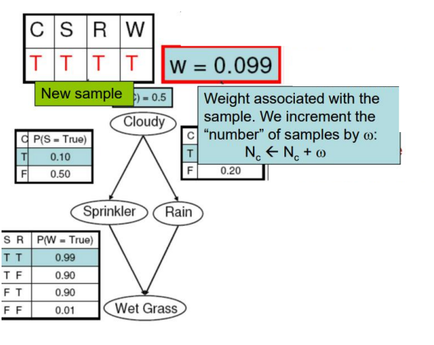

Likelihood Weighting

• Nc = 0; Ns = 0;

1. Generate a random assignment of the variables, fixing the variables assigned in E2

2. Assign the sample a weight ω = **probability that this sample would have been generated if we did not fix the value of the variables in E2**

3. Nc ← Nc + ω

4. If the sample matches E1 Ns ←Ns + ω

5. Repeat until we have “enough” samples

Ns /Nc is an estimate of P(E1 |E2 )

Likelihood Weighting

• Likelihood weighting is good

• We have taken evidence into account as we generate the sample

• E.g. here, W’s value will get picked based on the evidence values of S,R

• Likelihood weighting doesn’t solve all our problems

• Evidence influences the choice of **downstream variables**, but not **upstream ones** (C isn’t more likely to get a value matching the evidence)

• We would like to consider evidence when we sample every variable • Gibbs sampling.

Gibbs Sampling

• **Procedure**: keep track of a full instantiation x1 , x2 , …, xn.

• Start **arbitrary instantiation** consistent with the evidence.

• Sample one variable at a time, conditioned on all the rest, but keep evidence fixed.

• Keep repeating this for a long time

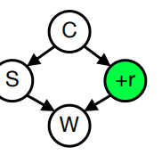Gibbs Sampling Example: P(S|+r)

• Step 1: Fix evidence

• R = +r

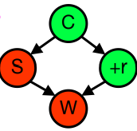

♣ Step 2: Initialize other variables

♣ Randomly

• Steps 3: Repeat

• Choose a non-evidence variable X

• Resample X from P( X | all other variables)

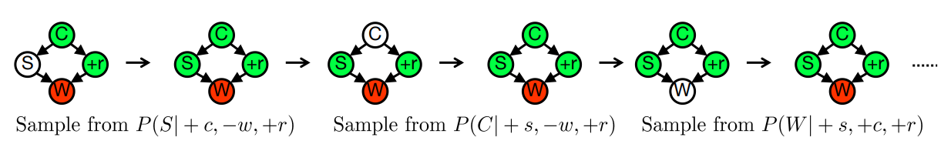

Efficient Resampling of One Variable • Sample from P(S | +c, +r, -w)

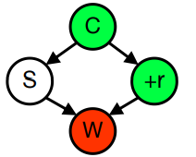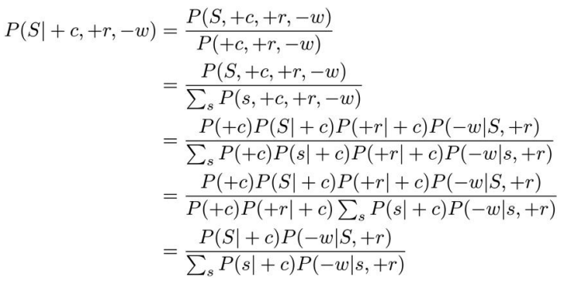

• Many things cancel out – only CPTs with S remain!

• More generally: only CPTs that have resampled variable need to be considered, and joined together

Further Reading on Gibbs Sampling*

• Gibbs sampling produces sample from the query distribution P(Q| e ) in limit of re-sampling infinitely often

• Gibbs sampling is a special case of more general methods called **Markov chain Monte Carlo (MCMC)** methods

• Metropolis-Hastings is one of the more famous MCMC methods(in fact, Gibbs sampling is a special case of Metropolis-Hastings)

• You may read about Monte Carlo methods – they’re just sampling.

Summary

• **Prior Sampling**: sampling from P

**• Rejection Sampling**: sampling form P(Q|e)

• **Likelihood Weighting**: sampling form P(Q|e)

• **Gibbs Sampling**: sampling form P(Q|e).

Use d-separation to determine

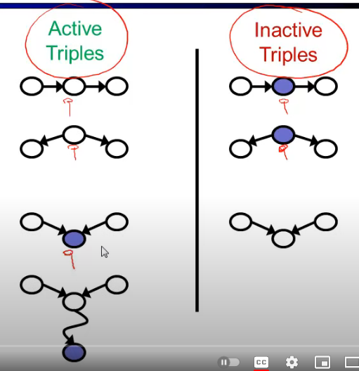

**Games of Chance**

Backgammon – Board

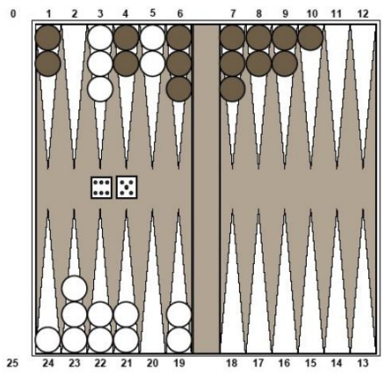• **Goal**: move all of your pieces off the board before your opponent does.

• Black moves **counterclockwise** toward 0.

• White moves **clockwise** toward 25.

• The number of steps depend on the outcomes of tossing two dices.

• A piece can move to any position except one **where there are two or more of the opponent’s pieces**.

Backgammon – Rules

• If you roll doubles you take 4 moves (example: roll 5,5,makemoves 5,5,5,5).

• Moves can be made by one or two pieces (in the case of doubles by 1, 2, 3 or 4 pieces)

• And a few other rules that concern bearing off and forced moves.

Backgammon – Rules

• White has rolled 6-5 and has 4 legal moves: (5-10,5-11), (5-11,19-24), (5-10,10-16) and (5-11,11-16).

Backgammon – Rules

• The player tosses two dices

• Based on the outcomes to make certain moves

• The opponent tosses the dices

• Based on the outcomes to make certain moves

Game Tree for Backgammon

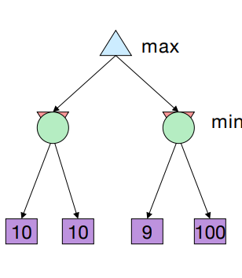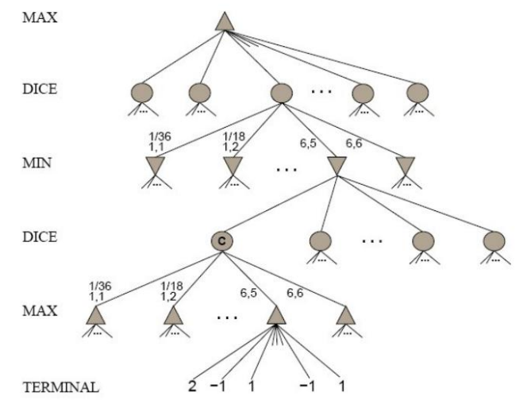

Uncertain Outcome

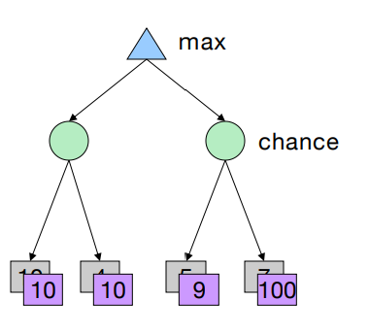• Idea: Uncertain outcomes controlled by chance, not an adversary!

Expectimax Search

• Why wouldn’t we know what the result of an action will be?

• Explicit randomness: rolling dice

• Unpredictable opponents: the ghosts respond randomly

• Actions can fail: when moving a robot, wheels might slip.

Reminder: Probabilities

• A **random variable** represents an event whose out come is unknown

• A **probability distribution** is an assignment of weights to outcomes

• Example: Traffic on freeway

• Random variable: T = whether there’s traffic • Outcomes: T in {none, light, heavy}

• Distribution: P(T=none) = 0.25, P(T=light) = 0.50, P(T=heavy) =0.25

Reminder: Expectations

• The **expected value** of a function of a random variable is the average, weighted by the probability distribute on over outcomes

• Example: How long to get to the airport?

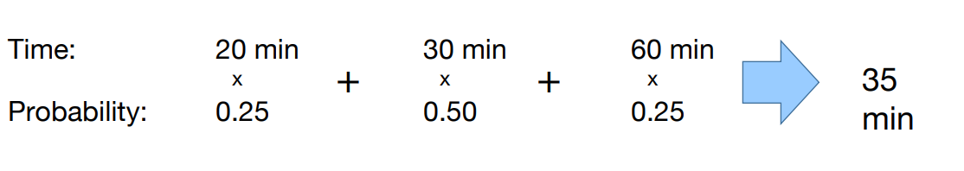

What Probabilities to Use?

• In expectimax search, we have a **probabilistic model** of how the opponent (or environment) will behave in any state

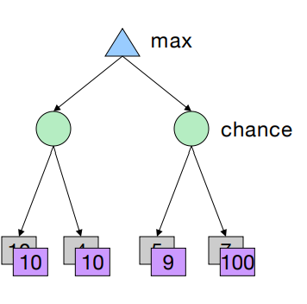• Model could be a simple uniform distribution (roll a die)

• Model could be sophisticated and require a great deal of computation

• We have a chance node for any outcome out of our control: opponent or environment

• The model might say that adversarial actions are likely!

• For now, assume each chance node magically comes along with probabilities that specify the distribution over its outcomes

Expectimax Search

• Values should now reflect average-case (expectimax) outcomes, not worst-case (minimax) outcomes

• **Expectimax search**: compute the average score under optimal play

• Max nodes as in minimax search

• Chance nodes are like min nodes but the outcome is uncertain

• Calculate their **expected utilities**

• I.e. take weighted average (expectation) of children

Expectimax Pseudocode

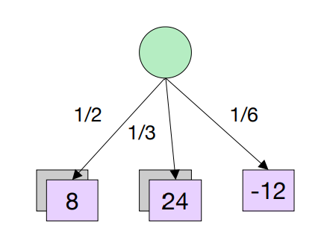def exp-value(state):

initialize v = 0

for each successor of state:

p = probability(successor)

v += p * value(successor)

return v

v = (1/2) (8) + (1/3) (24) + (1/6) (-12) = 10

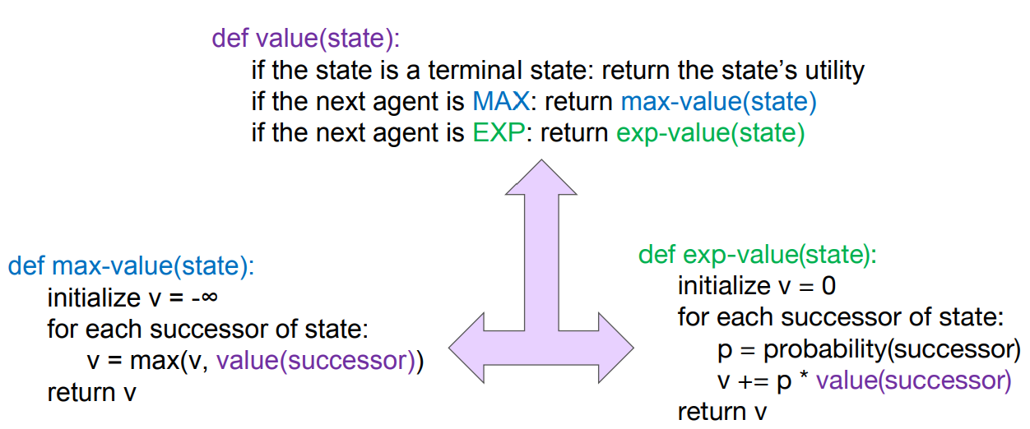

Expectimax Example

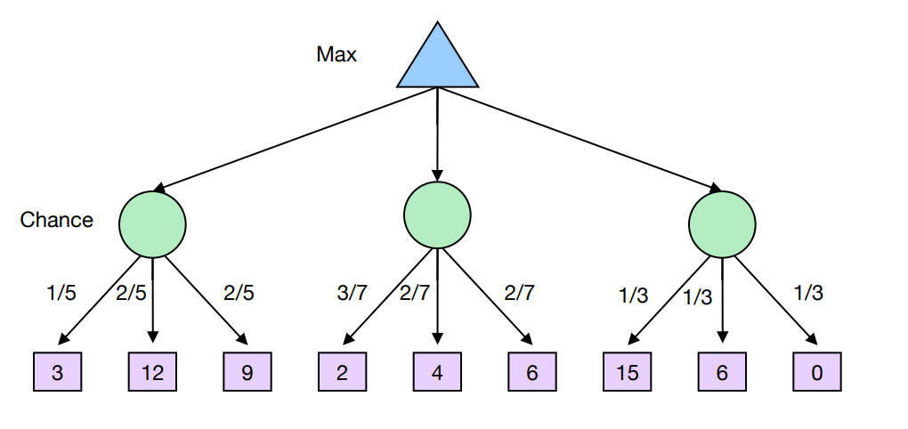

What Utilities to Use?

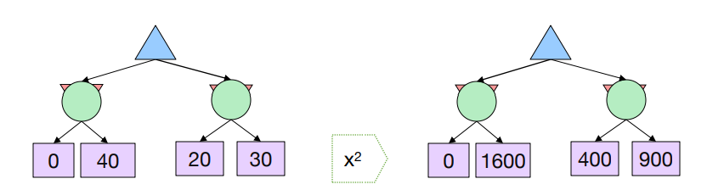

• For worst-case minimax reasoning, terminal function scale doesn’t matter

• We just want better states to have higher evaluations (get the ordering right)

• We call this **insensitivity to monotonic transformations**

• For average-case expectimax reasoning, we need magnitudes to be meaningful.

Depth-Limited Expectimax

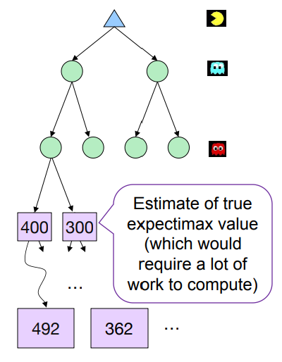

The Dangers of Optimism and Pessimism

• Dangerous Optimism

• Assuming chance when the world is adversarial

• MiniMax

• Dangerous Pessimism

• Assuming the worst case when it’s not likely

• ExpectiMax

Assumptions vs. Reality

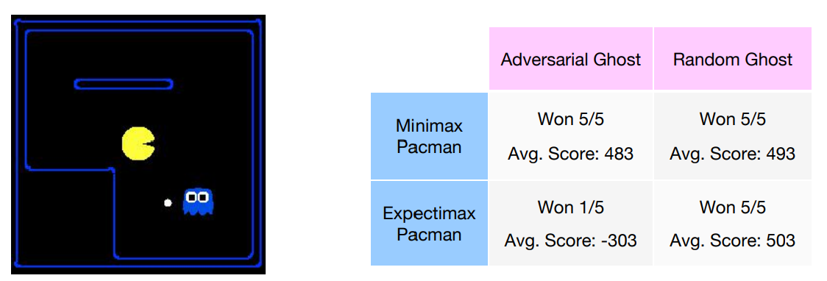

Pacman used depth 4 search with an eval function that avoids trouble

Ghost used depth 2 search with an eval function that seeks Pacman

Utilities

• **Utilities are functions from outcomes (states of the world) to real numbers that describeanagent’s preferences**

• Where do utilities come from?

• In a game, may be simple (+1/-1)

• Utilities summarize the agent’s goals

• **Theorem:** any “rational” preferences can be summarized as a utility function

• We hard-wire utilities and let behaviors emerge

• Why don’t we let agents pick utilities?

• Why don’t we prescribe behaviors?

• Why maximize expected utility?

• Expected utility theory is a theory about how to make optimal decisions under a given probability of utility.

Preferences

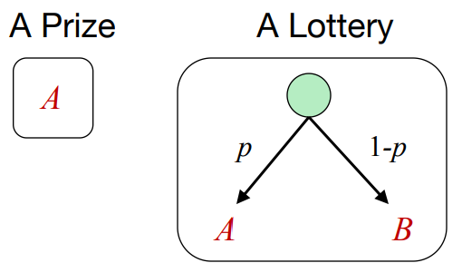• An agent must have preferences among:

• Prizes: A, B, etc.

• Lotteries: situations with uncertain prizes

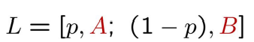

• Notation:

• Preference: 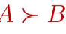

• Indifference: 

Rational Preferences

• We want some constraints on preferences before we call them rational, such as:

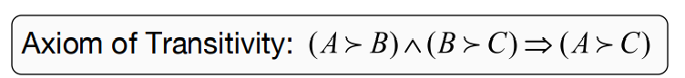

• For example: an agent with intransitive preferences can be induced to give away all of its money

• If B > C, then an agent with C would pay (say) 1cent to get B

• If A > B, then an agent with B would pay (say) 1cent to get A

• If C > A, then an agent with A would pay (say) 1cent to get C

Rational Preferences

The Axioms of Rationality

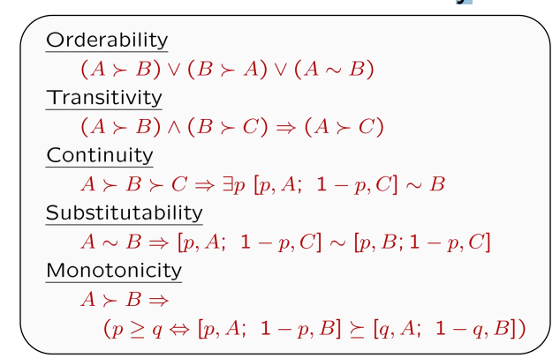

• If all the axioms are satisfied, the agent is said to be rational

MEU Principle

• Theorem [Ramsey, 1931; von Neumann & Morgenstern, 1944]

• Given any preferences satisfying these constraints, there exists **a real-valued function** U such that:

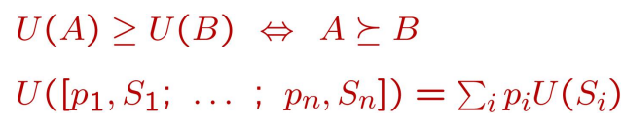

• I.e. values assigned by U preserve preferences of both prizes and lotteries!

• **Maximum expected utility (MEU) principle:**

• Choose the action that maximizes expected utility

• Note: an agent can be entirely rational (consistent with MEU) without ever representing or manipulating utilities and probabilities

• E.g., a lookup table for perfect tic-tac-toe.

Summary

• Minimax considers adversarial opponent

• ExpectiMax considers random opponent.

• Maximum expected utility leads to a rational agent.

**Games with Hidden Information**

Basic Ingredients of Games

• A set of participants

• Each play has a set of options for how to behave: strategies.

• For each choice of strategies, each player receives a pay off that can **depend on the strategies selected by everyone**.

Types of Games

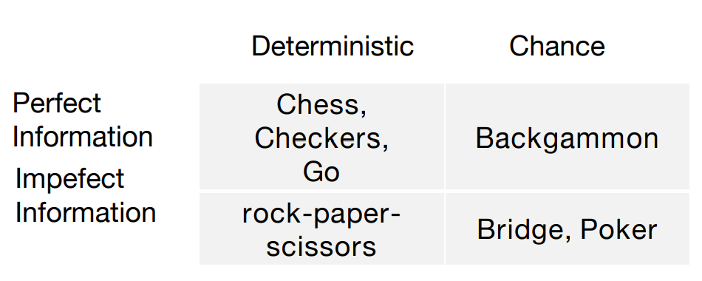

Types of Games

• **Assumptions so far**

• Two-player game: Players A and B.

• Perfect information: Both players see all the states and decisions. Each decision is made sequentially.

**• Zero-sum**: Player’s A gain is exactly equal to player B’s loss

• We are going to eliminate these constraints. We will eliminate first the assumption of “**perfect information**” leading to far more realistic models.

• Some more game-theoretic definitions →Matrix games

• Minimax results for perfect information games

• Minimax results for hidden information games.

The heart of the problem

• In a **1-agent setting**, agent’s expected utility maximizing strategy is well-defined

• But in **a multiagent system**, the outcome may depend on others’ strategies also.

Search Tree

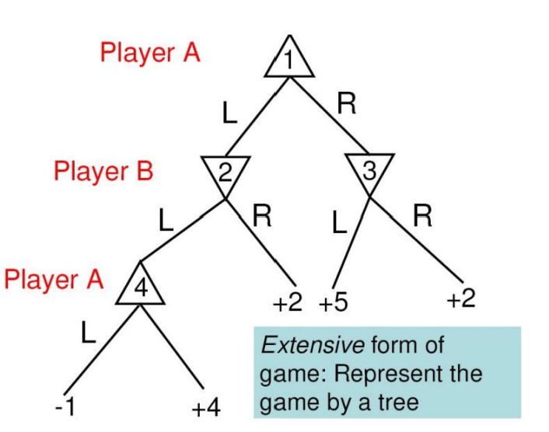A **pure strategy** for a player defines the move that the player would make for every possible state that the player would see.

**Pure strategies for A**:

Strategy I: (1L,4L) Strategy II: (1L,4R) Strategy III: (1R,4L) Strategy IV: (1R,4R)

**Pure strategies for B**:

Strategy I: (2L,3L) Strategy II: (2L,3R) Strategy III: (2R,3L) Strategy IV: (2R,3R)

Matrix Form of Games   
Pure strategies for A: Strategy I: (1L,4L) Strategy II: (1L,4R) Strategy III: (1R,4L) Strategy IV: (1R,4R)

Pure strategies for B: Strategy I: (2L,3L) Strategy II: (2L,3R) Strategy III: (2R,3L) Strategy IV: (2R,3R)

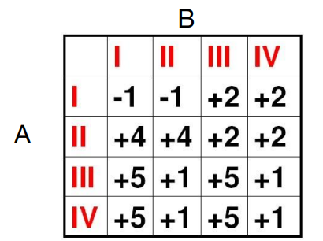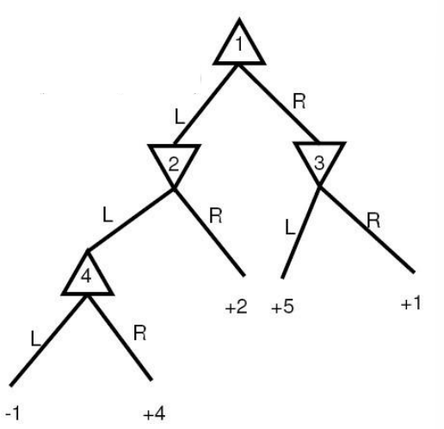

Minimax →Matrix Version

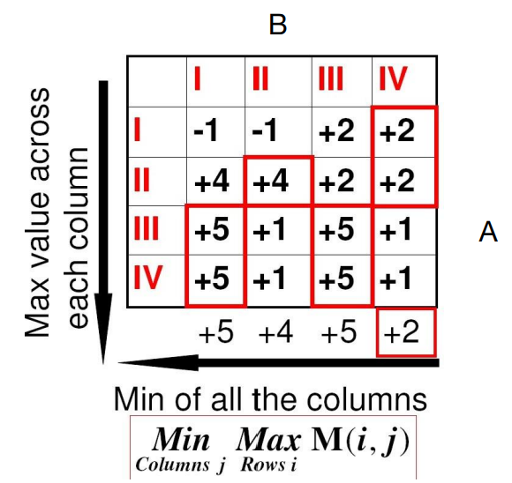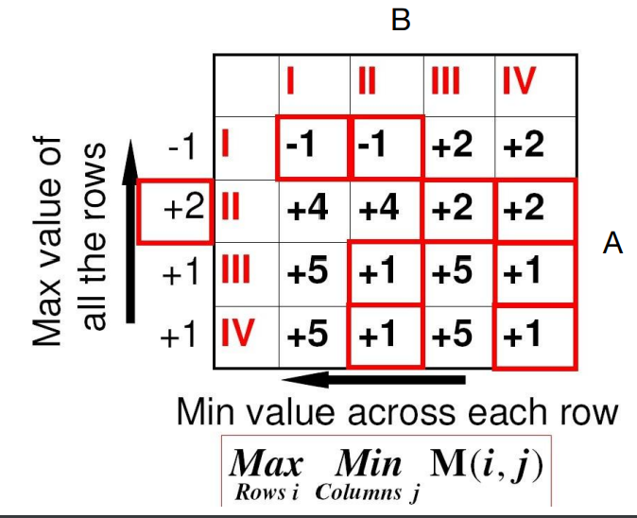

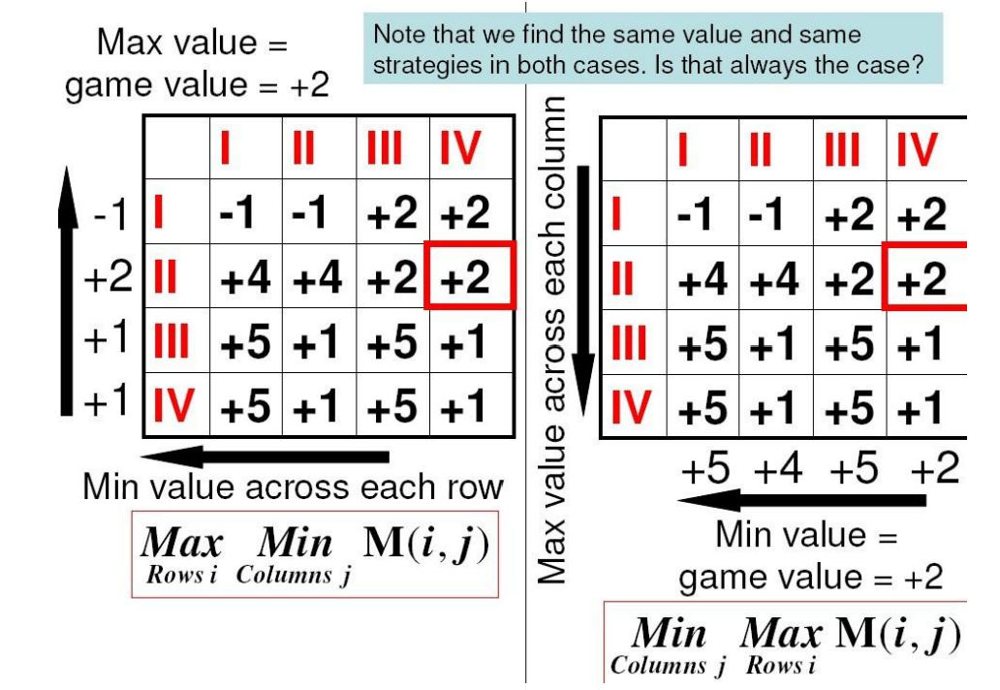

Minimax vs. Maximin

• Fundamental Theorem I (von Neumann):

• For a two-player, zero-sum game with perfect information:

• There always exists an optimal pure strategy for each player

• Minimax = Maximin

• Note: This is a game-theoretic formalization of the minimax search algorithm.

Another (Simple) Game

• The two Players A and B each have a coin

• They show each other their coin, choosing to show either head or tail

• If they both choose head Player B pays Player A$2

• If they both choose tail Player B pays Player A$1

• If they choose different sides Player A pays Player B$1

Side Note About All Toy Examples

• This kind of toy example models a large number of real-life situations.

• For example: Player A is a business owner (e.g., a restaurant, a plant..) and Player B is an inspector. The inspector picks a day to conduct the inspection; the owner picks a day to hide the bad stuff. Player B wins if the days are different; Player A wins if the days are the same.

• This class of problems can be reduced to the “coin game”(with different payoff distributions, perhaps).

Extensive Form

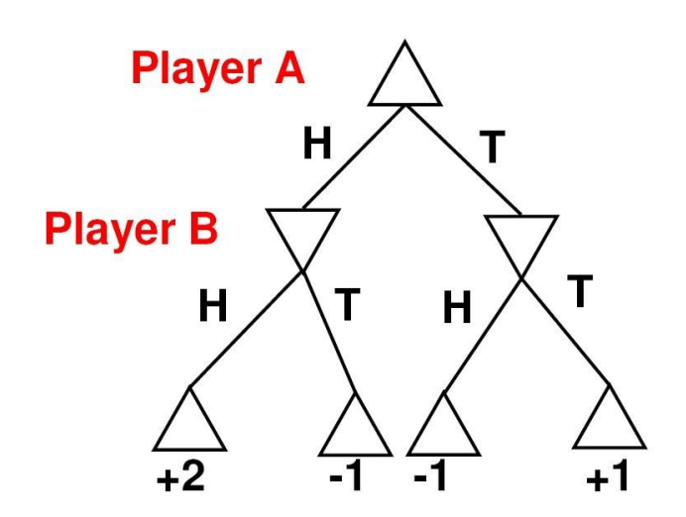

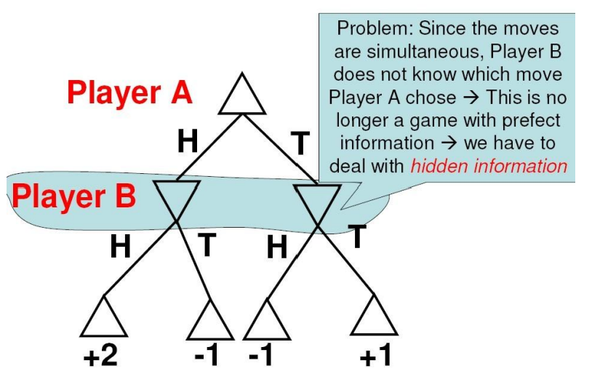

Matrix Normal Form

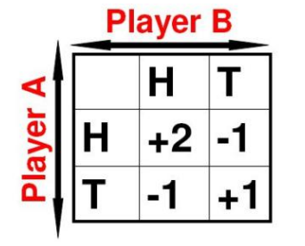• It is no longer the case that maximin = minimax (easy to verify:-1 vs. +1)

• Therefore: It appears that there is **no pure strategy solution**

• In fact, in general, none of the pure strategies are solutions to a **zero-sum game with hidden information**

Why No Pure Strategy Solutions?

• If Player A considers move H, he has to assume that Player B will choose the worst- case move (for A), which is move T

• Therefore Player A should try move T instead, but then he has to assume that Player B will choose the worst-case move (for A), which is move H.

• Therefore Player A should consider move H, but then he has to assume that Player B will choose the worst-case move (for A), which is move T……….

Using Random Strategies

• Suppose that, instead of choosing a fixed pure strategy, Player A chooses randomly strategy H with probability p, and strategy T withprobability1-p.

• If Player B chooses move H, the **expected** payoff for Player Ais:

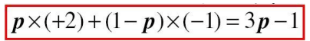

• If Player B chooses move T, the **expected** payoff for Player Ais:

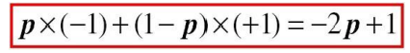

• So, the worst case is when Player B chooses a strategy that **minimizes** the pay off between the 2 cases:

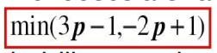

• Player A should then adjust the probability p so that its payoff is **maximized** (note the similarity with the standard maximin procedure):

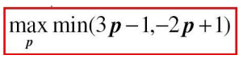

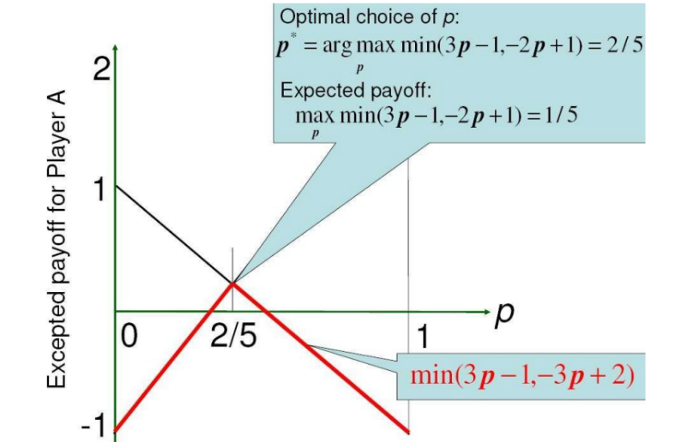Graphical Solution

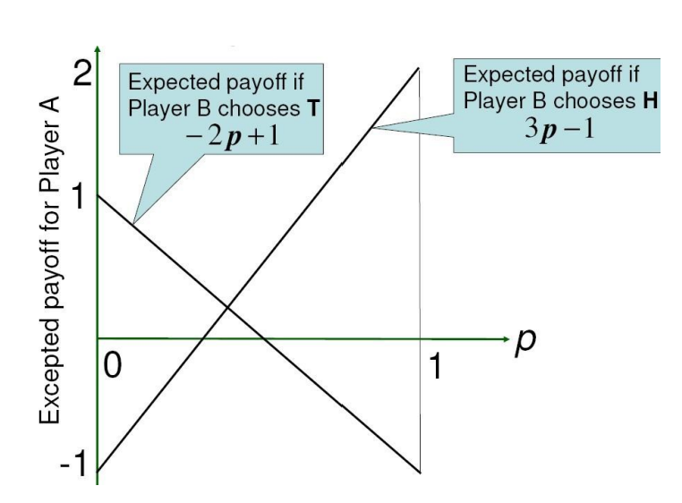

Mixed Strategies

• It is no longer possible to find **an optimal pure** strategy for Player A.

• We need to change the problem a bit: We assume that Player A chooses a pure strategy randomly at the beginning of the game.

• In that scenario, Player A selects one pure strategy probability and the other one with probability 1-p.

• This strategy of choosing pure strategies randomly is called a **mixed strategy** for Player A and is entirely defined by the probability p.

• The result that we derived for the simple example holds for general games. It yields a procedure for finding **the optimal mixed strategy** for zero-sum games.

Minimax with Mixed Strategies

• Theorem II (von Neumann):

• For a two-player, zero-sum game with hidden information, there always exists an optimal mixed strategy with value

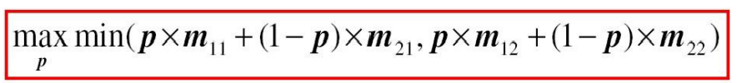

• Where the matrix form of the game is: 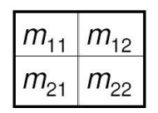

• Note: This is a direct generalization of the minimax result to mixed strategies.

Minimax with Mixed Strategies

• Theorem II (von Neumann):

• For a two-player, zero-sum game with hidden information:

• There always exists an optimal mixed strategy with value

• In addition, just like for games with perfect information, it does not matter in which order we look at the players, **minimax is the same as maximin**.

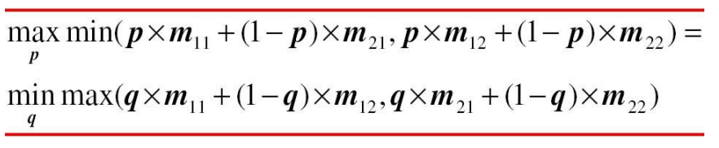

Recipe for 2 x 2 Games

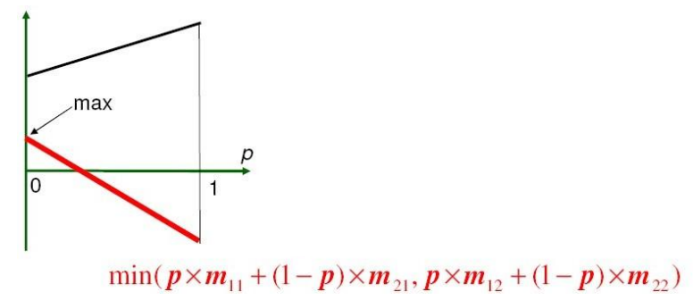

• Since the two functions of p are linear, the maximum is attained either for: • p = 0

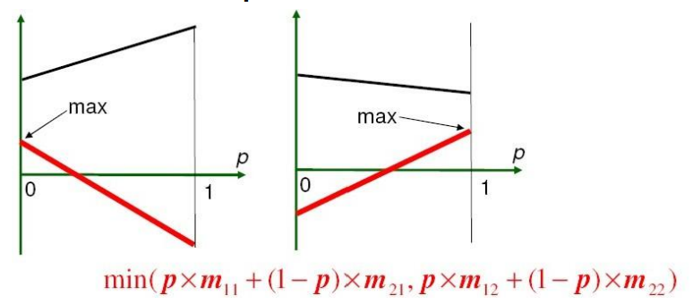

• Since the two functions of p are linear, the maximum is attained either for: • p = 0 • p = 1

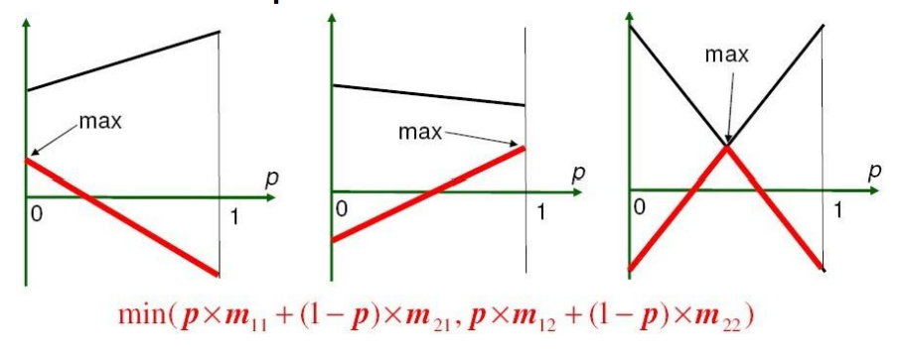

• Since the two functions of p are linear, the maximum is attained either for:

• p = 0 • p = 1 • The intersection of the two lines, if it occurs for p between 0 and 1.

General Case: N x M Games

• We have illustrated the problem on **2x2 games** (2 strategies for each of Player A and Player B)

• The result generalizes to NxM games, although it is more difficult to compute

• A mixed strategy is a vector of probabilities (summing to 1!) p = (p1,..,pN). pi is the probability with which strategy i will be chosen by Player A.

• The optimal strategy is found by solving the problem:

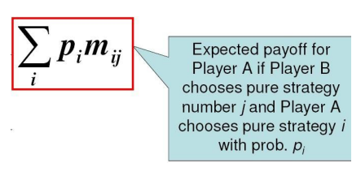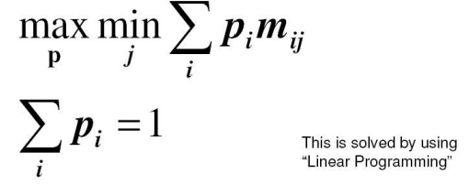

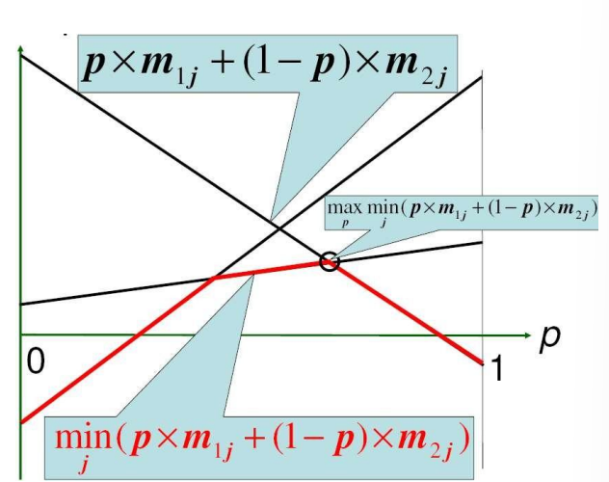Graphical Illustration: 2 x M Game

• Each strategy of the opponent corresponds to one straight line

• The opponent aims to minimize the payoff

• The player aims to maximize the minimum payoff

Discussion

• The criterion for selecting the optimal mixed strategy is the average payoff that Player A would receive over many runs of the game.

• It may seem strange to use random choices of pure strategies as “mixed” strategies and to search for optimal mixed strategies.

• In fact, it formalizes what happens in common situations. For example, in poker, if Player A follows a single pure strategy (taking the same action every time a particular configuration of cards is dealt), Player B can guess and respond to that strategy and lower Player A’s payoffs.

• The right thing to do is for Player A to change randomly the way each configuration is handled, according to some policy. A good player would use a good policy

Another Example: Poker

• Players A and B play with two types of cards: Red and Black

• Player A is dealt one card at random( 50 % probability of being Red)

• If the card is red, Player A **may resign** and loses $10

• Or Player A may **hold**

– B may then **resign** A wins $4

– B may **see**

• A loses $20 if the card is Red

• A wins $16 otherwise

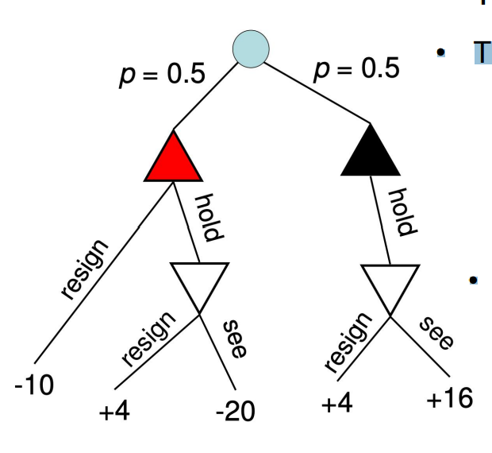Another Example: Poker

• The game is non-deterministic

• Hidden information: Player B cannot know which of these 2 states it’s in

Another Example: Poker

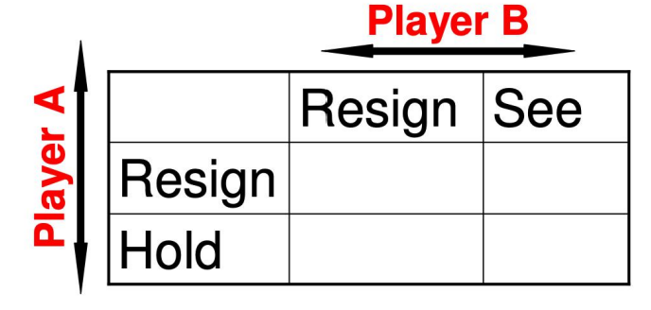

• Generate the matrix form of the game (be careful: It’s not a deterministic game)

• Find the expected payoff for Player A

• Find the optimal mixed strategy

Summary

• Matrix form of games

• Minimax procedure and theorem for games with perfect information Always **a pure strategy** solution

• Minimax procedure and theorem for games with imperfect information Always a **mixed strategy** solution

• Procedure for solving 2x2 games with hidden information

• Understanding of how the problem is formalized for N x M games (actually solving them requires linear programming tools which will not be covered here)

• Important: These results apply only to **zero-sum games**. This is still a severe restriction as most realistic decision- making problems cannot be modeled as **zero sum games**.